Appendix E

Birmingham Public Health
Sexual Health Services Redesign Consultation
Consultation and Findings

Report provided: Nicola Pugh
Involved in / contributed to Consultation: John Denley, Lynn Inglis, Clare Reardon, Jak Lynch, Charlene Mulhern, Ricky Bhandal Shazia Akram, Dawn Hannigan, Kulwant Ghaleigh, Belinda Brown, Jade Hussein, Priscilla Brown, Andrea Walker-Kay, Julie Bach and Debbie Bowen. Contributions and support also received from Freshwinds and Birmingham Sexual Health service providers.
08.01.2014

Contents

1 Executive Summary 4
2 Introduction 7
3 Data Sources and Scope 7
4 Key Findings 7
4.1 What is your email address? 7
4.2 We are proposing the following outcomes as priorities for the new Sexual Health system in Birmingham. Do you agree that these are the right outcomes to prioritise? 8
4.3 Do you agree with our proposal to create a joined up, managed, Sexual Health system rather than separate services? 9
4.4 We propose that Family Doctors (GPs) and Community Pharmacies should be providing more Sexual Health services. Do you agree? 10
4.5 We propose a significant role for voluntary organisations in the Sexual Health system, especially to support vulnerable group. Do you agree? 10
4.6 We propose three satellite clinics, one in the City centre, one just north of the City centre and one somewhere towards the south edge of the City. These will provide both contraception and testing and treatment. What should we think about when choosing where to put services? 11
4.7 Any other comments on the new Sexual Health system? 12
4.8 Which statement best describes your interest in the consultation? 12
4.9 What is your postcode? 12
4.10 Which age group applies to you? 13
4.11 Disability 13
4.12 What is your sex or gender? 15
4.13 What is your ethnic group? 15
4.14 What is your religion or belief? 16
4.15 What is your sexual identity? 17
5 Summary of Comments 18
5.1 Proposed Priority Outcomes 18
5.2 Proposal to create a joined up, managed Sexual Health system rather than separate services. 19
5.3 Proposal for GPs and community pharmacies to provide more Sexual Health services. 20
5.4 Proposal for Voluntary Organisations to have a more significant role in Sexual Health service provision 21
5.5 Proposal for three satellite clinics (central, north and south) 22
6 Priority Groups 22
6.1 Priority Groups 22
6.2 New Arrivals to the UK 23
6.3 Learning Disabilities 23
6.4 Homeless 24
6.5 Sex Workers 24
6.6 Lesbian Gay Bisexual Trans Community 25
6.7 People with Substance Misuse Problems 25
6.8 Gypsies and Travellers 26
6.9 Children in Need and Care Leavers 26
6.10 People with Mental Health issues 26
7 Conclusion 27
8 Recommendations 29
Appendices
Sexual Health Services Redesign Consultation Questionnaire (Easy Read Version)
List of consultation events and groups/organisations attending

Birmingham Sexual Health Services Consultation
Results and Findings

Executive Summary
The Sexual Health proposals received an overwhelming response with 2,500 questionnaires submitted.
The consultation had 5 questions relating to the proposals. There was broad acceptance of all the proposals ranging from 90% to 58% agreement. To help inform future plans, consideration was given to minority responses which expressed disagreement. A summary is provided below:
Question 1: Agreement with the ten outcomes as priorities for the new Sexual Health system.
Over 90% of respondents agreed with the proposed outcomes to improve support for people vulnerable to/victim of sexual coercion, find and treat more young people with chlamydia, and fewer numbers of HIV, Sexually Transmitted Infections (STIs) and Blood Borne Viruses (BBVs) passed to others. Slightly fewer agreed with the priority outcomes of reducing the numbers of initial and repeat abortions and fewer under 18s conceptions (77% and 82% agreement respectively).
Recommendation:
- To confirm the priority outcomes in the commissioning strategy.

Question 2. Agreement with the proposal to create a joined up, managed, Sexual Health system rather than separate services?
71% agreed there was a need for a joined up, managed, Sexual Health system. 9% disagreed and this related to two main themes:
1) Confidentiality - Respondents were concerned that a joined up system would mean that their personal data would be inappropriately shared within the system and compromise confidentiality and anonymity.
2) Scale of the system - There were concerns that the system would be so big, it would lose the ability to support individual needs, and the needs of smaller, vulnerable (priority) groups.
Recommendations:
- To require the service provider to implement all statutory and professional codes of practice.
- To require the service provider to develop standards of practice consistent with the individual needs of service users.
- To require service providers to develop service responses appropriate to priority groups.
- To confirm contractual arrangements that incentivises performance in relation to priority groups.
Question 3. Proposing that family Doctors (GPs) and community pharmacies should be providing more Sexual Health services.

The proposal for GPs and Pharmacies to provide more Sexual Health services was positively received (69%). 15% of respondents disagreed with this proposal. The associated comments were focussed on the capacity of GPs to cope with additional workload, existing access to GP services, and perceived lack of specialism of GPs and community pharmacists and confidentiality.
Recommendations:
- To confirm the intention to ensure GPs and community pharmacies have a significant role in the new Sexual Health system.
- Quick access and flexible opening times will be a core element of the outcomes framework. This extends across all service delivery.
- We will include a training and education element to ensure all clinical and non-clinical staff in the new Sexual Health ‘system’ are appropriately trained and developed. This will help support local specialism and improve quality for all service users, especially in primary care.

Question 4. Proposing a significant role for voluntary organisations in the Sexual Health system, especially to support vulnerable groups.

The suggestion to increase the role of voluntary organisations was agreed by 58% of respondents and disagreed by 11%. Associated comments related to the perception that the third sector was a cheaper alternative and also lacked the required specialism. The remarks relating to specialism were frequently compared with the current NHS Genito-Urinary Medicine treatment services.
Recommendations:
- To confirm the intention to ensure voluntary organisations have a significant role in the new Sexual Health system.
- The training and education element of the new specification will extend to all commissioned voluntary organisations.
Question 5. Proposing three satellite clinics, one in the City centre, one just north of the City centre and one somewhere towards the south edge of the City. These will provide both contraception, testing and treatment.
There was broad support for this suggestion. There were also suggestions of what else needs to be considered when locating services. The main response theme focused on access e.g. in ensuring that (public) transport links and parking availability are good. Many respondents emphasised the need for services to be local to where they lived but a similar number wanted the opportunity to be able to access a service that was further away to support confidentiality and anonymity. A City-centre service was favoured in this group.

Recommendations:
- To withdraw the requirement for three ‘satellite’ sites from the service specification. A City-centre presence remains important.
- To confirm that potential providers configure a service model based on accessible service location.
- Providers will be supplied with information which will include:
  - The location of all current Sexual Health services
  - An analysis of the public transport network in Birmingham
  - Epidemiological analysis based ward profiles
Respondents were asked whether they had any further comments relating to the proposed approach
- The provision of HIV support:
The Sexual Health consultation outlined that:
‘Treatment for HIV has improved over recent years to the point where it is now a manageable, chronic condition. There is no longer the need for the intensive targeted support services of the past. We do not intend to fund these services in the future but to shift emphasis to more targeted screening, prevention and health promotion.’
This was robustly challenged by some. Respondents indicated that the withdrawal of funding for these associated services would have a detrimental effect on people living with HIV in Birmingham as well as potentially contributing to an increase in HIV prevalence. More detail is outlined in the main body of this report.
Clinical treatment for people living with HIV is commissioned by NHS England.
Recommendations:
- To commission on the basis of need rather than condition.
- To negotiate with the HIV partnership to define and commission a programme of HIV awareness and social care training in relation to social need, for public, private and voluntary sector groups.
- An HIV testing programme will be included in the Sexual Health specification which will incorporate associated pre/post diagnosis support.

- The Sexual Health needs of school age children:
The Sexual Health Consultation outlined that Sex and Relationship Education (SRE) was not a mandatory Public Health function and therefore out of scope. There were clearly expressed views in the consultation that SRE is one of the building blocks to future healthy sexual wellbeing, and that the Sexual Health system should have a role in supporting schools to deliver quality SRE.

Recommendations:
- The Non mandatory specification should address the need for training for organisations in meeting the Sexual Health needs of Children and Young people that they deliver services to.
- The non-mandatory specification should account for the need for the new Sexual Health provider to develop a ‘Traded Services’ arm to ensure that fee paying organisations have access to quality assured training, e.g. Schools

Introduction
The following report provides the results of the Sexual Health Services Redesign Consultation which was undertaken between the 9th October 2013 and 9th December 2013. Birmingham City Council (Public Health) coordinated a number of public and professional events. Freshwinds were also commissioned (following an advertised opportunity on Find It In Birmingham) to undertake consultation with specific groups of the population who were identified through the summary needs assessment, initial Equality Analysis and local intelligence as having a priority need in relation to Sexual Health.

Data Sources and Scope
Birmingham City Council (Public Health) invited the public and interested parties to participate in the consultation. The Consultation summary paper and questionnaire were available online via Citizens Space, or could be completed manually and free-posted to BCC. Two versions of the documents were made available (standard text and Easy Read) to all consulted groups (copies of the Consultation summary paper and questionnaire are at Appendix B).
The Consultation aimed to include as many responses from the general public and priority groups as possible through direct consultation. This was undertaken by Birmingham City Council (Public Health), Freshwinds, PWR Recovery, community groups and other interested parties. A full list of consulted groups is available in the Appendices.
A total number of 2,339 questionnaires were submitted via the Citizens Space website, by post and through consultation events held by Birmingham City Council (Public Health), Freshwinds and PWR Recovery.
In addition we have received 112 questionnaires after the closing deadline. Whilst these numbers have not been included in the final report and charts, the comments therein have been incorporated as appropriate.

Key Findings

What is your email address?
To maintain anonymity, full emails addresses have not been made available in this report. However, from those listed we can determine:
- 1,419 have been input by BSH Consulting (on behalf of Freshwinds)
- 4 are from Education email addresses
- 25 relate to third sector / charities (inc. 12 from PWR Recovery)
- 8 have been submitted from an organisation email
- 21 are NHS or health related
- 7 are from Pharmacies
- 59 appear to be personal email addresses (yahoo, gmail etc)
- 796 did not give an email address / unknown
A total of 2,339 questionnaires were submitted.

We are proposing the following outcomes as priorities for the new Sexual Health system in Birmingham. Do you agree that these are the right outcomes to prioritise?
90% of respondents selected “yes” (as an average across all the outcomes). The outcome “Fewer numbers of initial and repeat abortions” received the largest number of “don’t knows” (14%), followed by “Fewer under 18 conceptions, especially our most vulnerable girls” with 11%.
Only 14 people did not select any of the outcomes.
Figure 1: We are proposing the following outcomes as priorities for the new Sexual Health system in Birmingham.
Do you agree that these are the right outcomes to prioritise?
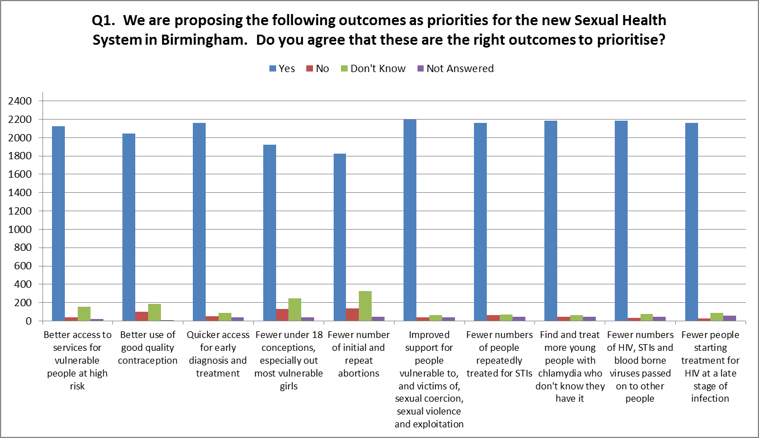
Outcome | ○  Yes | ○  No | ○  Don't Know | ○  Not Answered
Better access to services for vulnerable people at high risk | 2123 | 38 | 154 | 24
Better use of good quality contraception | 2044 | 100 | 184 | 11
Quicker access for early diagnosis and treatment | 2160 | 54 | 86 | 39
Fewer under 18 conceptions, especially our most vulnerable girls | 1921 | 130 | 247 | 41
Fewer number of initial and repeat abortions | 1826 | 137 | 328 | 48
Improved support for people vulnerable to, and victims of, sexual coercion, sexual violence and exploitation | 2194 | 41 | 63 | 41
Fewer numbers of people repeatedly treated for STIs | 2162 | 63 | 70 | 44
Find and treat more young people with chlamydia who don't know they have it | 2182 | 44 | 67 | 46
Fewer numbers of HIV, STIs and blood borne viruses passed on to other people | 2182 | 32 | 79 | 46
Fewer people starting treatment for HIV at a late stage of infection | 2163 | 29 | 89 | 58
Participants were asked to include any other outcomes they felt we should consider which have been summarised in Section 5 of the report.

Do you agree with our proposal to create a joined up, managed, Sexual Health system rather than separate services?
95% of respondents completed this question, the majority answering “yes” (74%) and 9% said “no”.
Figure 2: Do you agree with our proposal to create a joined up, managed, Sexual Health system rather than separate services?
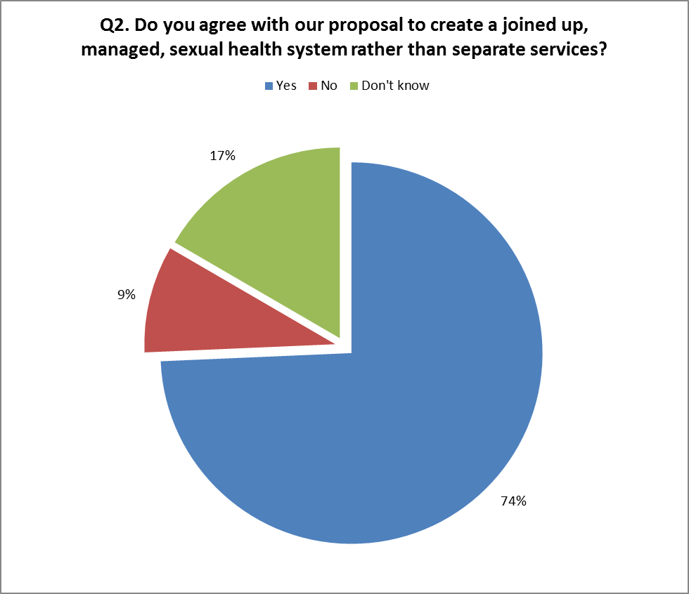
Participants were asked to give reasons for their answer and a summary of comments are provided in Section 5 of this report.

We propose that Family Doctors (GPs) and Community Pharmacies should be providing more Sexual Health services. Do you agree?
Figure 3 below shows the majority answered “yes” (73%) and 15% “no”. 94 people did not answer this question. Whilst the majority have answered in favour of this approach, many cited concerns over confidentiality, loss of anonymity, access restrictions and lack of specialism. The LGBT community in particular expressed serious concerns over confidentiality and their need for anonymity – for example, some respondents stated they had not informed their GP or family about their sexuality and would be uncomfortable “coming out” in a setting where family and friends worked or visited. Some other demographic groups such as Asian women and young people were also concerned about confidentiality for fear of the reprisals, should the nature of their visit become known to their families.
Figure 3: We propose that Family Doctors (GPs) and Community Pharmacies should be providing more Sexual Health services. Do you agree?
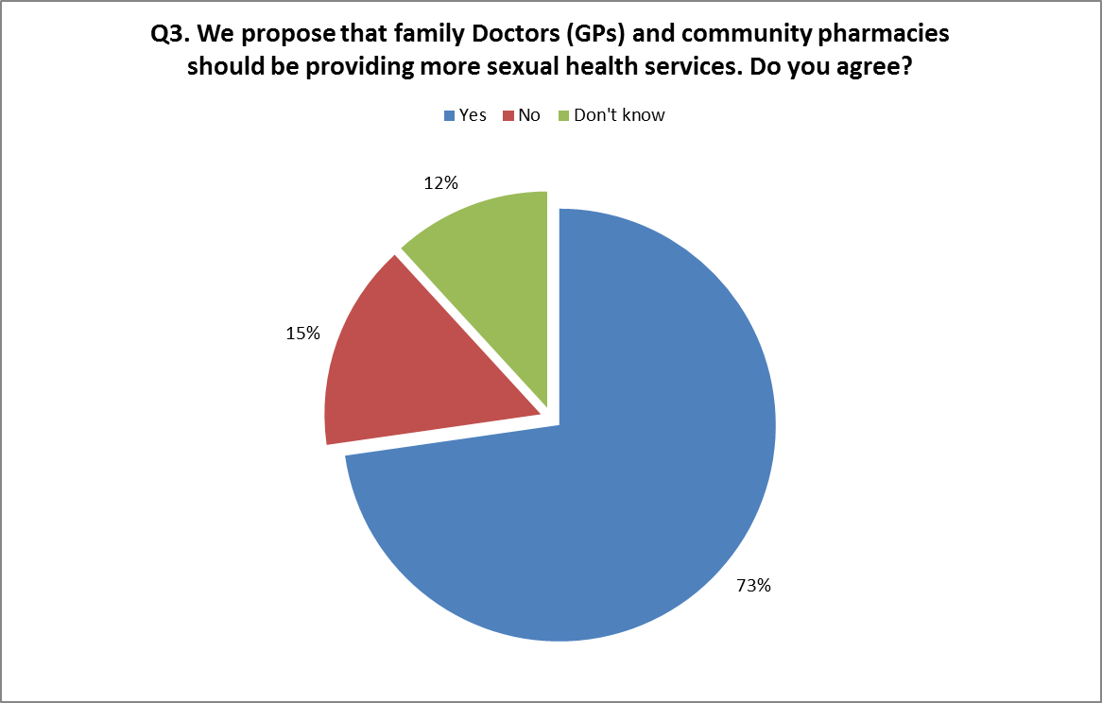
Participants were asked to give reasons for their answer and a summary of comments are provided in Section 5 of this report.

We propose a significant role for voluntary organisations in the Sexual Health system, especially to support vulnerable group. Do you agree?
Figure 4 below shows the majority answered “yes” (62%) and 12% “no”. This question received a high number of “don’t know” responses (26%) with many questioning the sustainability of voluntary organisations and the lack of medical interventions/expertise. Conversely, many also acknowledged voluntary groups had an established connection with hard to reach groups, specialist skills in providing long term support and good local knowledge.
Figure 4: We propose a significant role for voluntary organisations in the Sexual Health system, especially to support vulnerable group. Do you agree?
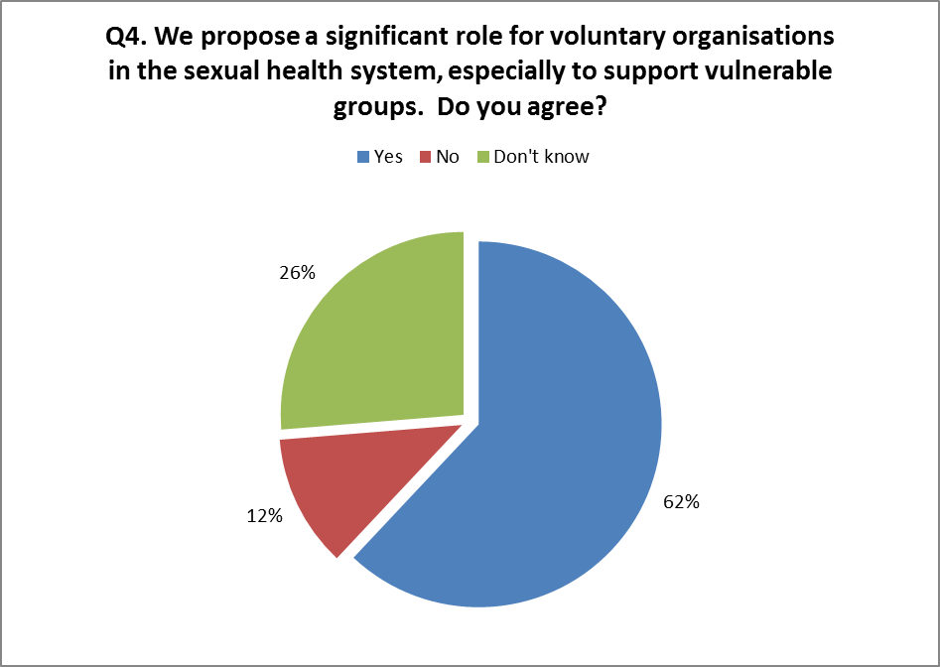
Participants were asked to give reasons for their answer and a comment summary is provided in Section 5 of this report.

We propose three satellite clinics, one in the City centre, one just north of the City centre and one somewhere towards the south edge of the City. These will provide both contraception and testing and treatment. What should we think about when choosing where to put services?

Respondents thought considerations should include good public transport links, adequate free parking, safe locations, access for all ages and abilities, discrete location, co-located services with other care services to provide some form of anonymity and joined up working, and located in areas of high risk.
There were, however, concerns regarding the number of clinics. Many felt 3 clinics were not enough and a larger presence was needed. In particular, some felt people were unlikely or unable to travel from the outskirts of the City into the centre due to cost of travel, difficulties with travelling with children or disabilities, language difficulties in negotiating public transport, time it takes to travel in and lack of convenience.
Respondents also felt 3 clinics would reduce the level of anonymity as they would be busier and more likely to bump into people they know.
A more in-depth summary of responses can be found in Section 5 of this report.

Any other comments on the new Sexual Health system?

Many respondents raised concerns regarding the proposed changes to HIV services. It was generally thought that GPs were unable to provide the specialised support to those living with HIV and were inexperienced in dealing with the condition. Specialist support services are highly valued by those living with HIV.
Other themes included greater education in schools and in the wider community in general. In particular those not registered with GPs (such as homeless and travellers); require focused outreach services and local access to information and screening.
There was a repeated need for services to communicate better with each other, not just within Sexual Health but across all health and care services.
A more in-depth summary of responses can be found in Section 5 of this report.

Which statement best describes your interest in the consultation?
47% of those who completed the questionnaire stated they were a member of the general public and 23% service users. It is important to note that some respondents ticked multiple boxes and have therefore been recorded under “Other”.
Figure 5: Which statement best describes your interest in the consultation?
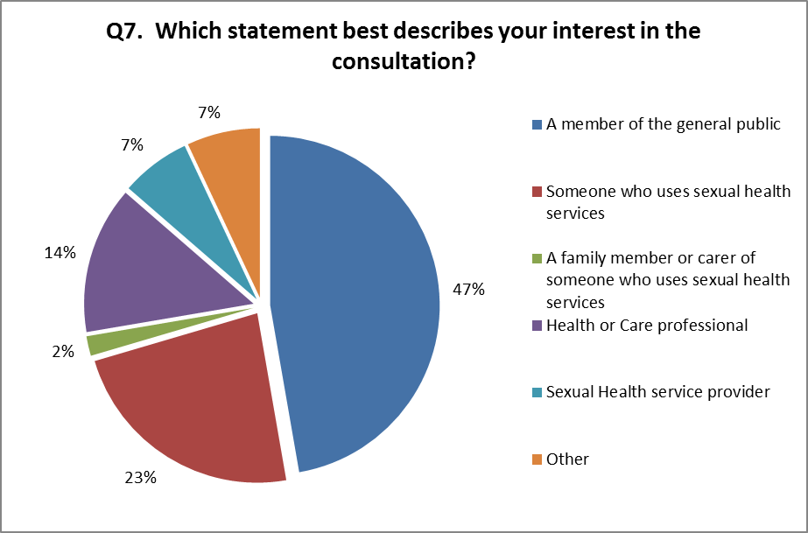

What is your postcode?

Almost half of the respondents declined to give their postcode (48%). Of those that did provide this information, 46% gave a Birmingham postcode and 6% gave a postcode outside of the Birmingham. Postcodes from wards around the City centre (B11, B13, B15, B23, B29, B30) featured heavily.

Which age group applies to you?
All age groups were represented with 14% respondents falling into the 20-24 year old category, followed by 25-29 year olds (10%) and 30-34 year olds (9%).
Figure 6: Which age group applies to you?
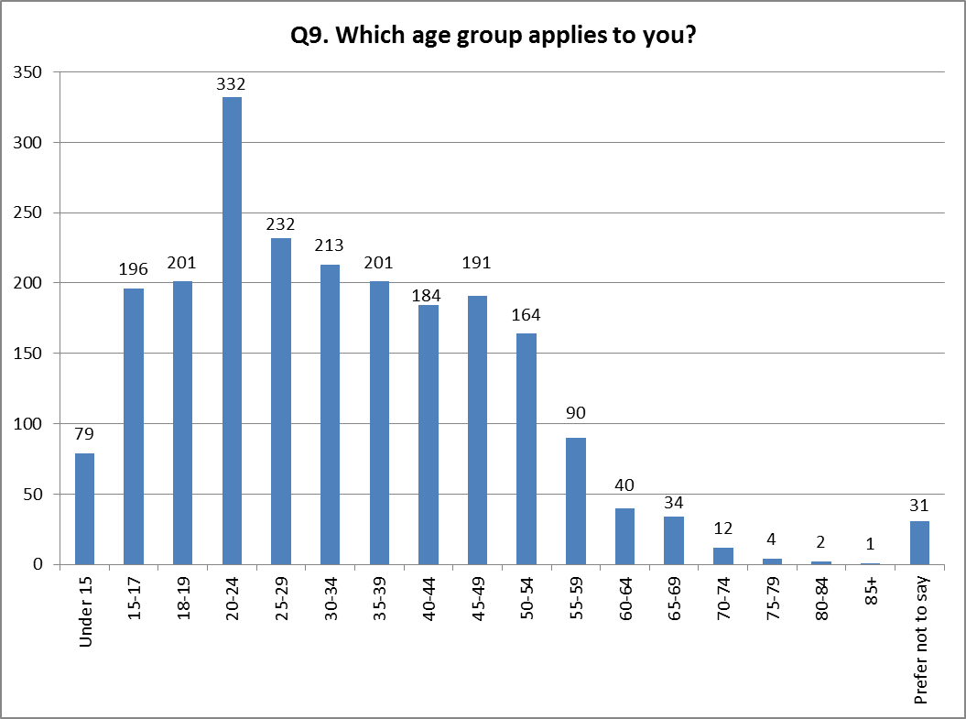

Disability

Do you have any physical or mental health conditions or illness lasting or expected to last 12 months or more?
The majority of respondents replied “no” to this question (65%), with just 16% answering yes.

Figure 7: Do you have any physical or mental health conditions or illnesses lasting or expected to last 12 months or more?
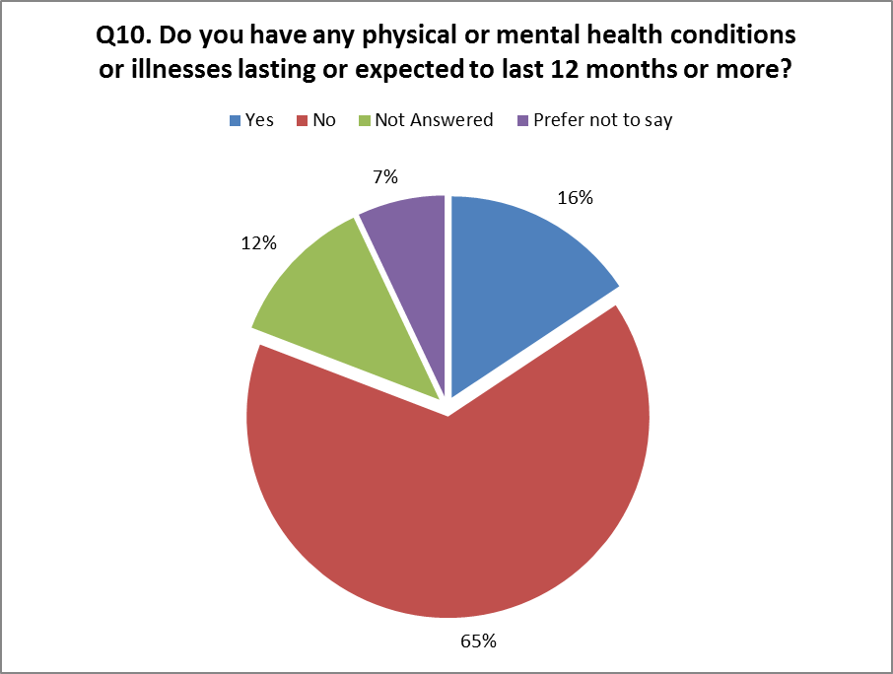

If yes, do any of these conditions or illnesses affect you in any of the following areas?
16% of respondents answered “yes” to 10(a) above, stating that they suffered from the following conditions (it is important to note that most respondents selected multiple conditions):
Figure 8: if yes, do any of these conditions or illness affect you in any of the following areas?
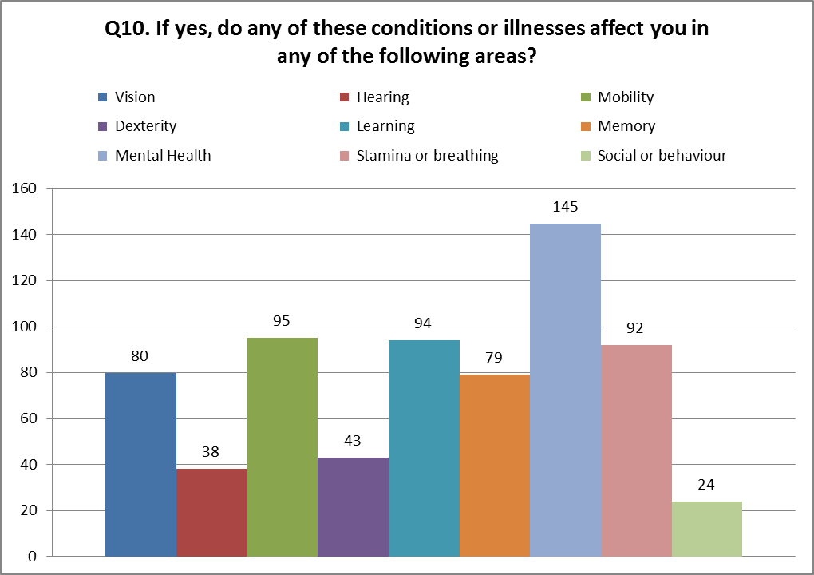
Respondents provided further detail of conditions including HIV (7 respondents), sex addiction, anger, cancer (3), diabetes (3), epilepsy, hepatitis B (2), depression (2), hypothyroid, hypertensive, psoriatic, Meniere’s disease and vitiligo.

What is your sex or gender?
We received 2,169 responses to this question (93%), of which 63% stated female and 34% stated male. There were several comments relating to the “transperson” option, stating the wording was offensive and inappropriate. Only 20 people ticked this option.
Figure 9: What is your sex or gender?
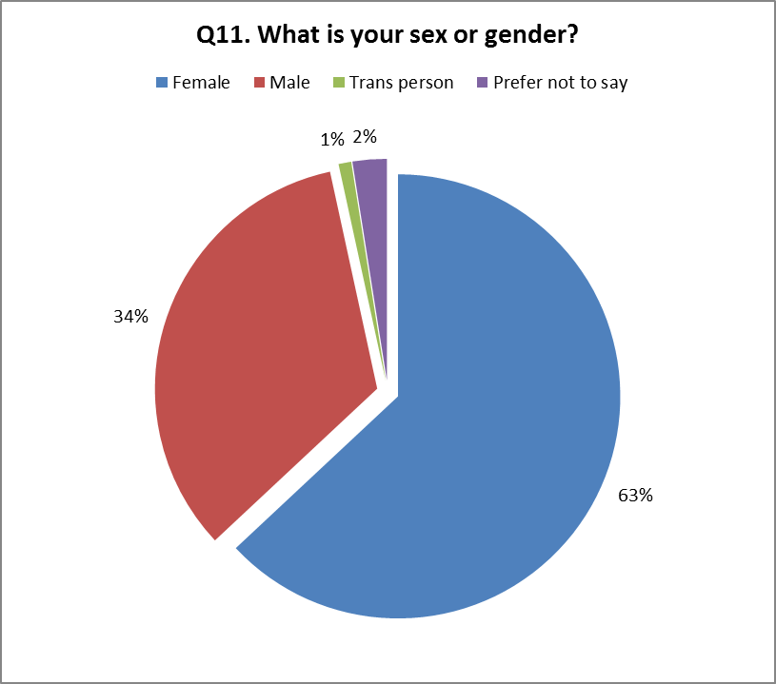

What is your ethnic group?
91% of respondents answered this question, with 56% selecting white or white other, 16% choosing Black African/Caribbean/Black British.
Figure 10: What is your ethnic group?
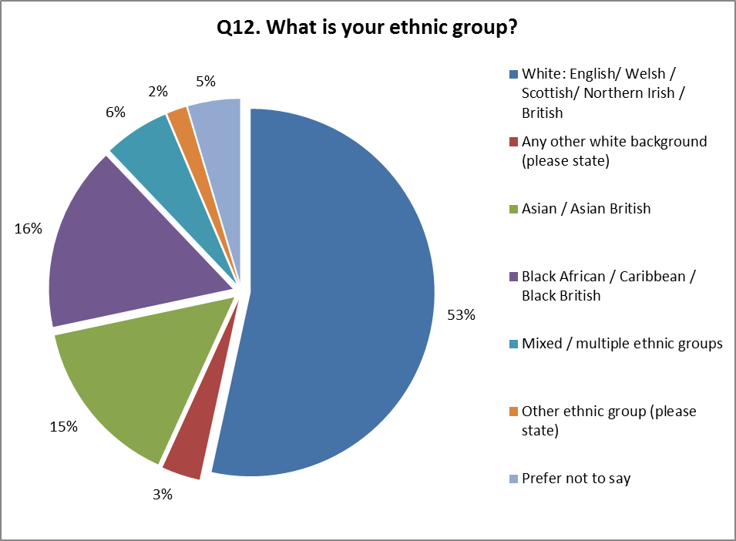
66 respondents provided further detail regarding their ethnicity.
Figure 11: What is your ethnic group, if other?
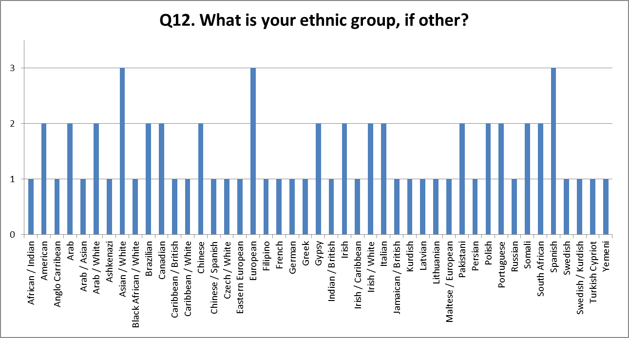

What is your religion or belief?
90% of respondents answered this question. 41% stated Christian (includes all Christian denominations), 13% Muslim and 39% being of no religion or preferring not to say.
Figure 12: What is your religion or belief?
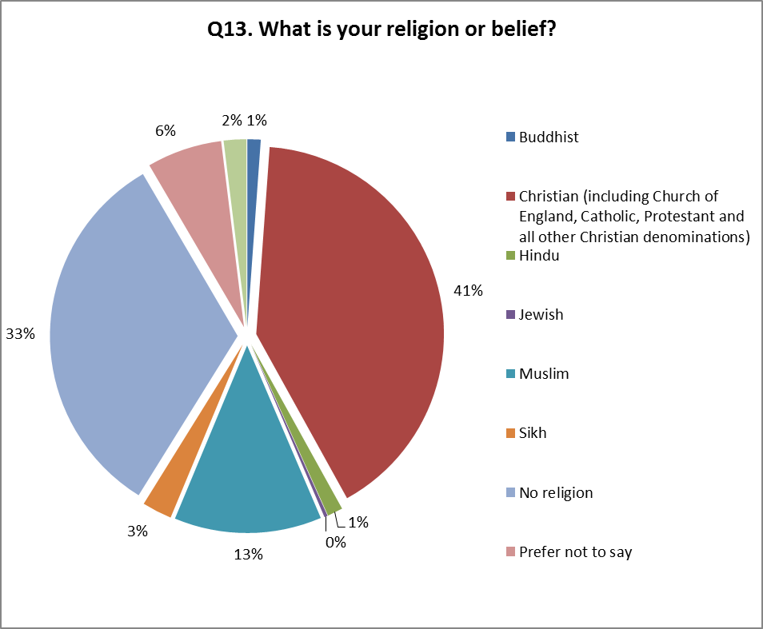
Respondents were given the opportunity to provide further detail of their religion (34 responses), and these can found below.
Figure 13: What is your religion or belief, if other?
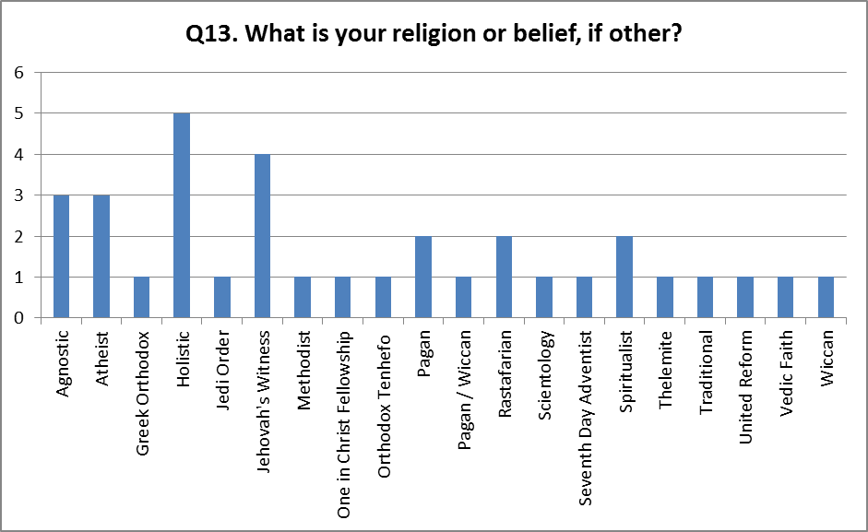

What is your sexual identity?
2088 respondents answered this question, 80% stating they were Heterosexual or Straight, 8% Gay or Lesbian and 4% bisexual.
Figure 14: What is your sexual orientation?
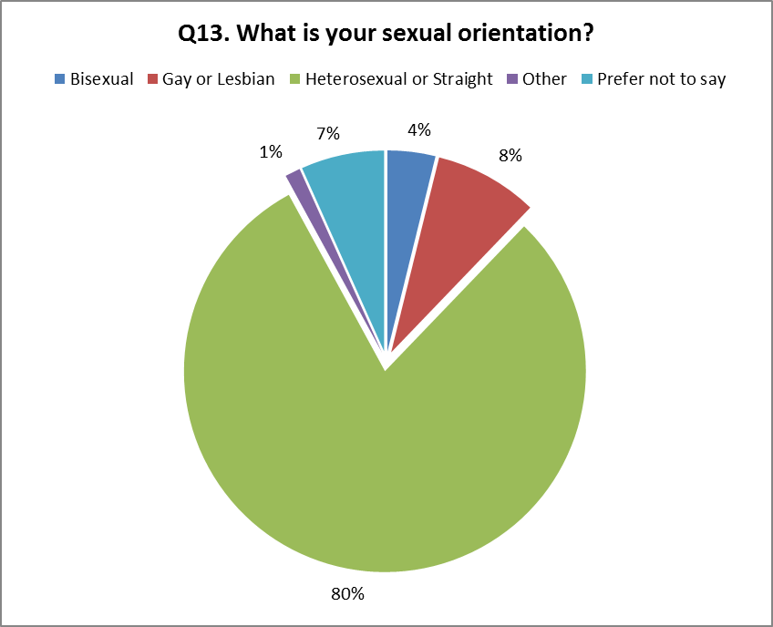

Summary of Comments
We received an overwhelming response to this consultation with 2,339 responses via Questionnaire. In addition we received 8 responses from organisations whose comments have been included in the report.
The comments and concerns raised have been summarised below under theme headings.

Proposed Priority Outcomes
Outcomes to be considered
- Better access for all, not just high risk.
- Increased education and awareness for all and especially in schools
- To more effectively communicate to the people needing to access these services
- To deliver and promote a simple integrated service with clear access points.
- Provision of service by a professional who knows the person's medical diagnosis/diagnoses & has access to previous tests, e.g. Blood pressure, and knows their psychosocial background.
- Provision of service by a professional who has high level, broad medical training
- Provision of a service by a professional who is co-ordinating care for the individual.
- Provision of contraceptive & Sexual Health services close to a person's home.
- Provision of contraceptive & Sexual Health services in the person’s preferred language.
- Improved HIV prevention messaging
- Promotion and counselling for young people on health relationships
- Improved confidentiality and privacy, providing private waiting rooms and not using names.
- Better promotion and marketing of Sexual Health messaging and service provision
- Normalise Sexual Health screening, Sexual Health discussion and reduce stigma
- Reduce waiting times for appointments and delays in receiving results
- Increased engagement for male sex workers as there is no longer a full time service for male sex workers in Birmingham.
- Increased engagement of no recourse to public funds especially the European customers who are extremely difficult to engage.
Considerations
- Culture and language barriers
- Continue support for HIV positive
- Abortion services need to be better and more transparent. With the current system it is unclear the motives of the organisation providing them.
- Counselling alongside HIV/Abortion needs to be better.
- Access to full range of contraceptive services delivered by knowledgeable health care professional.
- Always make sure spaces are LGBT friendly and make sure this very visible
- Include female genital mutilation
- Clinics suitable for older population that are sexually active i.e. 60-85 and over who also need advice, support and screening.
- Cervical smear tests age to be lowered and to highlight the risk of contracting HPV and its relation to abnormal results and the consequences.
- Improved communication between SHS, medical services, social care and other support services
- More non-medical interventions to support medical interventions e.g. self-esteem, grooming, etc.
Concerns
- Why limit outcomes to Chlamydia? Outcome should be for all STIs.
- How will these be measured? Outcomes need to be meaningful and measurable.
- What evidence is there to support these proposed outcomes?
- Current HIV provision is viewed as poor. With the proposed cuts to HIV services, where do patients go?

Proposal to create a joined up, managed Sexual Health system rather than separate services.
Comments
- Reduces duplication of services
- Improved use of available resources / value for money
- Consistent working practices
- Encourages innovation
- Joined up system is needed but fear this will widen the gaps in some areas of the City
- This system already exists in Primary Care
Considerations
- Ensure a more holistic approach to Sexual Health
- Share good practice
- Retention in treatment will be an important measure
- Reduce stigma around Sexual Health services
- Improved outreach programmes and mobile services to target young people in clubs, etc.
- Different communities have different needs. Might not fit within a one-stop-shop environment
Concerns
- Current system is very complex. Further integration required.
- May lose people. Some people won’t be comfortable visiting one large service, such as
- A big centralised clinic might not be able to provide an individualised service to the patient.
- Funding cuts and job losses
- Not everyone is qualified to provide medical interventions
- Increase in waiting times.
- High risk subcultures (e.g. gay men who have many partners and, sex workers) - respond better to a service which is aimed directed at them, for example the healthy gay life testing centre. If the services are mixed - care needs to be taken that people don't feel their testing is always 'on record' or a permanent mark on their medical records.

Proposal for GPs and community pharmacies to provide more Sexual Health services.

- GP Services
Comments
- Extending GP services has been well received by the over 25s groups.
- Some GPs offer Sexual Health clinics and /or screening already.
- May improve partner notification but this must be done at the request of the patient.
- Ensure consistent working practices and share best practice.
- Encourage the use of a Sexual Health specialist to provide specialised support for some conditions and counselling.
- Who will manage/measure GP services? Are these within the remit of BCC?
Concerns
- GPs are already overburdened with QOF/CQUIN. They only have 12 minutes per patient. This is not enough time for Sexual Health counselling or meaningful discussion.
- Young people and LGBT groups are reluctant to use GPs through fear that they will be recognised in the surgery, friends/family work at the surgery and have access to their records, and their treatment will be added on to their records. Some patients have not divulged their sexuality to their GPs and would be uncomfortable talking to someone they know.
- Felt GPs do not have the experience, expertise, understanding or skills to deal with long term conditions such as HIV and extend their services beyond basic screening
- Judgemental doctors and staff.
- Waiting times – it is difficult to get an emergency appointment and waiting times can be several weeks for a normal appointment.
- Not everyone is registered with a GP (homeless, Gypsies, immigrants, etc.).

- Community Pharmacies
Comments
- Pharmacies could provide more
- Initial and common point of contact for most
- Pharmacies offer a variety of services and so provide some anonymity
- Longer hours and weekend provision

Concerns
- Poorly trained and not qualified to deliver medical (and some non-medical) interventions
- Private and confidential facilities – consider toilet to provide urine samples, confidential enclosed rooms (not an open topped booth or curtained area) to discuss concerns.
- Would there be a prescription charge?

Proposal for Voluntary Organisations to have a more significant role in Sexual Health service provision
Comments
- Young people are more likely to access these services
- Some services have specialised knowledge and access to hard to reach groups
- Only involve services that have specialised knowledge
- Voluntary Services can provide specialised workers to provide support within GPs and other services
- They are more trusted than statutory sector services
- Too many organisations will fragment the service
- More training required.
- Integrated services regardless of whether statutory or voluntary to ensure consistent working practices and joined-up working

Concerns
- Voluntary services come and go depending on funding. They cannot provide a long term solution unless they are securely funded.
- Depends on which services are involved – some are better than others, and some are more qualified than others. Are they professionally competent?
- Is this just cheap labour or delegation of commissioning responsibility?
- They cannot provide medical interventions

Proposal for three satellite clinics (central, north and south)
Comments
- Locate where there is the greatest need
- Need good public transport links and adequate free parking
- Building and environment is important. It should be welcoming and non-clinical.
- Co-locate with other (social and health) services to ensure an holistic approach
- Increase mobile and outreach services
- Increase opening hours, out of hours and weekend provision.
- Must ensure full accessibility for those with disabilities, learning difficulties, non-gender specific toilets, multiple language information and private facilities.
- Discrete location. Don’t locate in unsafe areas (such as red light districts).

Concerns
- People won’t travel from the outskirts of the City. Some find it difficult to travelling long distances especially those with disabilities, young children or language problems.
- Three clinics are not enough. What about the east and west?
- Larger clinics increase the chance of someone seeing you enter or use the services. LGBT and at risk groups may not attend.
- Less anonymity - especially for Asian women who may face reprisals at home (e.g. honour related domestic abuse) and victims of sexual abuse or domestic violence. The abuser would be able to locate the victim easily at these centres.
- Closing or moving existing services will cause confusion and fragmentation.

Priority Groups

Priority Groups
As part of the consultation process into Sexual health Services Redesign, Freshwinds were commissioned to consult specifically with vulnerable and at risk groups within Birmingham.
Freshwinds sought to engage with a variety of groups including:
- New arrivals to the UK
- People with substance misuse problems
- Sex workers
- Gypsies and travellers
- Homeless
- Lesbian Gay Bisexual Trans community
- Children in need and carers
- People with mental health problems
- People with learning disabilities.

Overarching themes that emerged across priority groups were:

- The continued need for services to understand the impact of needs and characteristics of the priority group and those individuals at times feel that services do not account for these needs and characteristics.
- ‘Front of House’ - how access to services and quality of utilisation is driven from the very first contacts by the sensitivity of initial encounters with staff
- The insight and expertise of staff providing services to the needs of individuals should be improved to account for diverse needs that are associated with a pre-existing social or medical characteristic

New Arrivals to the UK
- 69% agreed with the proposal to create a joined up managed sexual health system suggesting more health promotion within communities and services was needed, as well as being culturally aware and an increase in specialist women services, focussing on victims of sexual assault and violence.
- 62% agreed GPs and community Pharmacies should provide more sexual health services but were concerned about time constraints on GPs and whether they had the specialist skills needed.
- 62% agreed voluntary organisations should be more involved suggesting they can provide the mental support needed and provide a good positive atmosphere.
- Additional comments included increased sex education in schools and the importance of patient choice.

Learning Disabilities
- 73% agreed with the proposal to create a joined up managed sexual health system citing it will reduce duplication and provide a more efficient service. This group also suggested linking with doctors to prevent repeating information and including sexual health within the annual health check.
- 77% agreed GPs and community Pharmacies should provide more sexual health services. However, there concerns regarding confidentiality, extra training required for the professionals and feeling uncomfortable discussing sexual health with your doctor.
- 60% agreed voluntary organisations should be more involved commenting there are able to target particular groups more effectively, have specialist skills, good relationships with vulnerable groups. However, concerns standards may differ with the possibility of a “postcode lottery” developing.
- Additional comments include increase in specialist services for adults with learning difficulties, increased sexual education in schools and improved awareness for communities, more patient choice, pregnancy support for those with learning difficulties, understanding training for professionals and making information available in a variety of different formats. Concerns were made over the number of clinics expressing the need for clinics in East and West, and ensuring they are accessible by public transport. Young people with learning difficulties also mentioned they would like existing young people service provision to cater for those with learning abilities, allowing them to access mainstream services.

Homeless
- 62% agreed with the proposal to create a joined up managed sexual health system, suggesting this would bring services together. Concerns however over losing specialists/specialism for engaging particular vulnerable groups.
- 55% agreed GPs and community Pharmacies should provide more sexual health services, stating this may be less embarrassing for the client and easy access. However, homeless do not always have access to a GP and there is still a requirement for anonymous testing which might not be available / appropriate at GPs.
- 48% agreed voluntary organisations should be more involved commenting peer support was important and have a good knowledge of the vulnerable sector.
- Additional comments include the need for support for the homeless who wish to access services but are reluctant because of their background, greater understanding of the homeless community’s needs and improvement in benefits/other social systems to ensure homeless do not turn to selling sex to create an income.

Sex Workers
- 54% agreed with the proposal to create a joined up managed sexual health system, suggesting this may improve services, but it may also exclude marginalised groups.
- 50% agreed GPs and community Pharmacies should provide more sexual health services. Concerns included not being registered to a GP and therefore not having access. However, accessing Pharmacist was seen as a good alternative.
- 37% agreed voluntary organisations should be more involved. SAFE Project was given as an example of good service provision.
- Additional comments included the need for improved education for children especially around sexual coercion / violence / exploitation, linking sexual health and substance misuse services, and improved outreach. There were concerns regarding the location of the new services – travel is costly and some are unable to come into the city centre (court orders, etc).

Lesbian Gay Bisexual Trans Community
- 62% agreed with the proposal to create a joined up managed sexual health system, stating integrating services would be an improvement, but concerns regarding consistency of service and common approaches.
- 70% agreed GPs and community Pharmacies should provide more sexual health services. Concerns included GPs not being specialists in sexual health and confidentiality. However, it was suggested GPs might have an improved role in offering testing but GUM services continue to provide on-going support and counselling.
- 60% agreed voluntary organisations should be more involved. Concerns regarding consistency of service, quality of care and sustainability.
- Additional comments included improved accessibility, good transport links, improved understanding of the LGBT community and its needs, improved training for professionals, out of hours service provision and improved awareness.

People with Substance Misuse Problems
- 58% agreed with the proposal to create a joined up managed sexual health system, stating integrating services would be an improvement, but concerns regarding confidentiality / anonymity.
- 63% agreed GPs and community Pharmacies should provide more sexual health services. Concerns included not being registered with a GP and lack of trust. However, it was thought pharmacies would be convenient and it was important to have improved access to testing.
- 44% agreed voluntary organisations should be more involved. This group felt voluntary services have greater access to vulnerable groups and provide a good service.
- Additional comments included self-testing kits, improved help with women suffering abuse, support through pregnancy, linked up substance misuse and sexual health services and improved awareness. Concerns were also raised about access and travelling costs to services.

Gypsies and Travellers
- 44% agreed with the proposal to create a joined up managed sexual health system.
- 37% agreed GPs and community Pharmacies should provide more sexual health services. This group felt pharmacies were not best placed to provide sexual health services. There were also concerning regarding stigmatisation and discrimination.
- 44% agreed voluntary organisations should be more involved. This group felt voluntary services would not be able to provide an impartial service.
- Additional comments included keeping contraception and STI service separate to avoid association and therefore improving engagement in each service, more help for the Gypsy community, improved understanding of and respect for the Gypsy community and improved awareness.

Children in Need and Care Leavers
- 79% agreed with the proposal to create a joined up managed sexual health system, stating it will reduce duplication, involve multiple services and improve preventing messaging
- 60% agreed GPs and community Pharmacies should provide more sexual health services. Concerns included difficulty getting appointments with GPs, lack of understanding and knowledge, judgemental attitudes and confidentiality
- 60% agreed voluntary organisations should be more involved. This group felt more comfortable accessing voluntary services.
- Additional comments included improved education and information regarding sexual health and healthy relationships, accessible friendly services, and additional support / access for those with learning and / or physical difficulties. Again good transport links and the need for more clinics were mentioned.

People with Mental Health issues
- 63% agreed with the proposal to create a joined up managed sexual health system, commenting it made sense for services to be linked.
- 73% agreed GPs and community Pharmacies should provide more sexual health services, stating using GPs may be less embarrassing and greater local access. However, it was also stated some may not be registered with a GP, a GP’s time is restricted and it is important to continue anonymous testing.
- 56% agreed voluntary organisations should be more involved. This group felt this was provide greater patient choice, peer support was important, and voluntary groups were able to relate to vulnerable groups better.
- Additional comments include the need for support for those who wish to access services but are reluctant due to issues, improved education and awareness, more access and clinics, anonymous locations, accessible for disabilities / difficulties and cost of travel.

Conclusion
Changes to any care service can be an emotive subject, as demonstrated by this consultation. The large number of responses is indicative of the importance of this service and comments have varied significantly across the groups.
Overall, the majority have been in favour of improvements to the service. The current system is deemed disjointed and complex, with difficult or hidden access. However, where service users have managed to locate a service and engage, they have been well received and comments are positive. In particular, Brook, Whittal Street, Heartlands Hospital and Boots Walk-in clinic have been repeatedly mentioned as providing a good confidential service.
There are 6 overriding concerns with the proposed new service:
- Confidentiality and anonymity. Pharmacies and GP do not provide anonymity. One large service will increase the possibility of meeting someone you know.
- Access for everyone regardless of disability, learning difficulties, mental health considerations, homeless, age, sexuality and culture.
- Long term care and counselling for specialised conditions such as HIV.
- Accessibility – information in multiple formats (large print, braille, etc.) and languages, and made available through all lines are communication (social media, library, universities, GP surgeries, etc.), and improved input into school education.
- Restriction to patient choice by reducing services to three services and loss of specialisms provided by smaller localised services.
- Capacity and sustainability. Do GPs have the time and the knowledge to extend their services? Will voluntary services be able to cope with the extra workload at their clinics and provide a sustained treatment programme, long term?
Priority Groups
It is clear that there is support to focus on Priority groups. New services will need to consider the needs and associated characteristics with proper sensitivity and significance. This is likely to have an impact on how outreach is developed and the training and orientation of all staff; in particular those who manage initial encounters.
GP and Pharmacies
The proposal to involve GPs and Pharmacies more in providing Sexual Health services has been mixed, with at risk groups and young people expressing their preference for anonymous GUM services. Whereas the over 25s appear to be more comfortable with speaking to their GPs about Sexual Health matters. The division in opinion seems to lie with the users’ particular Sexual Health provision need – for family planning, on-going contraception and routine screening; GPs appear to be an accepted choice. Whereas the need for emergency contraception, abortion advice and counselling, contraception for Asian women, those suffering abuse and for the LGBT community, seems better served by specialised Sexual Health services.
There are specific concerns regarding the ability of Pharmacies to deliver interventions and the lack of confidential or appropriate facilities available. It is apparent that whatever role Pharmacies and GPs play in the future of Sexual Health services, further training is needed.
Voluntary Organisations
Most accept that voluntary organisations already play a significant role in the Sexual Health service provision. Respondents seem to agree that voluntary groups have been able to successfully engage most vulnerable groups and provide a valuable support role, especially for those living with HIV, long term treatment, and dealing with young people. However, there were concerns regarding the sustainability of voluntary groups and if they were to play a formal active role in the Sexual Health service system, would they be able to secure funding? There are also concerns that they are not qualified to provide medical interventions.
Three Satellite Clinics
Again there is a division of opinion. It is clear that 3 clinics would provide a more stable provision platform, with consistent working practices, all services in one place and therefore a more holistic approach to treatment, and known secure location. However, this also raises the issues of accessibility, confidentiality and manageability. Larger practices are thought to be unwieldy and target focussed, with more emphasis on meeting targets (such as the 12 minute per patient recommendation for Doctors) and less on the needs of the patients.
There are also concerns regarding the location and access. Good public transport routes and adequate parking obviously need to be taken into consideration as does access for people with disabilities, non-gender specific toilet facilities, staff and information for those with learning difficulties and confidential meeting areas. However, vulnerable and at risk groups have specifically commented that they would not use these facilities as they may not provide the personal service they require, would run the risk of meeting someone they know or someone seeing them enter, and the facility would be accessible to all including the abuser of someone seeking help.
It is clear there is a difficult balance to be struck between making a service accessible and visible to all, and maintaining a discreet, anonymous service.

HIV Services and Continuing Care
The proposed changes to HIV have provoked some strong comments. In addition to the questionnaires received via BeHeard website, Public Health has received in-depth submissions by letter from the Heart of England Foundation Trust and 3 departments of Birmingham Heartlands Hospital.
All parties have expressed concerns with the discontinuance of services and the effect this will have of those already in care and those seeking treatment. There is significant work still to do in reducing the stigma of HIV, ensuring early diagnosis, supporting pregnant women and children with HIV and reducing the HIV transmissions.
HIV infection and the continuing care and support of those living with HIV is a complex subject. It impacts patients and families medically, socially and psychologically – ensuring the needs of patients are met, across all levels, requires careful consideration and co-ordination across services.

Recommendations
Question 1: Agreement with the ten outcomes as priorities for the new Sexual Health system.
Over 90% of respondents agreed with the proposed outcomes to improve support for people vulnerable to/victim of sexual coercion, find and treat more young people with chlamydia, and fewer numbers of HIV, STI and BBVs passed to others. Slightly fewer agreed with the priority outcomes of reducing the numbers of initial and repeat abortions and fewer under 18s conceptions (77% and 82% agreement respectively).
Recommendations:
- Confirmed the priorities groups in the commissioning strategy
- Ensured that part of the payment for services will be dependent on demonstrating a contribution towards these outcomes.

Question 2. Agreement with the proposal to create a joined up, managed, Sexual Health system rather than separate services?
Recommendations:
- Service providers will need to outline how they manage, store and, when necessary, share patient information and how they gain consent to do so.
- We will outline the need for services to target the defined vulnerable groups. Services will be paid on the basis of reaching these groups.

Question 3. Proposing that family Doctors (GPs) and community pharmacies should be providing more Sexual Health services.
Recommendations:
- We confirmed the intention to ensure GPs and community pharmacies have a significant role in the new Sexual Health system.
- The service specification for GP services will include obligations relating to quick access and flexible opening hours.
- We will include a training and education element to ensure all clinical and non-clinical staff in the new Sexual Health ‘system’ are appropriately trained and developed. This will help support local specialism and improve quality for all service users, especially in primary care.

Question 4. Proposing a significant role for voluntary organisations in the Sexual Health system, especially to support vulnerable groups.

Recommendations:
- We confirmed the intentions to ensure voluntary organisations have a significant role in the new Sexual Health system.
- The training an education element of the new specification will extend to all commissioned voluntary organisations.
Question 5. Proposing three satellite clinics, one in the City centre, one just north of the City centre and one somewhere towards the south edge of the City. These will provide both contraception, testing and treatment.
Recommendations:
- The three ‘satellite’ options outlined in the consultation will not be a required element of the service specification although a City-centre presence will be important.
- Providers will be asked to provide a model based on a mix of healthcare, and voluntary sector provision with good geographic spread.
- Providers will be provided with information which will include;
  - The location of current GP, Pharmacy and specialist providers across the City
  - An analysis of the public transport network in Birmingham
  - Epidemiological analysis based ward profiles
Respondents were asked whether they had any further comments relating to the proposed approach
The provision of HIV support:
Recommendations:
- In line with the Integrated Commissioning Strategy, commissioning will be on the basis of need rather than condition. Clinical need for people living with HIV will be commissioned by NHS England.
- In terms of social need, Public Health will negotiate with the HIV partnership to define and commission a programme of HIV awareness and social care training for public, private and voluntary sector groups.
- An HIV testing programme will be included in the Sexual Health specification which will incorporate associated pre/post diagnosis support.

The Sexual Health needs of school age children:
Recommendations:
- The Non mandatory specification should address the need for training for organisations in meeting the Sexual Health needs of Children and Young people that they deliver services to.
- The non-mandatory specification should account for the need for the new Sexual Health provider to develop a ‘Traded Services’ arm to ensure that fee paying organisations have access to quality assured training, e.g. Schools

Appendix 1
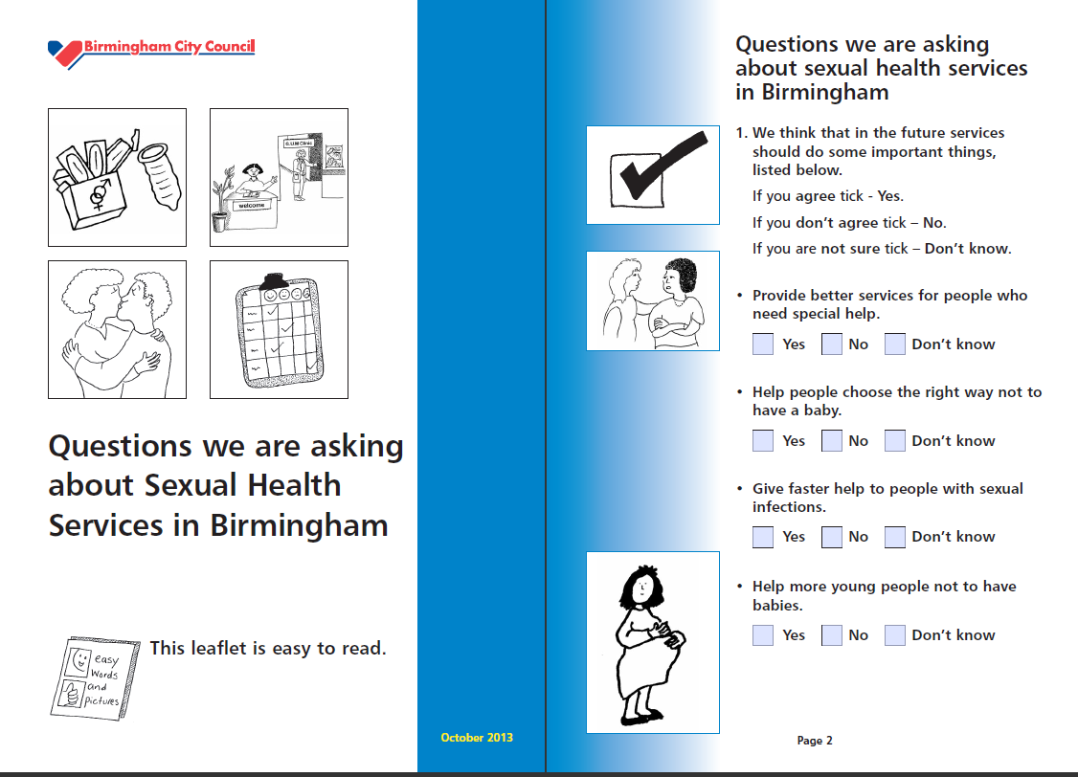


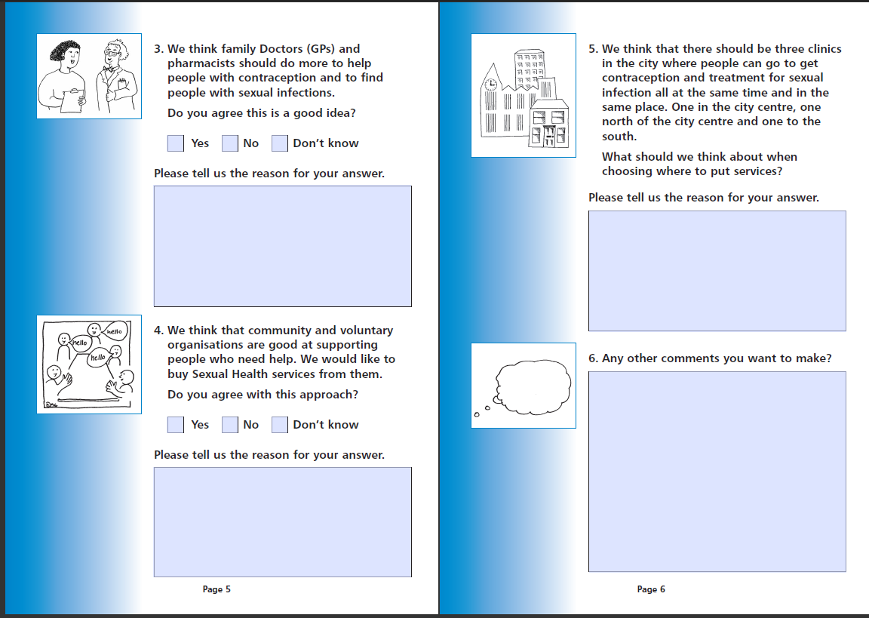



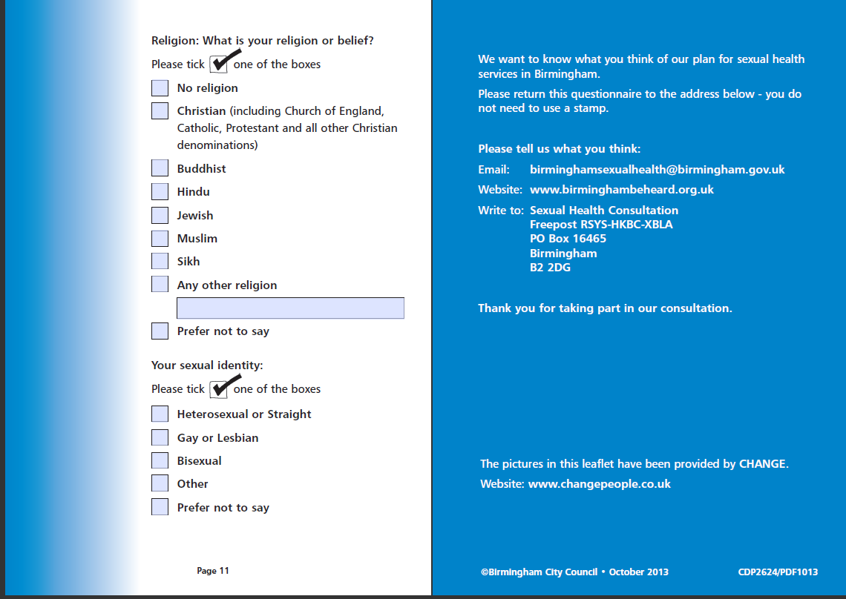
CONSULTATION EVENTS
Hosted by | Date | Contact | Group | Who has been consulted | Estimated numbers
FRESHWINDS | 10/10/2013 | Mohammed Al-Rahim and Liz Morris | Birmingham HIV Partnership | Frontline Staff and elected service user rep | 14
FRESHWINDS | 16/10/2013 | Tracey Rollinson | School Age Parent Support Team | Frontline Staff – Young People | 1
FRESHWINDS | 17/10/2013 | Tony Elkington | World AIDS Day Briefing | Frontline Staff – Service Users, People living with HIV | 50
PUBLIC HEALTH | 17/10/2013 |  | Stakeholder Workshop | Stakeholders
FRESHWINDS | 22/10/2013 | Hannah Wilson | Teenage Parents Multi-Agency | Young Parents including care leavers and those in care | 14
FRESHWINDS | 22/10/2013 | Lizzie Smith | Teenage Parent Support Group | Teenage Parents including homeless, frontline staff | 6
FRESHWINDS | 23/10/2013 | Sara Delaney | Harmful Behaviour Unit |  | -
FRESHWINDS | 23/10/2013 | Wendy Moore | Dove Clinic based | GP service users and frontline staff | 30
PUBLIC HEALTH | 24/10/2013 |  | Provider Workshop | Sexual Health providers
FRESHWINDS | 25/10/2013 | Phil Denley | Gypsies and Travellers Education Unit – Missing Children’s Team | Frontline staff – Gypsies and Travellers | 1
FRESHWINDS | 28/10/2013 | Mandy Tyler | HYPE (HEFT) | Young People – school age staff | 6
FRESHWINDS | 29/10/2013 | Danielle Epps | Positive Pathways – Children’s residential Home | Children in Care and frontline staff | 8
FRESHWINDS | 29/10/2013 | Carol | BPAS South | frontline staff | 14
FRESHWINDS | 30/10/2013 | Wendy Moore | Dove Clinic | Sexual Health Clinic service users and GP patients | 30
FRESHWINDS | 31/10/2013 | Namakau Maambo | HIV Partnership service user group | People living with HIV and New Arrivals | 14
PUBLIC HEALTH | 31/10/2013 |  | Primary Care Event Workshop | GPs, Practice Managers and Pharmacies
FRESHWINDS | 01/11/2013 | Flavia | Residential Care including LD | Offenders, Children in Care, Frontline staff | 8
FRESHWINDS | 01/11/2013 |  | Inclusions – UKOnline | Substance Misuse | 3
FRESHWINDS | 04/11/2013 |  | Soho clinic (all morning) | Service Users | 30
FRESHWINDS | 04/11/2013 | Tina Prashar | ABPlus AGM | People living with HIV, front line staff, service users | 40
FRESHWINDS | 05/11/2013 | Victoria Marshall | Whittal Street | Frontline staff | 60
FRESHWINDS | 05/11/2013 | Tony Spiteri | LGBT Alcohol Support Group | LGBT, Substance misuse | 12
FRESHWINDS | 05/11/2013 |  | Soho clinic (all morning) | Service Users | 30
PUBLIC HEALTH | 05/11/2013 |  | General public / service user workshop
FRESHWINDS | unknown | Phil Denley | Gypsies and Travellers Education Unit | Gypsies and Travellers | 6
FRESHWINDS | 06/11/2013 | Sara Delaney | Sexually Harmful Behaviour Unit | Frontline staff | 11
FRESHWINDS | 06/11/2013 |  | Greet health Centre clinic | Service Users | 20
FRESHWINDS | 07/11/2013 |  | Whittal Street clinic | Service Users | 30
FRESHWINDS | 07/11/2013 |  | BCU – Perry Barr Campus | Young People | 102
FRESHWINDS | 08/11/2013 |  | Young Parents Group | Young Parents | 16
FRESHWINDS | rearranging | Charlene Mulhern | North Academy Parents Group |  | 8
FRESHWINDS | 09/11/2013 |  | Boots clinic | Service Users | 30
FRESHWINDS | 11/11/2013 |  | All saints medical practice | Service Users | 20
FRESHWINDS | 12/11/2013 |  | Northfield | Service Users | 20
FRESHWINDS | 12/11/2013 | Cathryn Greenway | Yardley Tutor | Young People in care | 1
FRESHWINDS | 12/11/2013 |  | Selly Oak Probation Service | Offenders | 20
FRESHWINDS | 13/11/2013 |  | Quinton | Service Users | 20
FRESHWINDS | 13/11/2013 | Nigel Burbidge | Healthy Gay Life | Frontline staff and volunteers | 9
FRESHWINDS | 13/11/2013 | Donna Barrett | St Basil’s Team Meeting | Homeless | 12
FRESHWINDS | 13/11/2013 | Hugo McPherson | BME Forum | General Public/Services Users | 14
FRESHWINDS | 13/11/2013 | Sandra Dee | People First Birmingham | Learning Disabilities | 8
FRESHWINDS | unknown | Gillian Clarke | Hawthorne House | Frontline staff and service users | 35
FRESHWINDS | 14/11/2013 |  | Bourneville College | Young People | 60
FRESHWINDS | 14/11/2013 | Debbie Nixon | Teenies and Tinies Group | Young Parents | 12
FRESHWINDS | 14/11/2013 | Joanna Galloway | African Community Council for the Regions | New Arrivals | 12
FRESHWINDS | 15/11/2013 |  | Whittal Street | Service Users | 30
FRESHWINDS | 15/11/2013 | Pauline | Vesey Clinic | Service Users | 30
FRESHWINDS | 18/11/2013 | Stephen Jefferies | ASFUG (Mental Health Service Users Group) | Mental Health | 18
FRESHWINDS | 18/11/2013 |  | Aston Health Centre | Service Users | 20
FRESHWINDS | 19/11/2013 | Jane | Xc ccg | General public | 30
FRESHWINDS | 19/11/2013 |  | Yardley wood – young people | Young people | 4
FRESHWINDS | 20/11/2013 | Alison/Flavia | Disability Children’s Homes | Young People in care/Learning Disabilities | 16
FRESHWINDS | 20/11/2013 | Tassawar Hussein | YMCA Northfield | Homelessness | 12
FRESHWINDS | 21/11/2013 | Alicia Doyle | Castle Vale – Teenage Pregnancy Meeting | Frontline staff – Young People | 12
FRESHWINDS | 22/11/2013 |  | Sparkbrook | Service Users | 20
FRESHWINDS | 22/11/2013 | Richard Daley | REAL project Volunteers | Service Users | 12
FRESHWINDS | 24/11/2013 |  | Boots cinic | Service Users | 30
FRESHWINDS | 25/11/2013 | Lisa Thompson | RSVP team meeting | Sexual Violence frontline staff and volunteers | 7
PUBLIC HEALTH | 27/11/2013 |  | 2nd Primary Care Workshop
FRESHWINDS | 27/11/2013 | Baljit Bahi/Eric Barnett | 3rd Sector Consortia Meeting | Mental Health | 13
FRESHWINDS | 27/11/2013 | Alison | St Pauls Trust - group | Mental health | 8
FRESHWINDS | 28/11/2013 | Freshwinds | Community Health Champions (based in Priority needs neighbourhoods) | General Public – inc all stakeholder groups | 12 people returning (120 questionnaires)
FRESHWINDS | 28/11/2013 |  | Lighthouse my time group | Young people | 4
FRESHWINDS | 29/11/2013 | Ann Sargent – canclled as Ann was ill | Base KS | Young Parents | 8
FRESHWINDS | 30/11/2013 | Achielle – group has been moved to 7.12.13 | Fracophone Group THT | Newly Arrived | 9
PUBLIC HEALTH | 30/11/2013 |  | Substance Misuse Service User Forum
FRESHWINDS | 30/11/2013 |  | Brook
 | 30/11/2013 |  | Birmingham Central Library
PUBLIC HEALTH | 30/11/2013 |  | Substance Misuse Service User Forum
Freshwinds | 30.11.13 | British Arab Federation | FGM Event | General Public
Freshwinds | 30.11.13 |  | Kings Barber Saloon
PWR Recovery | 01/12/13 |  | Support Group Members | BME | 10
Freshwinds | 02.12.13 | Cathie Hill | New Attitudes Erdington | Service Users | 30
Freshwinds | 02/12/2013 | Penny Barber | Brook | Young People | 30
FRESHWINDS | 02/12/2013 | Steph Keeble | LGBT Focus Group | LGBT | 10
FRESHWINDS | 02/12/2013 |  | Trans Group LGBT Centre
PWR Recovery | 02/12/13 |  | BME Recovery Forum, Women Support Group | BME | 32
Freshwinds | 03.12.13 |  | Bita Pathways | Mental Health | 15
Freshwinds | 03.12.13 |  | Brushstrokes
Freshwinds | 03.12.13 |  | Looked After Children Nurses
Freshwinds | 03.12.13 | Cathie Hill | New Attitudes Warren Farm | Service Users
Freshwinds | 04.12.13 |  | Southbourne Children’s Residential | Young People in Care | 10
Freshwinds | 04.12.13 |  | SIAS
PWR Recovery | 04/12/13 |  | Muath Centre, Central Mosque, local centres | BME | 60
Freshwinds | 05.12.13 | Tony Elkington | HGL Clinic | LGBT communities | 15
Freshwinds | 05.12.13 |  | Children's Society
Freshwinds | 05.12.13 |  | Birmingham MIND Event | Mental Health | 20
Freshwinds | 05/12/2013 |  | Equator/Sidewalk - Gay Village |  | 39
FRESHWINDS | 05/11/2013 | Baljit Bahl | Mental Health Partnership Board | Mental Health | 11
PUBLIC HEALTH | 05/12/2013 |  | General Public / Service User workshop | Service Users
Freshwinds | 06/12/2013 |  | Drake Unit |  | 8
Freshwinds | 07/12/2013 |  | Francophone Group - Terrence Higgins Trust | New Arrivals | 6
Freshwinds | 09/12/2013 |  | Ballam Wood / Frankely Academy | Young People | 10
FRESHWINDS | 09/12/2013 |  | Moseley Day Centre - Social and Personal Development Women's Group | People with Learning Disabilities | 11
Freshwinds | 09.12.13 | Dave | Homeless Team Meeting Midland Heart | Homeless | 15
Freshwinds | 09.12.13 |  | Health Exchange Team Meeting | General Public | 15
Freshwinds | 09.12.13 |  | Edmonds Court Foyer - St Basil's | Homeless | 15

