
Birmingham Public Health
Substance Misuse Treatment Service Redesign
Consultation and Findings

Report provided: Nicola Pugh
Consultation managed by and contributed to: Andrea Walker Kay, Belinda Brown, Charlene Mulhern, Debbie Bowen, Julie Bach, Kulwant Ghaleigh, Max Vaughan, Nicola Pugh, Ricky Bhandal, Shazia Akram, Tim McGregor
7 October 2013

Contents

Document 1
- Executive Summary
- Introduction
- Data Sources and Scope
- Key Findings
- Conclusion and Recommendations
Appendix A Consultation Groups
Appendix B Consultation Paper and Questions

Document 2
Appendix 1 Do you agree with our approach to placing a greater focus on ‘recovery’? (Comments)
Appendix 2 Do you agree with our approach to place a greater emphasis on the needs of the family? (Comments)
Appendix 3 Tell us about any other outcomes you think the system needs to deliver (Comments)
Appendix 4 Other comments on the recovery system (Comments)

Birmingham Substance Misuse Service Redesign Consultation
Results and Findings

Executive Summary
There were three key commissioning intentions put forward for public consultation regards the development of a new substance misuse recovery system. The consultation findings contained within this report showed that the citizens of Birmingham were overwhelmingly supportive of them.
The three areas included:
- Family focus. The consultation revealed that there was clear support for a substance misuse recovery system which meets the needs of the family. This relates specifically to including child safeguarding issues as a primary issue where parents use drugs or alcohol harmfully. The benefits of involving family members in the recovery progress of a service user where appropriate, was also supported by those consulted with.
- Recovery outcomes. The consultation revealed that there is clear support for a much sharper focus on the achievement of a range of recovery outcomes which benefit the service user as well as their family and the broader community. These outcomes included:
- Freedom from dependence on drugs or alcohol
- Prevention of drug related deaths and infection by Blood Borne Viruses
- A reduction in crime and re-offending
- Sustained employment
- The ability to access and sustain suitable accommodation
- Improvement in mental and physical wellbeing
- Improved relationships with family members, partners and friends
- The capacity to be an effective and caring parent

- A single recovery system. The consultation also revealed that a single system needs to be commissioned as opposed to the 28 contracts which currently deliver the treatment system. This is so that service users can enter and then progress through the recovery system in a clear way, accessing the support which is most beneficial to them.

Introduction
Birmingham is a large and diverse city with a population of 1.1 million people. The inequalities in health and deprivation are stark across the city, with over 20 per cent of the city’s population living within the 5 per cent most deprived areas in the country. Deprivation, its associated factors, and substance misuse are entwined so it should be of no surprise that Birmingham has significant drug and alcohol misuse issues.
Drug and alcohol services have evolved over the past two decades, so much so that the city currently commissions £25 million of services for drug and alcohol treatment / harm prevention, with approximately 5,700 individuals in structured drug treatment and 8,000 harmful and dependent drinkers receiving some form of psychosocial support. This treatment and support is spread across 28 separate organisations in the city.
There is a general acknowledgement that the current Birmingham substance misuse treatment system has become increasingly outdated with respect to the achievement of more progressive recovery outcomes, and that this will be likely to start to affect future overall performance.
This consultation was conducted to seek the views of the population of Birmingham regards several defined commissioning intentions which aim to address identified weaknesses in the current system. A wide range of citizens were consulted including service users of the current treatment system, families and friends who are affected by substance misuse, members of the general public and professional workers within the city. Women, black, minority and ethnic groups as well lesbian, gay, bisexual and transsexual groups were also particularly supported to participate in the consultation. A number of focus groups as well as open forums were held; an online questionnaire was also made available. The consultation ran from August 28th to September 26th 2013.

Data Sources and Scope
Public Health invited community groups, treatment providers and interested parties to participate in the survey. The Consultation Paper and Questionnaire was available in a paper “easy read” version to be completed manually and posted in, and an electronic “standard” questionnaire available via the Be Heard website. Both these versions were made available to all consulted groups (copy of the Consultation Paper and questions are at Appendix B).
The Consultation aimed to include as many community groups as possible through direct consultation by Public Health, via Treatment Providers and their service user groups. In particular, KIKIT (BME drug treatment service) and PWR Recovery (BAME service user led support group and forum) were instrumental in gathering feedback from BAME communities and contributed 309 questionnaires of the final 796. Both KIKIT and BAME proved very effective at engaging with BME communities who do not engage readily with substance misuse services and they therefore added significant value to the consultation process and this final report. A full list of consulted groups is available in Appendix A.

Key Findings

What is your email address?
To maintain anonymity, full emails addresses have not been made available in this report. However, from those listed we can determine:
- 309 gave kikit@ashianacp.org.uk as their email address
- 29 have been submitted from an organisation email
- 21 appear to be personal email addresses (yahoo, gmail etc)
- 437 did not give an email address
A total of 796 questionnaires were submitted.

Do you agree with our approach to placing a greater focus on ‘recovery’?
As you can see from the 796 responses, the majority (94%) answered “Yes”. Only 3% of completed questionnaires left this answer unanswered.
Figure 1: Do you agree with our approach to placing a greater focus on 'recovery'?
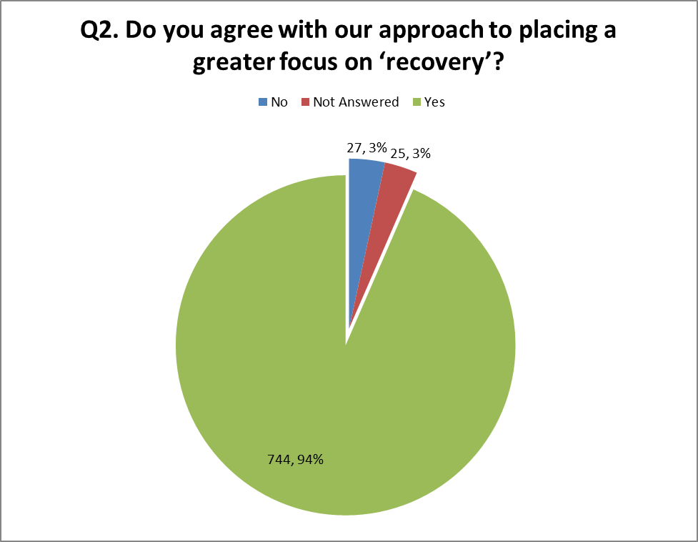
Participants were asked to include their reasons and a full list of responses is included in Appendix 1. Due to the detail within the responses it is difficult to categorise responses in a simplified matter, however, key themes included:
- Flexible recovery system to suit the needs of the users; listen to the needs of the service users
- More holistic diagnosis and therapy to tackle not just the problem but also the influencing/contributing factors; promote harm minimisation
- Improved support structure for family / carers and users which will co-ordinate or link to all services; improved services for women indirectly or directly affected by drugs/alcohol.
- Culturally sensitive support group and services; multi-lingual workers
- Youth awareness training; better education; increasing awareness session; more information available through all media
Of those that answered “no” comments included:
- I have been happy with my script for the last 25 yrs & never want to give it up. If forced to then I will just go back to using heroin.
- There is too much of a push to get people that either are not ready or do not want to go into abstinence.
- For some people abstinence will never be an option and the current push to get everyone off methadone is causing more problems for people.
- While a focus on recovery is important there also needs to be an appropriate focus on prevention and targeted campaigns for people who use drugs and alcohol recreationally. It is also important that approaches based on harm minimisation are incorporated into the model
- I believe from professional and personal experience that the emphasis needs to be put on residential out of area treatment. Prescribed drug replacement therapy should be time limited. Subutex not methadone (methadone is the equivalent of prescribing an alcoholic whisky!). I found as a professional working in the services that group therapy should be used in preference to 1;1 to deal with guilt and shame - most addicts relapse on these issues. People should be encouraged to at least try AA/NA - these organisations are tried and tested and have and will continue to outlive all professional modalities.

COMMENT SUMMARY
- Recovery is important and should be key focus within treatment. However abstinence is not always possible for every client. Treatment should be a multi-faceted approach considering the client circumstances and community/family support services. Harm reduction advice, alternative therapies, structured programme of treatment should all be considered and included when engaging in services.
- It was felt that there should be more on the ground resources being holistic in nature and mindful of individuals needs for example culturally aware services.
- Encourage the use of and link into free and non-commissioned services such as Narcotics Anonymous to provide an integrated and complementary treatment service, and support for the user where a support network is not available or appropriate through their family.

Do you agree with our approach to place a greater emphasis on the needs of the family?
Again, the majority answered “yes” (94%) with 4% not answering at all and just 4% “no”.
Figure 2: Do you agree with our approach to place a greater emphasis on the needs of the family?
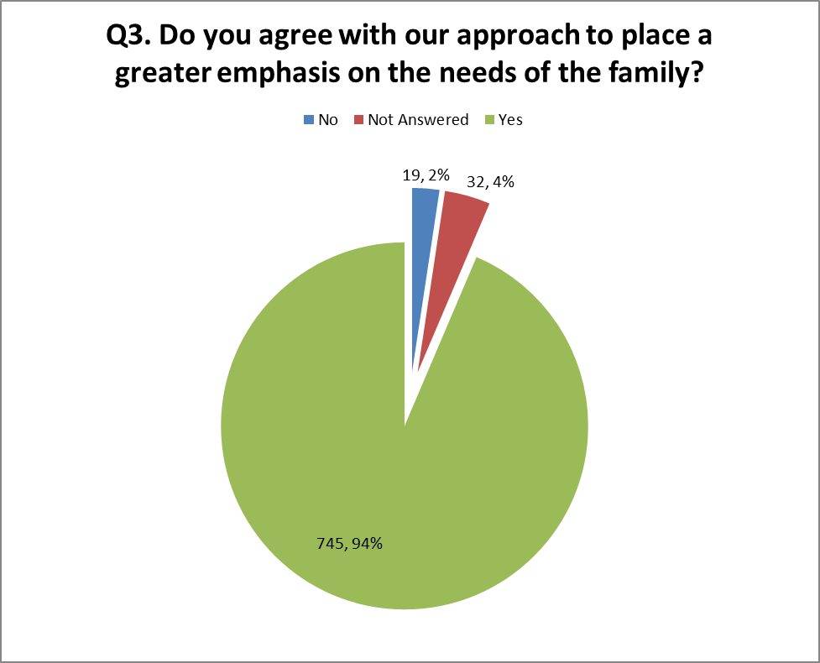
Participants were asked to include their reasons and a full list of responses is included in Appendix 3. Key themes included:
- Substance misuse does not only affect the individual but the family/carer also. Interventions to help the family such as family liaison officers to work with families/carers could help understand what to expect from a service users journey of recovery.
- The family is often the effect of the addict's condition and so needs some attention. But attacking the source of their problems by recovering the addict to abstinence good health and productivity is vastly more important.
- Increase in home visits, more regular or access to drug testing and more local centres for advice.
- Improved access to GPs, Primary Care and counselling services.
Of those that disagreed with this approach reasons given included:
- Families are either supportive or not, or until such stage as they can’t take any more. There are already services for families or user and family counselling etc. I think focus/ funds over and above what’s available should be directed at the user.
- Much too simplistic a view or approach - discussion assumed a single user impacting on a "family" - much addiction fuelled by "family" relationships - source of abuse, PTSP, neglect. How can families be empowered/enabled to positively contribute to the recovery journey - usually first line of "treatment" before come near "services"? What about mutual aid groups - where do they fit in? (Person centred means meeting individual needs, wants to achieve outcomes. For some people that will mean "family" involvement - for many, it won't - pointless question).
- For some people it is not helpful to have their families involved in their treatment.
- The main focus should always be the individual, but yes to involve the family is very important. the family may be able to help the individual or may need help and support/advice themselves
- Family support is important however I believe the needs of the substance user in treatment is of paramount importance. If we can support the service user throughout their journey of need and continue to support in recovery the needs of the family in terms of protecting from harm as a result of substance misuse could be met. This may mean removing a substance user from a family environment if harm is a concern although often substance misusers have already become isolated from their families when entering into treatment. I am not sure what additional safety measures could be put in place to protect families other than what is already available.
- I live alone and don't have much family; I hardly have any family. Family issues weren't reason for me taking drugs
- Some people might not want family involved and some families might not want to know
- Families are important but it is the individual who needs the bit of help. Agree all agencies should work together, however to support the family.

COMMENT SUMMARY
- It is recognised that a strong family and friend network helps service users through their treatment journey and reduces the risk of relapse. However it is important to note that some service user issues initially stem from family issues and it is not always possible or advisable to involve families in a user’s treatment journey. Drug workers need to recognise the appropriateness of involving families and where family support is not available ensure other support mechanisms are in place (NA, AA, SUI, SUSGs, etc)
- It is thought improved family/carer support services are needed to provide help to affected families advice and coping mechanisms.
- Working together with other agencies and services is thought to be paramount, together with improved and continued training for care workers

Do you agree with our proposal to simplify the treatment system by having one lead organisation working with a smaller number of partners?
The Figure 3 below shows the majority answered “yes” (79%), 14% “no” and 7% not answering at all. However, whilst the majority have answered in favour of this approach, many cited concerns over how one organisation would be managed and feared losing smaller community services.
Figure 3: Do you agree with our proposal to simplify the treatment system by having
one lead organisation working with a smaller number of partners?
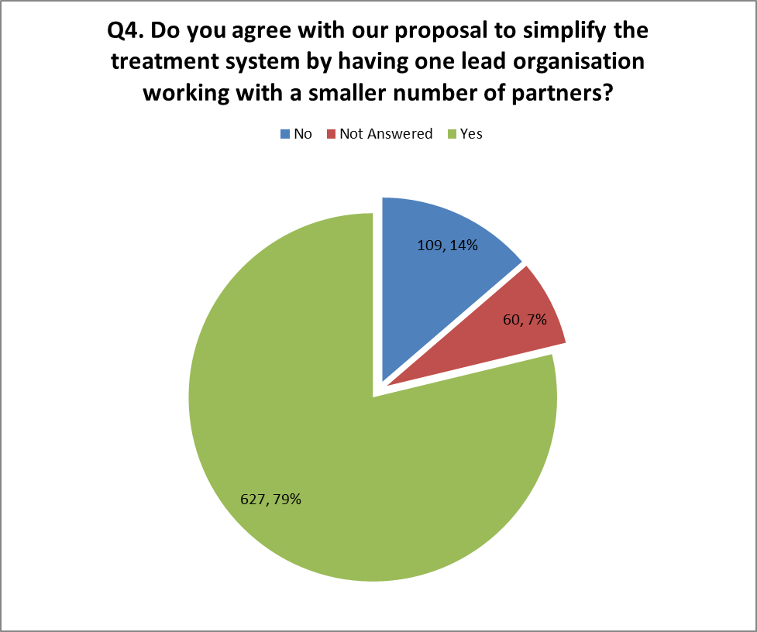
Participants were asked to include their reasons and a full list of responses is included in Appendix 4. Key themes included:
- BUT ONLY if it is an effective organisation in terms of recovery to lasting abstinence. The last 60 years has shown that this is seldom if ever achieved by so-called "treatment" and in fact the successes of the last 47 years have been achieved solely by training addicts in self-help addiction recovery techniques which they apply to themselves
- Engage grass root organisations and have the grass root organisations leading and developing projects; More service at local areas especially targeted areas for drug and alcohol
- Not sure about this. If this service fails to support or deliver build support with the client there may not be another avenue of support if there is only one organisation in charge. There must be more information how this will be managed.
- Avoid situation whereby services compete against each other to the detriment of the service user. As future resources are reduced a model that can reduce background costs is attractive. Need to avoid salami-slicing services from future budget cuts.
- Need strong emphasis on partnership working and local delivery of services
Of those that disagreed with this statement comments included:
- No as this restricts choice for clients. Not everyone believes in the philosophy of particular models. Sometimes commissioners think one size fits all; when it doesn't this restricts choice as commissioners may go for the cheapest option ie NA as it doesn’t cost any money!!!
- Too big - see examples of Services Birmingham – Capita, Acivico, Pertemps, MITIE. Big contract with single providers don't work - add more cost and downward performance. Competition can be positive in maintaining standards as seen in current performance. There are too many services but balance between 1&2 8 - 3-5
- Birmingham is too large for one commissioning agency (eggs in one basket come to mind). Danger that smaller groups and agencies may get lost in the process. Danger of losing small providers. District committees needs an input on delivery; WNF program needs to separate drug and alcohol
- The size of Birmingham makes it impossible to manage as one contract. Having one lead provider - commissioning responsibility from LA and this is not the best for service provision and meeting clients' needs. Just looking at the difficulty experienced by Children's Services in Birmingham highlights the need to have Birmingham broken down into smaller manageable areas. Risk to smaller providers - might go into the wrong lead provider and then lose all current contracts in Birmingham.

COMMENT SUMMARY
- Concerns have been raised regarding loss of community or grassroots organisations which are largely felt are more effective at a local level. Also concerns over the amount of influence/power/presence one lead organisation would have – need to consider how this organisation will be managed, for example, including contract limitations such as 20% of its funding to be used to procure culturally focussed community organisations.
- Consideration should also be given to how the lead organisation will be performance managed and if it fails to deliver on key indicators, how will this be enforced and improved.

Q5. We propose to use the following outcomes to measure the difference made by the new system for the benefit of service users. Are these the outcomes that are important to you?
Figure 4 below shows the 10 outcomes listed in the Consultation Questionnaire. The majority have selected “yes” (91%-94%), with 2%-3% answering “no”. The graph shows a relatively even spread of results, however, it is important to note that only 79% of those that replied answered yes to all 10 questions.
Figure 4: We propose to use the following outcomes to measure the difference made by
the new system for the benefit of service users. Are these the outcomes that are important to you?
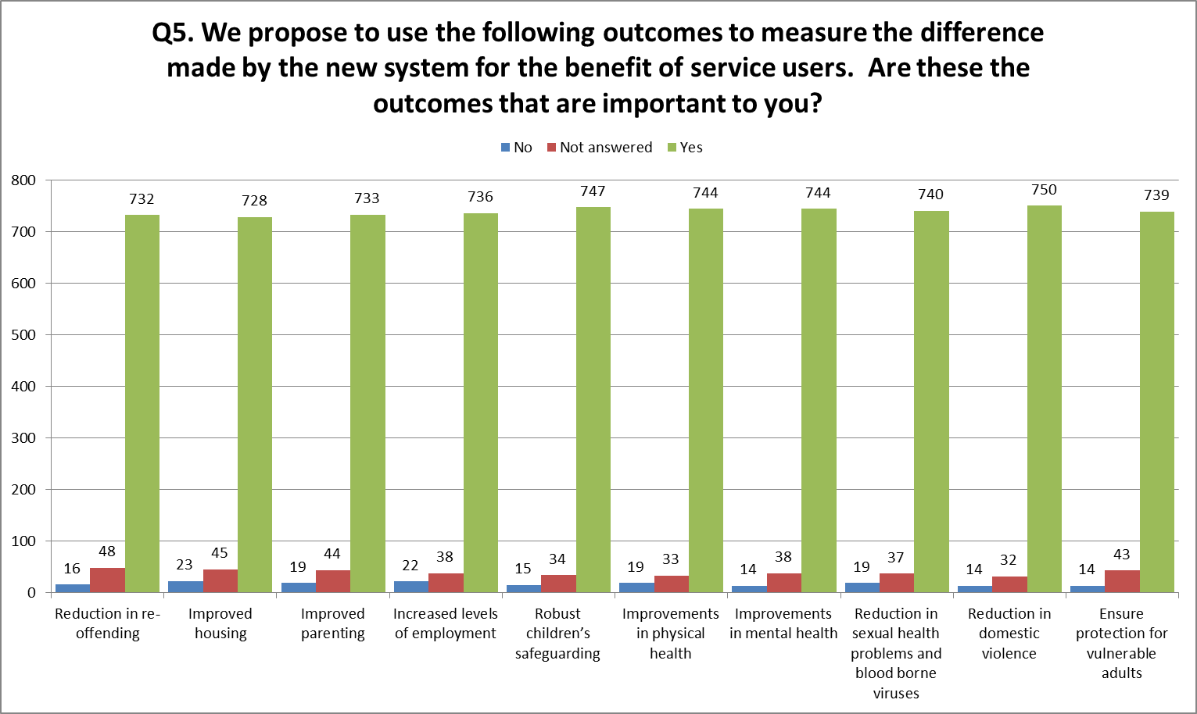
Comments were not sought on these individual outcomes.

Tell us about any other outcomes you think the system needs to deliver
People were asked to provide any additional outcomes they felt should be considered. A full list of comments is provided in Appendix 4 and a summary of the many themes is below.
Drug trends and services | - New psychoactive substances and club drugs  - Drug testing more often  - Open access services  - Local services
Education and Training | - More drug and alcohol training in schools  - Education on drugs and its effect in the community  - More workshops targeted for young youths at youth centre and schools  - School attendance (linked to parental capacity) and encourages joint work on safeguarding and CYP educators  - Homework clubs
Employment and Welfare | - Flexibility or needs of employed users  - Improved link into benefits systems  - Training into work  - Financial advice and services  - Helping searching for work  - Pregnancy reductions and terminations linked to Safeguarding  - Understanding around domestic abuse and links to substance misuse
Abstinence and Maintenance Services | - Needs of those who are not ready for abstinence but want maintenance at the present time
Improved Therapies and Counselling | - Counselling access  - Diversionary/informal activities  - BME focused interventions.  - Relapse prevention  - Multi-lingual services  - Family mediation  - Improved and target outreach programmes
Holistic services | - Better Asian support for health, diabetes, blood pressure, and mental health issues  - Improved health facilities (free gym)  - Increased women services and facilities  - Mental health support  - Care for older people  - Hospital support  - Accessible service/materials for people with learning difficulties  - Need to focus on supporting change through promoting healthy lifestyles and change in lifestyle  - Teenage parent support made a priority
Strong after-care programme | - Strong focus on after-care  - Easier to access to detox – Rehab  - Home visits
Personal Development and Community Reintegration | - Reintegration with educational grants etc  - Life skills  - Community resettlement outcomes for prisoners being released.  - Community concerns related to drugs/alcohol  - Community safety  - Tackle gangs, street violence, crime and anti-social behaviour  - Liaise with mosques and other religious centres
Recovery and Support | - Buddying/mentoring  - Family support  - Community support  - 24 hours telephone support  - Events and days out
Commissioning | - No more funding cuts that limit the range at interventions available to service users  - Improved partnership between organisations providing services therefore delivery improved services/sharing resources  - Clear consistency in data collection and recording allowing detailed and informative evaluation  - Regular consultations with key stakeholders (service users, etc) to ensure service meet needs  - Engage and work closer with primary care to ensure prompt access to treatment  - Clear pathways between GPs and support service such as metal health, psychotherapy etc. A directory of experts?

COMMENT SUMMARY
Many expressed concern that the outcomes mentioned did not include “reduction in alcohol and drug use”. It was felt important that whilst all these outcomes are desirable and have value, the focus should be on treating the drug or alcohol addiction, minimising harm and provided joined-up working with support services. Some expressed concern over how a drug treatment agency would be able to deliver outcomes on improved housing, etc, where that is not their focus. More clarity is required on how these outcomes will be measured, what is expected and how these outcomes will support the service user’s recovery. Is delivery these outcomes by treatment providers realistic?

Comments also include more awareness about drug and alcohol dangers and risks – a more visible advertising campaign, posters and commercials to raise awareness. Schools and education should be targeted for awareness sessions, and help given to employers to understand the value of a service user and help work with them to improve a service user’s employability.

Q6. Other comments on the new recovery system.
People were asked for any additional comments about the recovery system. 537 people answered this question, however, themes are similar those mentioned above.
In particular, many mentioned community groups and specialist agencies such as KIKIT and SAFE, are invaluable to their local community and some felt that they would not be in recovery or survive without them. It was suggested there is an opportunity to link these specialist services with other commissioning, for example, SAFE is a drug treatment service for women sex workers – in addition they provide a methadone clinics and sexual health advice. Should this be linked in/become part of the sexual health commissioning and improve pathways between the two?
Most approved of the holistic approach to dealing with substance misuse. However, there were concerns and this can be summarised by one particular comment:
“Many addicts are intelligent people, and boredom and lack of opportunity led them to addiction if they were vulnerable due to past life experiences. Most have had 'bad childhoods', traumas, bad influences in early adulthood, probably undetected mental health issues due to damage caused in childhood, and either actively or, naively fell into addiction. (Sorry I am only talking about drugs here as alcohol is beyond my remit of knowledge).
The REASONS why a person becomes an addict, and has the need to fill gaps inside them need to be addressed, in an in depth way and I do feel that psychotherapy is essential. An addict was usually crying out for help when they became an addict, and still are. If those reasons are not addressed, their recovery is likely to be slow and/or unsuccessful. Intense, holistic help needs to be given, and people need to be given a purpose and hope for the future. Telling people where they can go for further training, for example, to help with work prospects will not get them there. It needs to be under one roof. A 'hub' - someone from the CAB to advise re: debts, someone who is proactive from the Job Centre who will take real time to look at job options and training, someone to advise on healthy, cheap eating and be available to chat about balanced diets and shopping on a budget. Volunteer hairdresser/barber. Yoga classes - REAL exercise - exercise is so important mentally for a person trying to e.g. reduce their meth script. Volunteers (ex addicts) available just for people to talk to if they are feeling low and want to off load if they are feeling sad and lonely. Recovery is a lonely process. “

Q7. What best describes your interest in the consultation?
Respondents were asked to select the best category to best their interest in the Substance Misuse Treatment Redesign. 26% of respondents are Service Users and 20% are family members or carers of service users.
Figure 5: Which best describes your interest in the consultation?

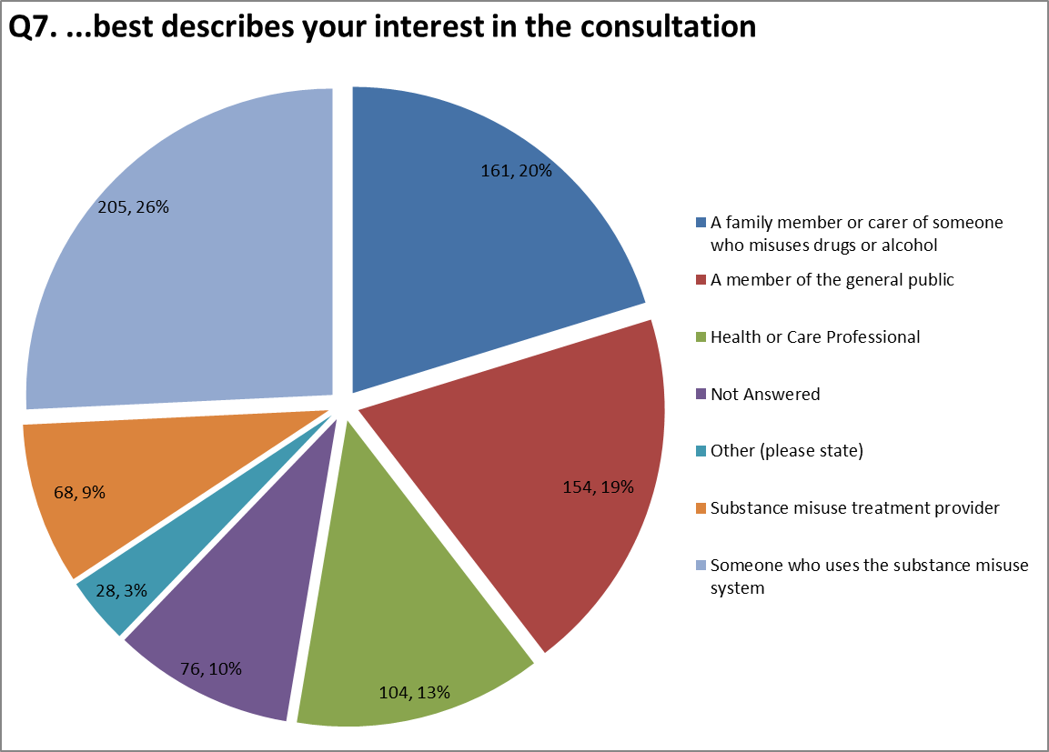

Q8. What is your postcode?
646 (81%) provided their postcode and of those 18% were from the B11 postcode. This is the Sparkbrook area where KIKIT is based and whom submitted 309 completed questionnaires. 18 postcodes were from outside Birmingham and included Dudley, Coventry , Walsall and Dublin.
Figure 6: What is your postcode?
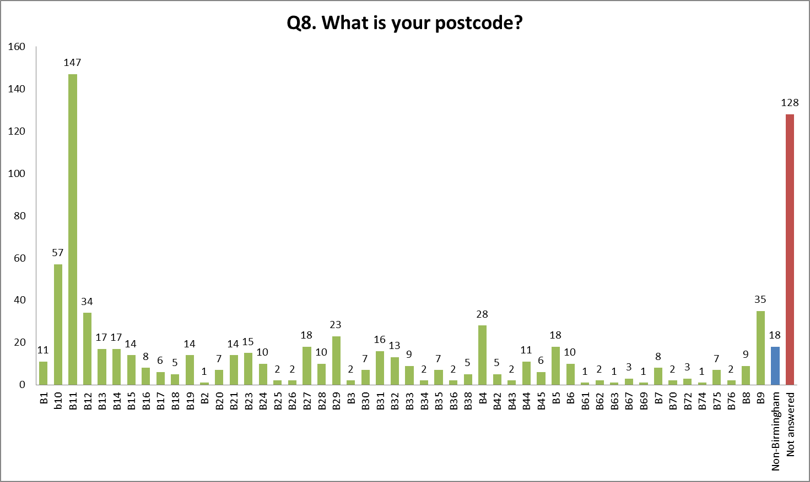

Q9. Which age group applies to you?
As you can see from the Figure 7 below, every age group is represented. The majority (17%) fell within the 30-34 age group, followed jointly by the 40-44 and 45-49 age groups (13%).
Figure 7: Which age group applies to you?
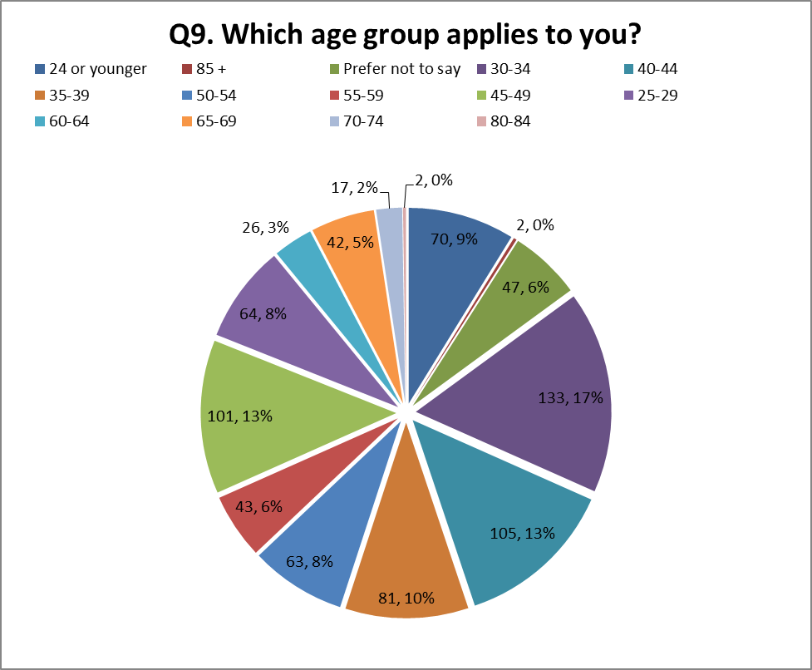

Q10. Do you have any physical or mental health conditions or illnesses lasting or expected to last for 12 months or more?
Only 79% of people answered this question, with 59% stating no.
Figure 8: Do you have any physical or mental health conditions or illnesses
lasting or expected to last for 12 months or more?
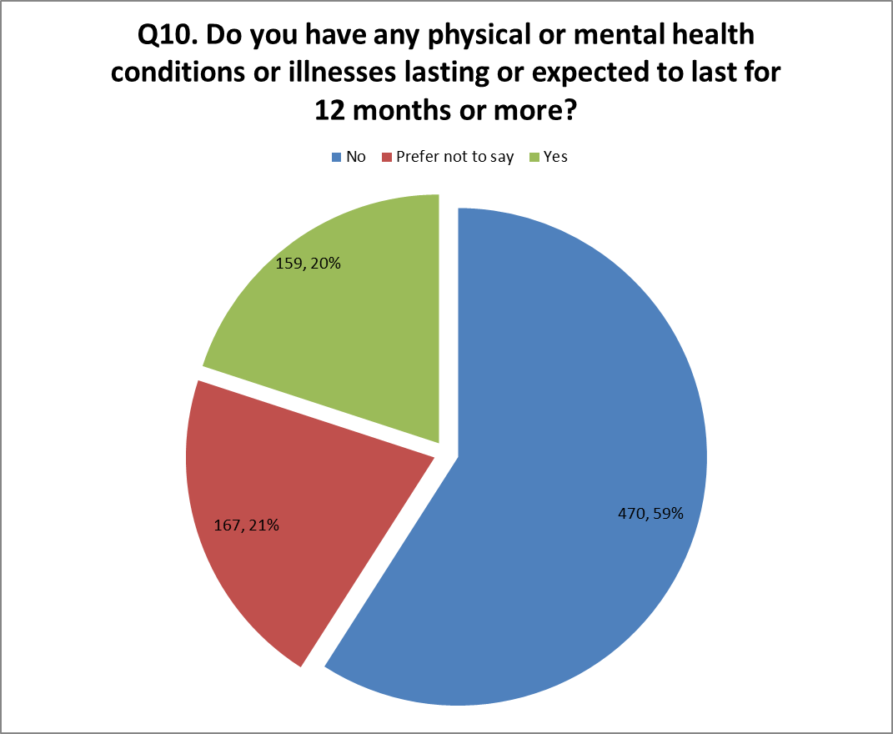
The question further asked if the people suffered from 9 different types of disability (see figure 9 below). Only 47% provided further details and those that responded yes, are shown below – this figure does however include those who have answered yes to more than one question. In actuality 612 people did not provide an answer to any of the categories provided in figure 9 below.
Figure 9: Do you have any of the following disabilities or conditions?
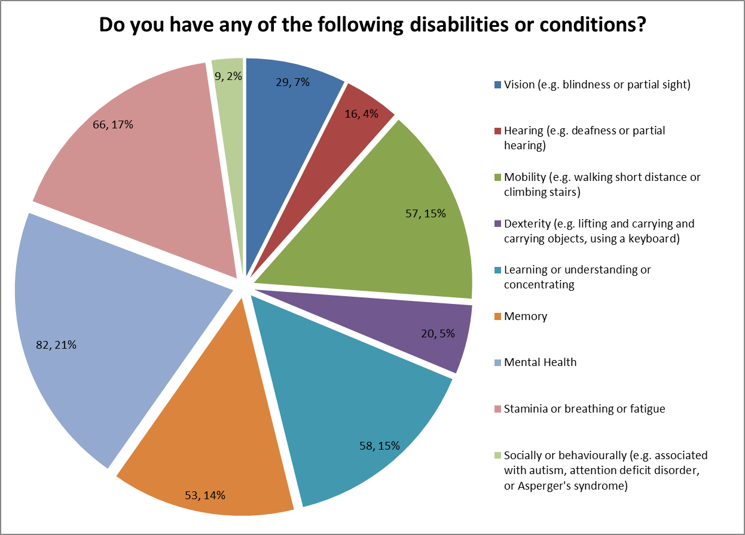

Q11. What is your sex / gender?
Figure 10 shows there is a relatively even split between the number of males and females who have submitted replies.
Figure 10: What is your sex / gender?

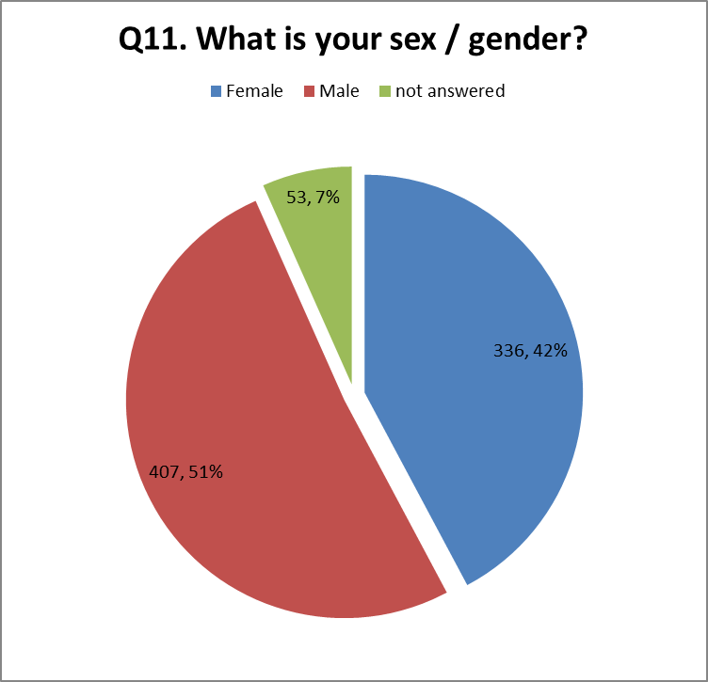

What is your ethnic group?
The Consultation followed the standard ethnic categories used within the 2011 Census. Although these categories are relatively wide, the majority of ethnicities are included within these categories and the opportunity to further state their ethnicity was provided in Figure 12.
Figure 11 shows a fairly even split between the number of submission from those with “white” ethnicity and those “Asian”, 40% and 30% respectively.
Figure 11: What is your ethnic group?
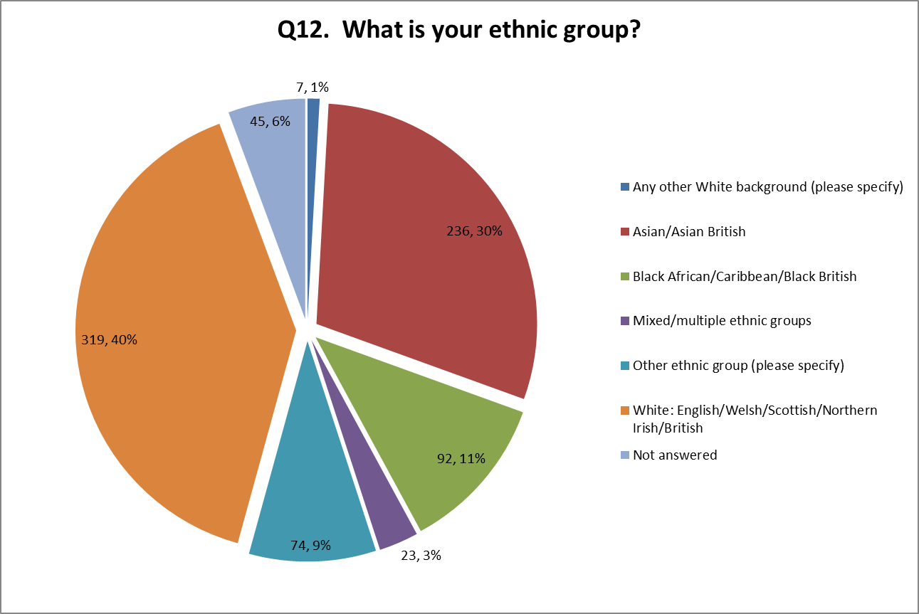
Figure 12 shows the further breakdown of ethnicity and includes Somali (26) and Pakistani (22), as well as smaller groups from Eastern Europe such as Bosnia and Kosovo. (Please note: numbers shown are values not percentages.)
Figure 12: What is your ethnic group (other)?
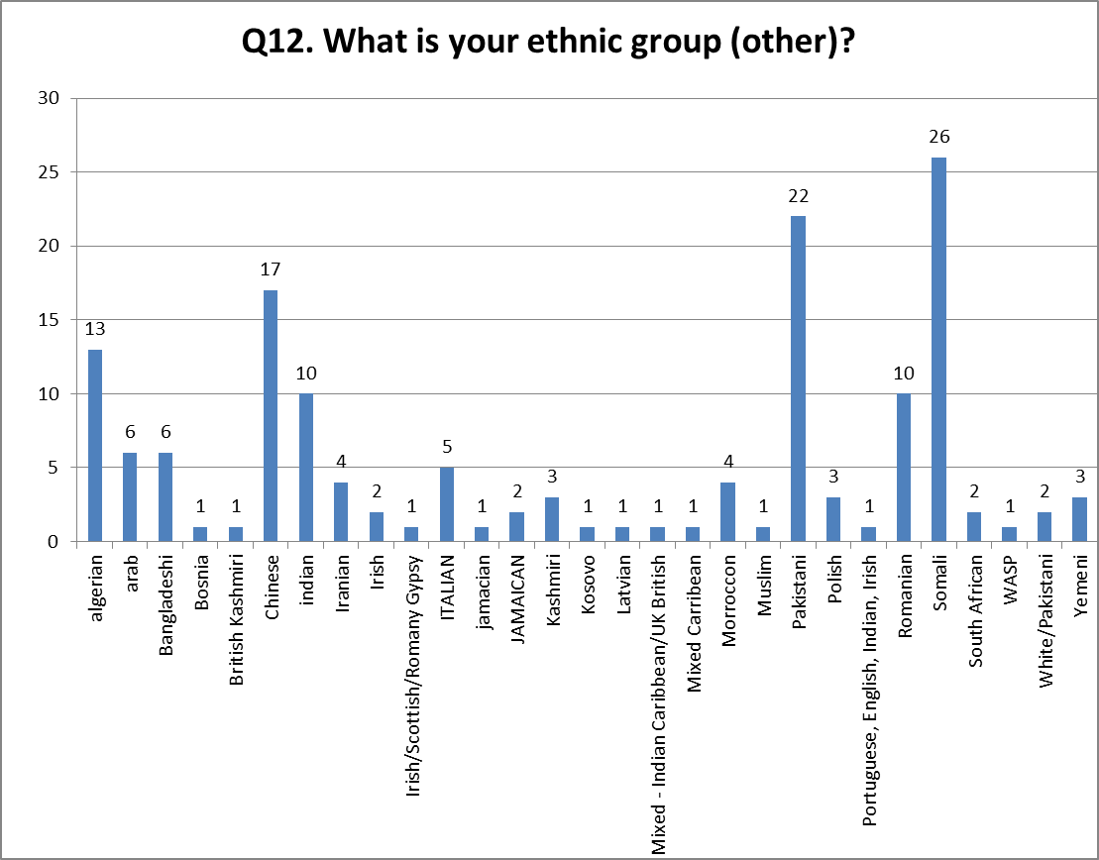

What is your religion or belief?
Of those that submitted their questionnaires, 700 responded to this question. Christianity (and related faiths) and Muslim were the most popular answers at 28% and 30% respectively. Only 1 person stated Jewish.

Figure 13: What is your religion or your belief?
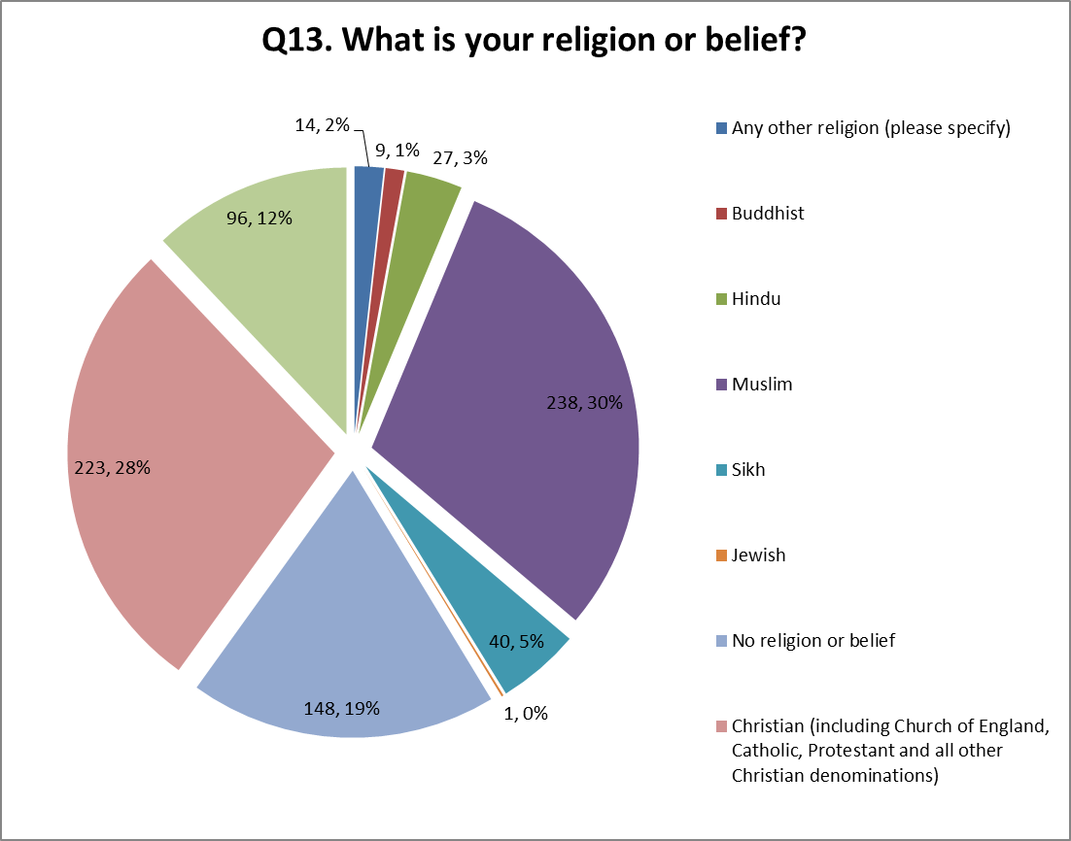
Respondents were given the opportunity to further state their faith. Only 14 people gave further details listing Rastafarian (42%, 6), Agnostic (21%, 3) and COVE, Humanist, Pagan, Spiritualist and Jedi all having just one response each (representing 35% collectively or 7% individually).

What is your sexual identity?
89% of respondents answered this question, with 81% stating Heterosexual or Straight. Other categories (Bisexual, Gay or Lesbian, Other) comprise of only 3% of the total responses collectively, and 5% stated they would prefer not to say.
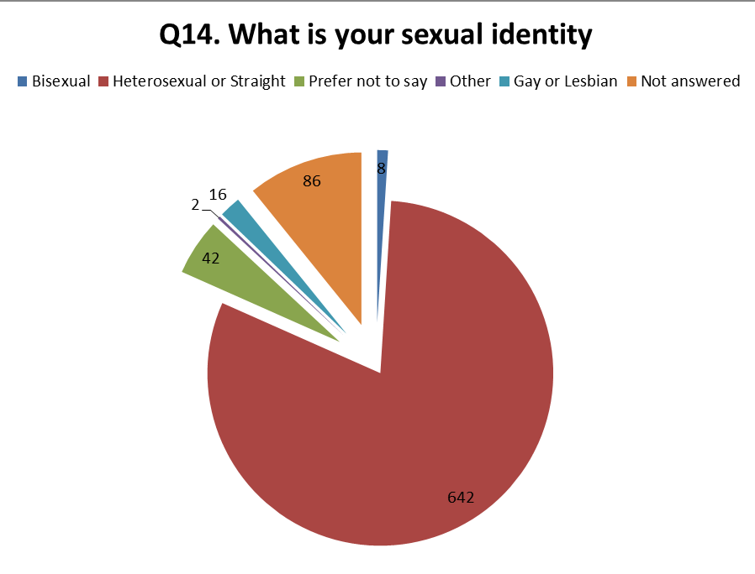

Conclusion and Recommendations
The consultation attempted to be as inclusive as possible, actively engaging as many different groups as possible, to gather feedback and include their view within the consultation process. This is reflected in the high level of responses (796) and the wealth of comments provided.
Due to the extensive detail and variety of comments it has proven difficult to categorise the feedback in a meaningful way and without diluting their comment. As such full comments are provided in the attached appendices and will be considered in their entirety.
However, there are some clear messages. Respondents were, in the main, supportive of change and accept that the current system is not as robust or as inclusive as it should be. It is clear that a holistic approach is considered more beneficial. What this holistic approach should and should not include is not as clear and there are concerns that by streamlining the current system into one or two main providers, service users will lose contact with their existing services, many of which are small community group services. These grassroots services provide a personal and intimate service, and this strong relationship between these groups, and service users have been quick to support their groups. Any future commissioning must consider the impact on the groups and support clear pathways into these services to ensure these often hard-to-reach groups remain engaged.
Pathways into services are a common theme. Many have expressed a need for strong links with other support service such as mental health services, GPs, Primary Care, benefits advice, financial advice and debt support, as well as into education, employment and volunteering groups. A service user’s journey through to recovery will touch on many different services and comments provided should there is some confusion on where to go and disparity in the quality of service provided. The Commissioner need to consider how to address this to create the holistic service the service users require. There also seemed to be some concerns about current provision being insufficient, for example, the lack of relevant trained GPs, access to GP appointments and surgeries. This will need to be addressed in the final commissioning.
Treatment Service Providers and Service Users alike have also raised concerns regarding the measurement of the outcomes listed in the consultation. Is it realistic for a Treatment Service Provider to be measured against a housing outcome? And if so, will this result in less time and money being spent on engaging and treating service users, and more time and money being spent on their welfare needs? Whilst respondents generally accept that a holistic approach will include all of these outcomes, there is some concern to how that will be managed and what will be expected from them.
Finally, Birmingham is a diverse city, with many different cultures and nationalities, and many comments point towards more services specifically for the BAME (Black Asian Minority Ethnic) community. Conversely other comments suggest more inclusive services. Whichever service(s) is/are put in place, it must be capable of providing services suitable for all cultures within Birmingham and include multi-language literature, multi-lingual drug workers, gender specific facilities and be culturally aware.

Appendix A : Consulted Groups

Focus Group | Organisation | Numbers attended (if known)
Public Health consultations
Women and BME | UK Asian Women’s Centre | 9
Women and Service Users | Phoenix Futures | 3
Staff supporting LGBT and HIV clients and service users | Freshwinds | 10 staff; 9 service users
Chinese community | Birmingham Chinese Society | 7 men; 10 women
Bangladeshi Women | Bangladeshi Women’s Association | 9
Homeless and Male Sex Workers | Turning Point RSVP | 5 service users; 2 staff
Muslim women | Saheli | 17 service users
Muslim community | MECC | 1 Manager
Elderly service users in shared care service | Swanswell | 2 service users
Families and Domestic Violence | Star | Could not meet due to client commitment
Domestic Violence and Women | Birmingham Women’s Aid | Unknown
Treatment Providers and interested parties | Public Health Substance Misuse Consultation Workshop: 4 Sept | 11
Treatment Providers and interested parties | Public Health Substance Misuse Consultation Workshop: 5 Sept | 58
Treatment Providers and interested parties | Public Health Substance Misuse Consultation Workshop: 12 Sept | 24
Service users | Public Health Service User Event: 11 Sept | 3 service users and 1 provider staff member
Service users | Public Health Service User Event: 25 Sept | 58 attendees
LGBT | LGBT Group | 6 attendees
Recovery Walk: 22 Sept | - | 40 questionnaires completed
KIKIT Consultations
BME Service Users | PWR Recovery | 100
BME community groups | KIKIT | 209

Appendix B : Consultation Questionnaires

