Community Consultation Document: Proposed Changes to Children’s Centres in Birmingham
Table of Contents
Community Consultation Document: Proposed Changes to Children’s Centres in Birmingham 1
Introduction 1
What are Children’s Centres? 1
Context of the Project? 1
Why Are We Consulting on Changes to Services? 2
What Are the Proposed Changes? 2
How the Proposed Changes Affect Me (the Community) 3
Consultation Within the Community 3
Here Are the Ways You Can Get Involved 4
What Happens Next? 4
Appendix A - Children’s Centre and Family Hub Location Map: 6

Introduction
This document outlines proposed changes to services at six Children’s Centres across Birmingham and invites feedback from local families and community members. The centres involved are St. Thomas’s and Bertram in the Ladywood district, Tame Valley and Anthony Road in Hodge Hill, Wychall in Northfield, and Featherstone in Erdington. These changes aim to ensure continued access to vital early years services through nearby Family Hubs, while making better use of resources and improving how support is delivered. Your input is essential to help shape services that meet the needs of our communities.

What are Children’s Centres?
Children’s Centres provide vital support for families with children under five years old. They offer early childhood services such as early years education, parenting support, health and wellbeing services, and outreach programmes.

Context of the Project?
The overall aim of this project is to maximise the efficiency of our resources and services in response to growing financial pressures. The 0-5 Early Years Healthy Child Programme in Birmingham has been extended to February 2027 under the current contract arrangement, but the budget has remained unchanged since 2018. With rising costs and the impact of the cost-of-living crisis, this has created significant strain on service delivery. To address these challenges, Birmingham Community Healthcare NHS Foundation Trust (BCHT) are working with Birmingham City Council on this proposal to deliver services from a reduced number of places while continuing to provide the same level of support, through different service delivery models including the Family Hub network.

Why Are We Consulting on Changes to Services?
Due to evolving community needs and budgetary constraints, Birmingham City Council is reviewing the use of Children’s Centres. We are consulting to gather input on the proposed repurposing (which means changing how a building is used, such as offering different services or being managed differently) of the 6 stated centres, ensuring that services are maintained through other locations such as nearby Family Hubs. The law requires the Council to consult before making significant changes to the services provided through our Children’s Centres and before anything is done that would result in a relevant children's centre ceasing to be a children's centre.
We are consulting on these potential changes with the local community to ensure that they accurately reflect your needs and priorities. Feedback from consulting with the community will help inform how we deliver support around early development, maternal and infant health, mental health for both parents and children, breastfeeding and immunisation advice. Involving the community in this process allows us to build services that are more accessible, effective and tailored to the unique needs of each local community.

What Are the Proposed Changes?
The proposal includes the repurposing of Children’s Centres that are not being used as much. Services are proposed to be moved to nearby Family Hubs, other locations or on an outreach basis which the Council hopes may offer a more joined up support for families and are better equipped to meet community needs.
The services we are proposing to move to a different location are: family and childcare advice, parenting support, health visiting, and stay and play sessions. This also includes promoting access to antenatal care, expanding maternal mental health services, offering more breastfeeding support and education, and providing guidance on early childhood immunisations and growth monitoring.
The Council will continue to provide early childhood services but in some cases these may move from the location where they are currently provided, to another nearby location.
List of all Centres being considered for repurposing:
- Anthony Road in the Hodge Hill District
- St. Thomas's and Bertram in the Ladywood district.
- Tame Valley in the Hodge Hill District.
- Wychall in the Northfield District.
- Featherstone in Erdington.

How the Proposed Changes Affect Me (the Community)
The Council aims to maintain access to all services however they may be delivered from different locations. Families would have access to the same support through Family Hubs located close to the affected centres. The Council will provide information about any transport and outreach assistance that it makes available once plans have been finalised, with the aim of ensuring a smooth transition for families.
The changes we have proposed are designed to give families in our community better access to the support they need during the early years of a child’s life. By more services being located together for example, early intervention, maternal and infant health, and key areas like breastfeeding support, mental health, and immunisation advice, families would be able to get help earlier and more easily. This means more opportunities for children to thrive and for parents and carers to feel supported and informed throughout pregnancy and early childhood.
Service Coverage
Where Can I Still Access Services?
This map shows the locations of Children’s Centres and Family Hubs across Birmingham.
Even if your local centre is changing, support would still be nearby.
Look for the Family Hub icons to see where services may continue. Including parenting support, early years activities, and health advice.
Link to full size map:
📍 Family Hubs = Ongoing support
✅ Children’s Centres = Sites under review
(For full map please refer to “Appendix A”)

Consultation Within the Community
We are engaging with parents, carers, local residents, staff, and community organisations to gather feedback. Your views are essential in helping to form the future of family services in Birmingham.
To support this, we are hosting a series of drop-in sessions at the 6 Children’s Centres being included in this consultation. These sessions will run over 6 days in September, starting September 15th.The session dates and times can be found below. These face-to-face events will give an opportunity for families and community members to speak directly with staff, ask questions, and share their views on the proposed changes.
In addition, a community consultation survey is available through the BeHeard website https://www.birminghambeheard.org.uk/bcc/community-consultation-childrens-centres/
and will remain open until 5th October. This survey allows you to provide detailed feedback on the proposals and help inform how services are delivered in your area.

Here Are the Ways You Can Get Involved
One of the ways you can get involved is by attending one of our drop-in sessions, which will be held at the 6 Children’s Centres in scope over 6 days in September giving the community plenty of opportunities to attend, ask questions, share views and speak directly with staff about the proposed changes. These drop-ins will be open to everyone, and we encourage all local families and community members to take part and help inform the future of your services.
Drop-in sessions Starting September 15th:
Week 1
Tame Valley – Hodge Hill
Monday, 15 September 2025
Midday Session: 12:00 PM – 1:30 PM
Afternoon Session: 3:30 PM – 5:00 PM
Anthony Road – Hodgehill
Tuesday, 16th September 2025
Midday Session: 12:00 PM – 1:30 PM
Afternoon Session: 3:30 PM – 5:00 PM
Wychall – Northfield
Wednesday, 17 September 2025
Midday Session: 12:00 PM – 1:30 PM
Afternoon Session: 3:30 PM – 5:00 PM
St. Thomas – Ladywood
Thursday 18th September 2025
Midday Session: 12:00 PM – 1:30 PM
Afternoon Session: 3:30 PM – 5:00 PM
Featherstone – Erdington
Friday, 19 September 2025
Midday Session: 12:00 PM – 1:30 PM
Afternoon Session: 3:30 PM – 5:00 PM
Week 2
Bertram – Ladywood
Monday 22nd September 2025
Midday Session: 12:00 PM – 1:30 PM
Afternoon Session: 3:30 PM – 5:00 PM

What Happens Next?
Following the consultation period, all feedback gathered through the drop-in sessions and the community survey responses will be carefully reviewed. This input will help inform the final proposals and ensure that any changes reflect the needs and priorities of local families.
A summary of the consultation findings will be shared publicly, and a final decision will be made by the Council’s Cabinet and the Council’s partners, having regard to the consultation feedback. If the proposals are approved, a detailed transition plan will be developed to support families and staff through the changes.
We are committed to keeping you informed throughout this process and your service provider will keep you updated on next steps, timelines, and how services will continue to be delivered.

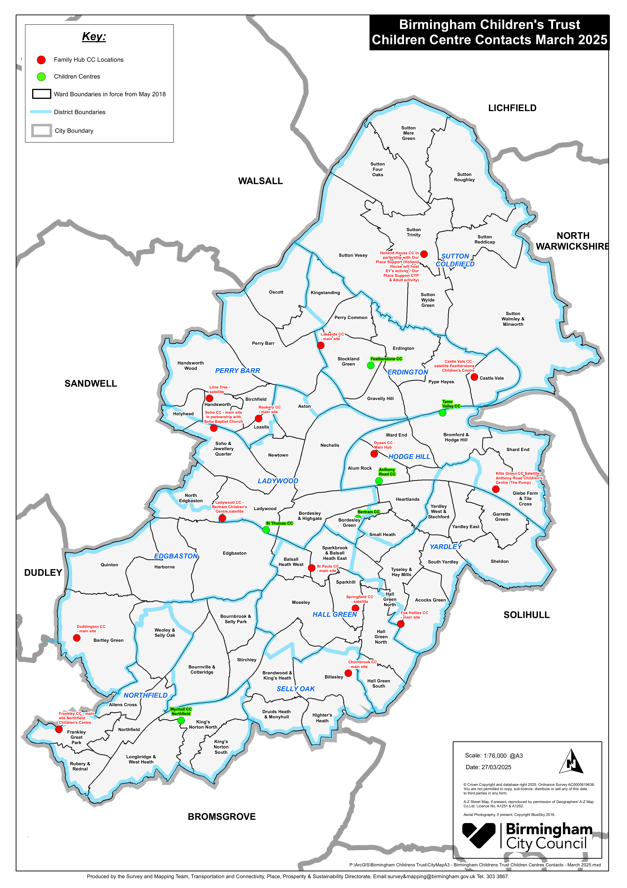
Appendix A - Children’s Centre and Family Hub Location Map:

