  - Birmingham City Council
  - Highways Asset Management Framework and Strategy
  - [xxxxx 2026]

Purpose and context
This document sets out a strategic approach for how Birmingham City Council’s highways assets will be managed and operated. This encompasses national and regional plans, asset management policy and strategy, asset and operational plans and key enablers for the system.
The production of core asset management system documentation is a core requirement of Council as stewards of the highways network. Birmingham City Council recognise the need to manage the asset well and have adopted the best practice guidelines of the Well Managed Highway Infrastructure: A Code of Practice and the Highway Maintenance Efficiency Programme to ensure the impact of the limited resources available is maximised.
The purpose of this document is:
- To describe a proposed Asset Management Framework, including the policies, strategies and plans which are needed, as well as their relationship to each other.
- To provide an Asset Management Strategy, which outlines a strategic vision for the management of highways assets and describes the key processes, controls and procedures which are required for managing a safe and reliable asset system.
- Translate the draft Asset Management Policy into a strategic approach, defining how Birmingham City Council will achieve the policy commitments.

Highways Infrastructure Asset Management Framework
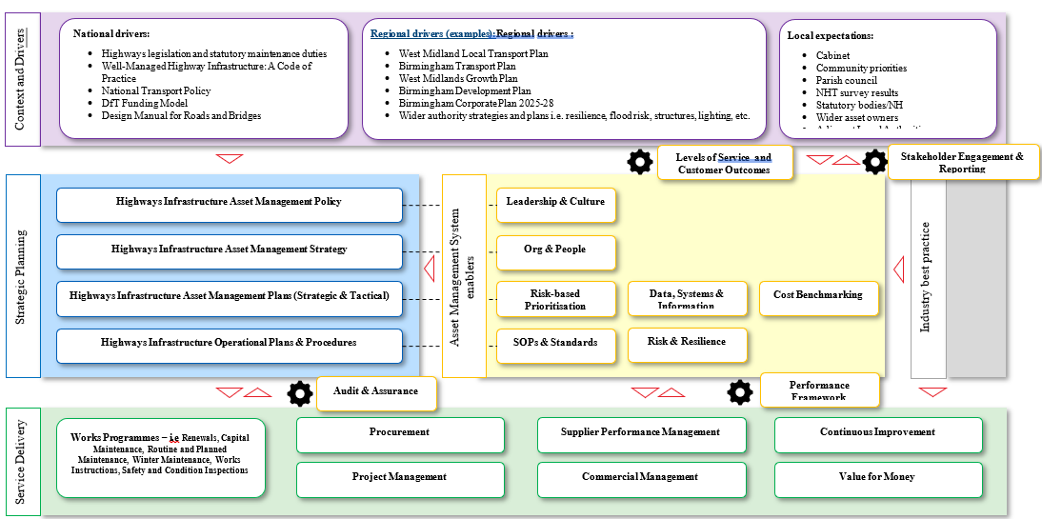
  - The Highways Asset Management Framework provides a visual representation of how the future asset management system is intended to work. The Highways Asset Management Strategy is a key Strategic Planning artefact within this framework.

Highways Infrastructure Asset Management Framework Diagram
The diagram illustrates the Highways Infrastructure Asset Management Framework as a hierarchy showing how strategic drivers and planning activities lead to service delivery.
At the top of the framework is Context and Drivers, which provides the external influences on highway asset management. These are grouped into three categories:
National drivers
- Highways legislation and statutory maintenance duties
- Well-Managed Highway Infrastructure: A Code of Practice
- National Transport Policy
- DfT Funding Model
- Design Manual for Roads and Bridges
Regional drivers
- West Midlands Local Transport Plan
- Birmingham Transport Plan
- West Midlands Growth Plan
- Birmingham Development Plan
- Birmingham Corporate Plan 2025-28
- Wider authority strategies and plans, including resilience, flood risk, structures and lighting
Local expectations
- Cabinet
- Community priorities
- Parish council
- NHT survey results
- Statutory bodies and National Highways
- Wider asset owners
Below this are two cross-cutting elements:
- Levels of Service and Customer Outcomes
- Stakeholder Engagement and Reporting
The next layer contains three components:
Strategic Planning, comprising:
- Highways Infrastructure Asset Management Policy
- Highways Infrastructure Asset Management Strategy
- Highways Infrastructure Asset Management Plans (Strategic and Tactical)
- Highways Infrastructure Operational Plans and Procedures
Asset Management System Enablers, comprising:
- Leadership and Culture
- Organisation and People
- Risk-based Prioritisation
- Standard Operating Procedures and Standards
- Data Systems and Information
- Risk and Resilience
- Cost Benchmarking
Industry Best Practice, which informs both the Asset Management System Enablers and Service Delivery.
Below these are:
- Audit and Assurance
- Performance Framework
At the base of the framework is Service Delivery, which consists of:
- Works Programmes (including renewals, capital works, maintenance, inspections and winter maintenance)
- Procurement
- Project Management
- Supplier Performance Management
- Commercial Management
- Continuous Improvement
- Value for Money
The diagram shows that Context and Drivers inform Strategic Planning and Asset Management System Enablers. Asset Management System Enablers support Strategic Planning and Service Delivery. Industry Best Practice feeds into both Asset Management System Enablers and Service Delivery. Audit and Assurance and the Performance Framework provide oversight of Service Delivery.

High Level Purpose of Key Asset Management Framework artefacts

Context and Drivers
- The strategic and stakeholder context for the asset managements system.

Strategic planning
- The vision for highways asset management
- Asset management objectives and associated Performance Indicators
- Strategic and tactical asset management plans
- Operational plans and procedures required to deliver the strategy and plans

Service Delivery
- The processes required to safely and reliably deliver core asset management services

Asset Management System Enablers
- The key processes and controls which enable strategic planning and service delivery

Strategy Structure
The contents of the strategy are outlined below. The intent is to provide a vision and desired ‘to be’ state for the key processes and controls required to deliver the strategy. Detailed implementation plans and work programmes are to be included in the asset management planning process. The framework alignment has been included in brackets following the section title.

Section:
- Context Overview _{(Context & Drivers)}
- Legislative Landscape _{(Context & Drivers)}
- Strategic Landscape _{(Context & Drivers)}
- Strategic Drivers _{(Context & Drivers)}
- Scope of the AM System _{(Strategic Planning)}
- Asset Management Vision & Principles _{(Strategic Planning)}
- Asset Management Objectives _{(Strategic Planning)}
- Levels of Service (Asset Management System Enablers)
- Performance Indicators (Asset Management System Enablers)
- Performance Management (Asset Management System Enablers)
- Asset Management Lifecycle Planning _{(Strategic Planning)}
- Risk-based Prioritisation (Asset Management System Enablers)
- Risk & Resilience (Asset Management System Enablers)
- Data, Systems & Information (Asset Management System Enablers)
- Leadership & Culture (Asset Management System Enablers)
- Continuous Improvement _{(Service Delivery)}
- Stakeholder Engagement & Reporting (Asset Management System Enablers)
- Strategy Implementation, Review & Update _{(Service Delivery)}

Context Overview
Birmingham City Council is responsible for managing one of the largest and most diverse local highway networks in the United Kingdom. The asset base includes approximately 2,600 km of carriageways, 5,000 km of footways, 800 highway structures, 95,000 lighting columns, and a wide range of other critical assets that support the safe and efficient movement of people and goods across the city. The scale, complexity and value of these assets make a structured, evidence-led approach to asset management essential to ensuring that investment decisions maximise value, manage risk and maintain service performance over the long term.
The highway network plays a vital role in delivering the Council's wider strategic objectives. Birmingham's transport strategy seeks to improve connectivity, support economic growth, encourage sustainable travel, enhance road safety, reduce environmental impacts and create healthier, more attractive places for people to live, work and visit. Effective highways asset management must therefore extend beyond the traditional focus on maintenance and renewal, ensuring that assets actively contribute to broader transport, place-making, commercial, social and environmental outcomes.
At the same time, the city faces a range of significant and interconnected challenges. Much of the highway infrastructure is ageing, placing increasing demands on maintenance budgets and intervention programmes. Ongoing pressure on public finances requires the Council to make difficult choices about how available funding is prioritised and invested. Climate change is increasing the frequency and severity of extreme weather events, creating new risks to asset condition, resilience and service continuity. In parallel, residents, businesses and stakeholders rightly expect safe, reliable and well-maintained infrastructure, together with greater transparency, responsiveness and value for money. Whilst these pressures are substantial, they also present an opportunity to modernise approaches to asset management, embrace innovation, improve efficiency and deliver a more resilient, sustainable and customer-focused highway service.
This Strategy is written at a time when there is a great opportunity for the Council to strengthen strategic asset management practices, embed a more risk-based and outcomes-focused approach to decision making, and align investment more closely with the city's long-term objectives. By doing so, Birmingham can create a highway service that is better equipped to respond to future challenges while continuing to deliver value for residents, communities and businesses.

Legislative Landscape
Birmingham City Council’s highways asset management and operational activities are governed by a range of legislation, with selected key examples outlined.

Highways Act (1980)
The principal legal framework governing highways in England and Wales. Establishes the legal baseline for inspection, maintenance and risk management.

Traffic Management Act (2004)
Creates a framework for managing congestion and coordinating roadworks. Asset decisions must therefore consider network impact, congestion and coordination.

New Roads and Street Works Act (1991)
Regulates the activities of utilities working on highways. Introduces powers to control the timing and location of works which enables the better coordination of maintenance activities.

Road Traffic Regulation Act (1984)
Provides powers to regulate traffic e.g speed limits, parking, restrictions.

Infrastructure Act (2015)
Introduces a framework for strategic highways management and infrastructure delivery. Clarifies boundary between local authority and strategic road network.

Town and Country Planning Act (1990)
Controls development that impacts highways. Birmingham City Council as a result will assess the impact of development on the highway network.

Environmental Protection Act (1990)
Introduces controls on waste management, noise and pollution.

Climate Change Act (2008)
Introduces carbon reduction obligations.

Flood and Water Management Act (2010)
Assigns responsibilities for drainage and flood risk to local and national authorities across England and Wales.

Road Tunnel Safety Regulations (2007)
Establish minimum safety requirements for long road tunnels in the UK.

In addition, there are codes and guidance which, whilst not formally legislation, are essentially mandatory in practice.
- Well-Managed Highway Infrastructure (UKRLG Code of Practice)
- Highway Infrastructure Asset Management Guidance (HMEP)
- Design Manual for Roads and Bridges (DMRB)

Strategic Landscape
The following key strategy documents provide key drivers for the management of Birmingham highway assets. The following gives the strategy/plan title and the relevance to Birmingham City Council Highways.

Birmingham’s Corporate Plan for 2025-2028 (BCP)
Sets the Council’s priorities for the next 3 years focusing on how to operate, meet statutory responsibilities and deliver better outcome for citizens.

West Midlands Growth Plan (WMGP)
Sets out a bold vision to transform the region’s economy over the next decade, with real action starting now and big outcomes by 2035.

West Midlands Local Transport Plan (WMLTP)
The statutory, long-term strategy that sets out how transport will be planned, prioritised and delivered across the West Midlands Combined Authority area. It provides the regional framework for decisions on investment and policy, setting clear outcomes for supporting inclusive economic growth, improving health and air quality, and shaping better places.

Birmingham Development Plan 2031 (BDP)
Sets a vision and strategy for the sustainable growth of Birmingham for the period up to 2031.

Birmingham Transport Plan 2031 (BTP)
Contains a set of principes to guide investment in transport so that it is able to serve a future Birmingham.

There are a number of converging themes across these strategies and plans:
- Growth and connectivity: Highways must enable economic development and labour mobility with a strong emphasis on strategic corridors and access to development sites.
- Shift away from car-dominated networks: Increasing emphasis on public transport and active travel
- Integration of transport and place: Streets are seen as places for people and enablers of community outcomes
- Decarbonisation and sustainability: All documents highlight climate change, air quality and low-carbon transport
- Outcome-focused approach: Shift from the delivery of engineering outputs to wider customer and societal outcomes i.e safety, accessibility, reliability and economic growth
- Value for money and affordability: Recognition of the strain on the public purse and the need for the efficient allocation of resource and focus on return on investment (ROI)

Strategic Drivers
Considering the legislative and strategic landscape, a set of strategic drivers for asset management can be synthesised. These are explained below, along with the relative mapping to the strategies and plans included within the strategic landscape summary.
Maximising safety and service reliability through whole life asset care
- BCP - Very Strong
- WMGP – Supporting
- WMLTP – Strong
- BDP – Moderate
- BTP – Very Strong

Enhancing asset resilience to extreme weather
- BCP - Very Strong
- WMGP – Moderate
- WMLTP – Strong
- BDP – Moderate
- BTP – Strong

Recognising affordability and whole life value for money in asset prioritisation choices
- BCP - Very Strong
- WMGP – Very Strong
- WMLTP – Very Strong
- BDP – Moderate
- BTP – Implicit

Introducing carbon reduction and circular economy thinking into asset management practice and scheme design
- BCP - Very Strong
- WMGP – Strong
- WMLTP – Very Strong
- BDP – Strong
- BTP – Very Strong

Driving an outcome and customer focused approach into decision making with a focus on Level of Service
- BCP - Very Strong
- WMGP – Strong
- WMLTP – Very Strong
- BDP – Moderate
- BTP – Very Strong

Creating an auditable and risk-based framework for asset management decision making to guide prioritisation
- BCP - Strong
- WMGP – Strong
- WMLTP – Very Strong
- BDP – Moderate
- BTP – Moderate

Scope of the Asset Management system
Birmingham City Council manages one of the UK’s largest and most complex highway asset portfolios. A snapshot of the asset base is shown in the table below.
The table shows 8 asset types and their order of magnitude. Including Roads, Footways, Structures, Lighting Columns, Traffic Signals, Drainage Gullies, Trees and Guardrail/fencing.
Asset Type | Order of Magnitude
Roads | ~2,600 km
Footways | ~5,000 km
Structures | ~800+
Lighting columns | ~95,000
Traffic signals | ~1,200
Drainage gullies | ~100,000+
Trees | ~76,000
Guardrail / fencing | ~135 km

Asset Management Vision and
Principles
The Council’s highway network is one of its most valuable infrastructure and community assets. It is essential for a successful city and regional economy. It provides access to jobs, goods and services, as well as to schools, healthcare and leisure activities. While the council has statutory duties to ensure that the network is safe and available to use, the condition of this asset links and contributes to the wider policy objectives of the council.
The core objective for highways asset management is to manage Birmingham’s highway infrastructure as a strategic asset, providing safe, reliable, inclusive, resilient and low-carbon networks that support people, place, prosperity and environmental improvement.

Aligned with industry best practice (ISO55000), the core asset management principles which will guide our thinking and decision making are:
- Whole-life cost optimisation
- Total value approach
- Customer and outcome approach
- Evidence led and data driven
- Right intervention, right time

Asset Management Objectives
Our Asset Management Objectives translate corporate and regional drivers and objectives into tangible and measurable outcomes which can be targeted through best practice asset management.
These are listed with their reference below.
AMO1: Maintain a highway network that minimises risk of harm and ensures a consistent, reliable service for all users.
AMO2: Maximise value for money by adopting whole-life costing approaches to design, asset investment, balancing cost, commercial benefit, performance and risk within available funding.
AMO3: Improve the resilience of highway assets to climate impacts and extreme weather, ensuring critical networks remain operational.
AMO4: Minimise the carbon impact of highway asset management and embed circular economy principles in design, maintenance and renewal.
AMO5: Deliver a service that reflects customer needs, expectations and wider place-based outcomes, taking into account the diversity across the City.
AMO6: Prioritise asset investment to support economic growth, connectivity and access to key employment, development and strategic corridors.
AMO7: Ensure asset management decisions are transparent, evidence-based and auditable, using consistent risk and performance frameworks.
AMO8: Embed innovation and continuous improvement into asset management practice through the use of new materials, technology and processes.

Levels of Service
Levels of Service are used to translate strategy into measurable outcomes. They are a set of customer and outcome focused statements defining the service the highway network should provide.
Level of Service statements are shown below aligned to the respective asset management objectives.
AMO1: The highway network will provide a safe and reliable environment for all users, with risks managed through timely inspection, maintenance and intervention.
AMO2: Highway assets will be managed to maximise whole-life value, balancing cost, performance and risk to deliver an affordable and sustainable service.
AMO3: The highway network will be resilient to disruption and adaptable to the impacts of climate change, maintaining functionality during and after extreme events.
AMO4: Highway assets will be managed to minimise environmental impact, reduce carbon emissions and promote sustainable and circular practices.
AMO5: The highway network will deliver a level of service that reflects the needs and expectations of customers, communities and stakeholders.
AMO6: The highway network will support economic growth and connectivity by enabling efficient movement of people and goods.
AMO7: Highway asset management decisions will be evidence-based, transparent and auditable, ensuring consistency and accountability.
AM08: Users of the Highway network and local communities will benefit from an evolving and constantly improving approach to highways maintenance and works delivery

Performance Indicators
Performance Indicators provide a means to measure the successful delivery of objectives and corresponding Levels of Service. These can be both leading and lagging indicators. Specific Performance Indicators can be termed ‘Key Performance Indicators’ for reporting and audit purposes.
A proposed set of Performance Indicators are included below. These should be reviewed and iterated on an ongoing basis based on data availability and emerging priorities for the Council.
AM01
Leading Performance Indicators
- % of safety inspections completed on time
- % of high risk defects repaired within SLAs
- Number of safety-related work orders raised proactively
- Network availability
Lagging Performance Indicators
- Killed and Seriously Injured (KSI) rates
- Number of third party claims
- Customer satisfaction with safety
- Average journey time reliability
- STATS19 data

AM02
Leading Performance Indicators
- % of planned vs reactive maintenance expenditure
- % of asset classes with lifecycle plans in place
- % of schemes assessed using whole-life cost models
- Unit rate vs benchmark for key treatments
Lagging Performance Indicators
- Total cost per km of network (trend over time)
- % of network in target condition bands
- Deferred renewals due to optimal maintenance
- Journey time reliability vs spend

AM03
Leading Performance Indicators
- % of network with resilience plans in place
- Number of known resilience risks mitigated
- Investment in resilience schemes

Lagging Performance Indicators
- Number of flood related incidents
- Network disruption due to weather events
- Asset failure rate linked to extreme weather
- Recovery time following major disruption events

AM04
Leading Performance Indicators
- % of schemes using recycled/low-carbon materials
- Embodied carbon per scheme (£/tCO2)
- % of supply chain aligned to carbon targets
Lagging Performance Indicators
- Total carbon emissions from highways maintenance (tCO2/year)
- Reduction in annual emissions
- Waste sent to landfill (%)

AM05
Leading Performance Indicators
- Customer complaints responded to within target time
- % of Level of Service measures actively monitored
- % of network meeting defined Level of Service standards
- Customer engagement activity completed
Lagging Performance Indicators
- Customer satisfaction score
- Number of complaints per 1000 population

AM06
Leading Performance Indicators
- % of investment aligned to strategic corridors/growth areas
- Average journey time reliability on key routes
- % of network on strategic corridors meeting performance standards
Lagging Performance Indicators
- Congestion measures
- Travel time to key employment areas

AM07
Leading Performance Indicators
- % of decisions supported by data/asset management systems
- Data completeness/quality in asset inventory
- % of schemes prioritised using agreed risk framework
Lagging Performance Indicators
- Audit compliance
- Reduced challenge/dispute over investment decisions

AM08
Leading Performance Indicators
- Number of innovation ideas identified
- Number of innovation trial/pilots implemented
- % of pilots with defined business cases
Lagging Performance Indicators
- Improvement in asset performance attributable to new materials, technology or processes
- % reduction in process cycle times due to new technology or improved process
- Whole life cost savings delivered through innovation initiatives

Performance Management
Performance Management for highways will form part of the directorate performance scorecard and the Council’s performance framework. This will enable the council to monitor, review and continually improve the delivery of its highways asset management objectives.
This will establish a clear line of sight between the Council's strategic goals, levels of service, performance measures, decision-making processes and service delivery activities, ensuring that investment and operational decisions remain focused on the outcomes that matter most to residents, businesses and stakeholders.
An agreed suite of Performance Indicators and Key Performance Indicators, together with agreed targets, reporting arrangements, governance processes and escalation procedures have been identified.
Performance data will be collected through service delivery activities, asset management systems and customer feedback mechanisms, and will be monitored through a series of dashboards and management reports. This will enable performance to be assessed consistently, trends to be identified, and timely corrective actions to be taken where performance is below agreed targets or where emerging risks are identified.
This will support customer-focused, risk-based and outcome-led decision making. This ensures that performance is assessed not only in terms of operational outputs, such as the volume of maintenance activities delivered, but also against the wider outcomes that the Council is seeking to achieve, including network safety, asset condition, reliability, accessibility, sustainability, resilience and customer satisfaction.
Performance management will also play a key role in driving accountability and continuous improvement. Regular performance reviews will be undertaken enabling performance to be challenged, lessons learned to be identified, and improvement actions to be prioritised. This process will support evidence-based decision making and ensure that resources are directed towards activities that provide the greatest value and benefit.
To ensure alignment between strategic objectives and operational delivery, relevant performance measures will be embedded within future highways service contracts and delivery arrangements. This will provide a consistent performance management approach across the entire asset management lifecycle, ensuring that suppliers and delivery partners contribute directly to the achievement of the Council's asset management objectives and Levels of Service.
The outputs from the Performance Framework will be brought together within a Highways Asset Management Balanced Scorecard. The scorecard will provide a clear and accessible summary of performance across key themes, including customer outcomes, asset stewardship, financial performance, operational efficiency, sustainability and organisational capability. It will be used to support performance reporting, governance and stakeholder engagement, providing transparency on how the highway network is performing and how investment is contributing to the Council's wider strategic priorities.
Through this approach, Birmingham City Council will establish a robust and transparent performance management system that enables informed decision making, drives continuous improvement and supports the long-term stewardship of the city's highway assets.

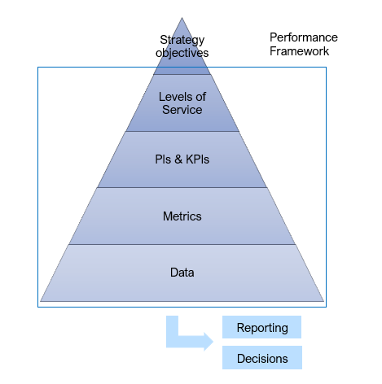
The image shows a five-layer pyramid representing the Performance Framework. The layers become progressively smaller from bottom to top.
From bottom to top, the layers are:
- Data
- Metrics
- PIs and KPIs
- Levels of Service
- Strategy Objectives
A box labelled "Performance Framework" surrounds the lower four layers, from Data up to Levels of Service. The Strategy Objectives layer sits above this box at the top of the pyramid.
Beneath the pyramid, an arrow points from the pyramid towards two boxes labelled "Reporting" and "Decisions", indicating that information from the framework is used to support reporting and decision-making.

Asset Management Lifecycle
Planning
Our Lifecycle planning process will:
- Maximise whole life value
- Maintain assets at the right condition, at the right time
- Support risk-based decision making
- Align with Levels of Service
- Provide a transparent, evidence-based approach to investment planning
- Incorporate environmental and social value into decision making
- Apply a systems view of the network
Lifecycle planning will operate across a range of planning horizons.
- Long-term with a typical timescale of 10-25+ years with the purpose of whole lifecycle modelling.
- Medium-term with a typical timescale of 3-5 years with an investment plan purpose.
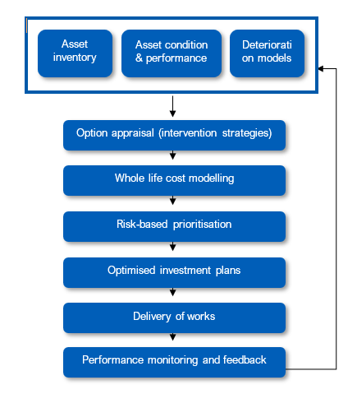
- Short-term with a typical timescale of 0-3 years with the purpose of delivery and operational planning (tactical).

The proposed lifecycle planning process is shown on this page.
- The process initiates from an asset inventory which is regularly updated through inspection and work orders as per asset type care plans. Deterioration models provide forecasting tools to predict intervention points.
- Whole life cost modelling provides a whole life cost view of like-for-like long-term value.
- Risk-based prioritisation then allows a workbank to be constrained based on agreed value metrics. This is explored further on the following page.
- Optimised delivery plans can then be created and delivered.

The diagram shows a continuous asset management proposed lifecycle planning process with seven stages connected by arrows.
The process begins with asset information, including:
- Asset Inventory
- Asset Condition and Performance
- Deterioration Models
This information is used to progress through the following stages:
- Option Appraisal (Intervention Strategies)
- Whole Life Cost Modelling
- Risk-Based Prioritisation
- Optimised Investment Plans
- Delivery of Works
- Performance Monitoring and Feedback
Arrows show the stages progressing in sequence from top to bottom. A final arrow links Performance Monitoring and Feedback back to the asset information stage, forming a continuous improvement cycle in which performance data is used to update future asset management decisions.

Risk-based Prioritisation
Risk based prioritisation is a critical step in the lifecycle planning process. At any one time the Council will maintain an unconstrained workbank detailing all potential schemes which could be undertaken. This will inevitably need to be constrained by funding availability.
Decisions on what interventions to undertake will be done using a risk-based approach. There are 2 broad components of this approach – likelihood and consequence.
A proxy for likelihood is Asset Health. Asset health can be determined from a range of factors including condition, performance i.e. failure rate or number of disruptions, annual maintenance cost, backlog trend, resilience factors, customer satisfaction. Asset health is a more robust metric than condition alone however this can be used in the absence of other metrics.
A proxy for consequence is Criticality. This can be within an asset type i.e an A-road is more critical than an unclassified road and so a similar defect should be prioritised on the A-road first. Certain roads are also part of an active travel or public transport network which further adds to their criticality. Criticality can also be between asset types i.e pavement is more critical than fencing. Criticality is also assessed based on the proximity of an asset to factors such as the Active Travel Network, the Public Transport Network and the Essential Services Network.
Within Criticality, the intent is that measures of value are also included. Through linking schemes to strategic outcomes i.e safety or carbon this will provide a more robust means to prioritise between schemes.
Asset health multiplied by criticality equals risk.
The ambition is to maintain a ‘live’ prioritised unconstrained workbank in an interactive tool such that this can be queried and constrained based on different scenarios. This will enable adaptive, efficient and robust decision making.

Risk & Resilience
A risk can be defined as an uncertain event which influences the desired performance of an asset or the Level of Service provided by the asset base. It consists of a combination of the likelihood of a perceived threat or opportunity and the magnitude of its impact.
The most commonly understood type of risk is safety however there are a variety of other risk types which might arise from highways assets:
- Reputation
- Asset loss or damage
- Service reduction or failure
- Operational
- Environmental
- Financial and contractual
Risk management must influence decisions on:
- Providing different levels of service
- Redistributing funding between asset groups
- Intervention choices i.e. renew vs maintain
- Interventions in the asset management framework

Birmingham City Council’s risk management process should follow ISO33001 (as outlined in the diagram below).
The diagram illustrates a five-stage risk management process.
The main process flows through three sequential stages:
- Establishing Context
- Risk Assessment, including Risk Identification, Analysis and Evaluation
- Risk Treatment
Communication and Consultation is shown alongside these stages and is connected to each by two-way arrows, indicating that communication and consultation take place throughout the process.
Monitoring and Review is also shown alongside the process and is connected to each stage by two-way arrows, indicating that monitoring and review occur continuously throughout the process.
One-way arrows show the progression from Establishing Context to Risk Assessment and from Risk Assessment to Risk Treatment.
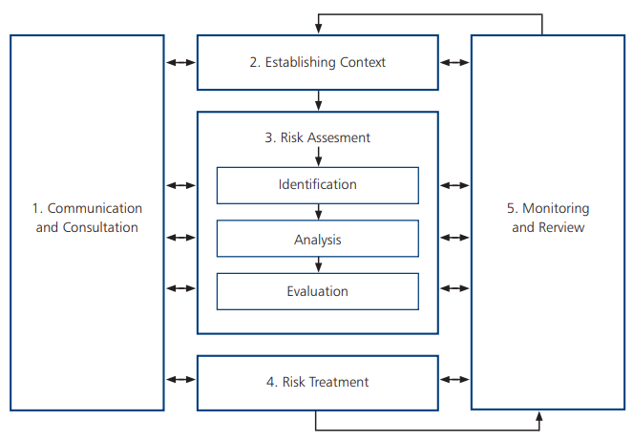

Resilience is the ability of the highways network to anticipate, withstand, adapt to and recover from disruption, including extreme weather and climate-related impacts.
Key resilience risks for Birmingham’s highways network include:
- Flooding and surface water: leading to road closures, damage to assets and safety risks
- Heat stress: leading to accelerated deterioration of key assets including pavement and structures
- Ageing assets: older assets are more vulnerable to failure, particularly in the context of higher traffic loads and urban pressures
These risks can cause increased network disruption which directly impacts economic activity, emergency access and prevents the required Level of Service being delivered for customers.
Strategic priorities are to reduce the vulnerability of assets to climate risks, better maintain service continuity for critical parts of the network and improve recovery times following disruption.
This will be done through:
- Developing a network-wide risk profile for resilience risks
- Considering future climate scenarios within investment planning
- Designing for changing climate risk
- Review and update incident response and recovery processes with the aim of recovering network performance as rapidly as possible post an event.

Data, Systems and Information

High-quality asset information is fundamental to effective highways asset management. Accurate, reliable and accessible data enables Birmingham City Council to make informed, consistent and auditable decisions, supporting investment planning, risk management, service delivery and performance reporting. As the Council transitions to a new highways operating model, a robust asset information and digital strategy will be essential to ensuring that data is treated as a strategic asset and used effectively across the asset management lifecycle.
To support this ambition, the following principles will guide the future management of asset data, systems and information:
Asset Information Strategy & Governance
The Council will develop and maintain an Asset Information Strategy that establishes a clear framework for the management of highways asset data and information. This will define data ownership, governance arrangements, quality standards, audit requirements and management processes, ensuring that asset information is fit for purpose and aligned to business needs.
A formal asset data hierarchy will be established to identify critical datasets, define data specifications and quality requirements, and ensure that information collected is proportionate to the importance of the decisions it supports. This will enable resources to be focused on maintaining the quality of information that has the greatest influence on risk, investment and service outcomes.
Information Management Throughout the Asset Lifecycle
Robust processes will be implemented to ensure that asset information is captured, maintained and transferred consistently throughout the asset lifecycle. This will include clear handover, handback and asset acceptance procedures for capital projects, maintenance activities and supply chain partners, ensuring that asset records remain accurate, complete and up to date following any intervention or change to the network.
Information requirements will be clearly defined within contracts, specifications and project delivery processes, ensuring that new assets, asset changes and maintenance activities are reflected within the Council's asset management systems in a timely and consistent manner.
Enterprise Asset Management System
The Council will maintain a single Enterprise Asset Management platform as the authoritative source of highway asset information and the corporate master asset register. The Enterprise Asset Management solution will support core asset management functions including asset inventory management, condition management, works planning, maintenance management, risk management and performance reporting.
The current Enterprise Asset Management solution, Enterprise Asset Platform, delivered through Brightly, will be periodically reviewed to ensure that it continues to meet the evolving requirements of the highways service and supports the Council's long-term asset management objectives. Future system decisions will consider functionality, integration requirements, user needs, value for money and alignment with industry best practice.
Data-Driven Decision Making
Digital tools and analytical capabilities will be utilised to support evidence-based and risk-based decision making. Asset deterioration modelling, lifecycle planning and investment optimisation tools, whether delivered through integrated modules such as Brightly Predictor or alternative specialist solutions, will be used to improve understanding of future asset performance and investment requirements.
These tools will support the development of long-term investment strategies, enabling the Council to evaluate intervention options, assess risks and optimise whole-life value across the highway asset portfolio.
Geospatial Integration and Network Intelligence
Geographical Information Systems will be used alongside the Enterprise Asset Management platform to provide a spatial view of asset information and support integrated planning and decision making. The combination of asset, condition, performance, environmental and customer data within a geospatial environment will enable enhanced analysis of network risks, investment priorities, maintenance programmes and service delivery activities.
The use of Geographical Information Systems will also support greater visualisation of information, improved stakeholder engagement and more effective coordination of highway activities across the city.
Data Sharing and Collaboration
Effective asset management relies on the sharing of information between the Council, delivery partners, utility companies, contractors and other stakeholders. Appropriate data-sharing agreements, governance arrangements and technical standards will therefore be established to facilitate the secure exchange of information and reduce the risk of data duplication, loss or fragmentation.
This will help create a single source of truth for asset information, improve cross-organisational collaboration and ensure that decisions are based on consistent and reliable data.

Leadership & Culture
It is essential to foster a culture where asset management principles are embedded across all levels of the organisation, and supply chain partners, ensuring consistent, evidence-based decision making that delivers value for money, agreed Levels of Service and long term asset sustainability. Key principles of asset management leadership and culture are set out as follows:
Visible Leadership
The Cabinet member of Transport and the Executive Director for City Operations will actively champion asset management as a strategic and corporate approach to managing infrastructure assets. Leadership commitment will help ensure that asset management principles are consistently applied across policy development, investment planning, service delivery and organisational decision making.
By providing clear direction and promoting the benefits of asset management, leaders will help create a culture that values long-term thinking, evidence-based decision making and continual improvement.
Clear Accountability
Effective asset management requires clearly defined roles, responsibilities and accountabilities throughout the organisation. Responsibilities for asset ownership, performance management, risk management, investment planning and service delivery will be documented and understood by all those involved in managing the highway network.
This clarity will support informed decision making, improve organisational efficiency and ensure that individuals and teams are accountable for delivering agreed asset management outcomes and Levels of Service.

.

Continuous Improvement
Embedding a culture of continuous improvement ensures that asset management processes, performance and outcomes are regularly reviewed, refined and enhanced to maximise value, improve service delivery and respond to changing conditions. A rapidly evolving technology and innovation landscape is providing increasing opportunities for continuous improvement.
Key principles to inform Birmingham City Council’s continuous improvement of highways asset management:
- Evidence led: Improvements should be driven by data, trends and benchmarking
- Outcome focused: Improvement initiative should be aligned to asset management objectives and LoS
- Systematic and governed: There should be structured processes for identifying haps, implementing change and tracking outcomes
The Plan-Do-Check-Act model provides a structured, repeatable loop that ensures performance is not only monitored, but actively improved over time.
Below shows an image with 4 arrows curved in a circle formal a continuous loop that shows the plan, do, check, act structure. The top right shows a red arrow labelled ‘Plan’, moving clockwise the next section in the bottom right is orange labelled ‘Do’, continuing to the bottom left is a green arrow labelled ‘Check’, the final section at the top-left is a blue arrow ‘Act’ which loops back to ‘Plan’. Together the four arrows form a complete circle with an empty space in the centre.



Stakeholder Engagement &
Reporting
Effective stakeholder engagement and transparent reporting are essential to delivering a customer-focused, accountable and evidence-led service.
- Asset management needs to be informed by the needs of a wide range of stakeholders including:
- Residents and communities
- Road users
- Businesses and freight operators
- Elected members
- Regional authorities i.e WMCA/TfWM
- Central Government
- Emergency services
- Utility companies and delivery partners
Engagement with these stakeholders will inform the asset management approach and a stakeholder engagement plan should be developed to document the tailored engagement approach for each stakeholder including reporting requirements. A key principle of the engagement plan is to prioritise proactive engagement through providing early insight of planned works and investment priorities as well as open and transparent reporting on delivery performance.
Reporting should be enabled by the performance framework with regular updates on agreed Performance Indicators.

Strategy Implementation, Review
and Update
This strategy provides the vision for highways asset management. Following acceptance, the anticipated next step are as follows:
- Confirm as-is baseline position
- Develop a high-level roadmap to build enterprise capability as outlined in the Asset Management Framework
- Create a suite of asset management plans for the next 1-2 years, aligned to the overall roadmap
- Continue to update asset specific work plans on the current (annual) cycle with a view these enhance and improve as asset management capability develops.
Strategy and plan review timeline per document:
Asset Management Strategy
- Typical Frequency: 3-5years
- Trigger: Major policy, funding or external driver changes

Asset Management Plans
- Typical Frequency: Every 1-2years
- Trigger: Performance review, funding, progress against roadmap

Asset specific plans and work programmes
- Typical Frequency: Annual
- Trigger: New data, modelling updates, new processes

