
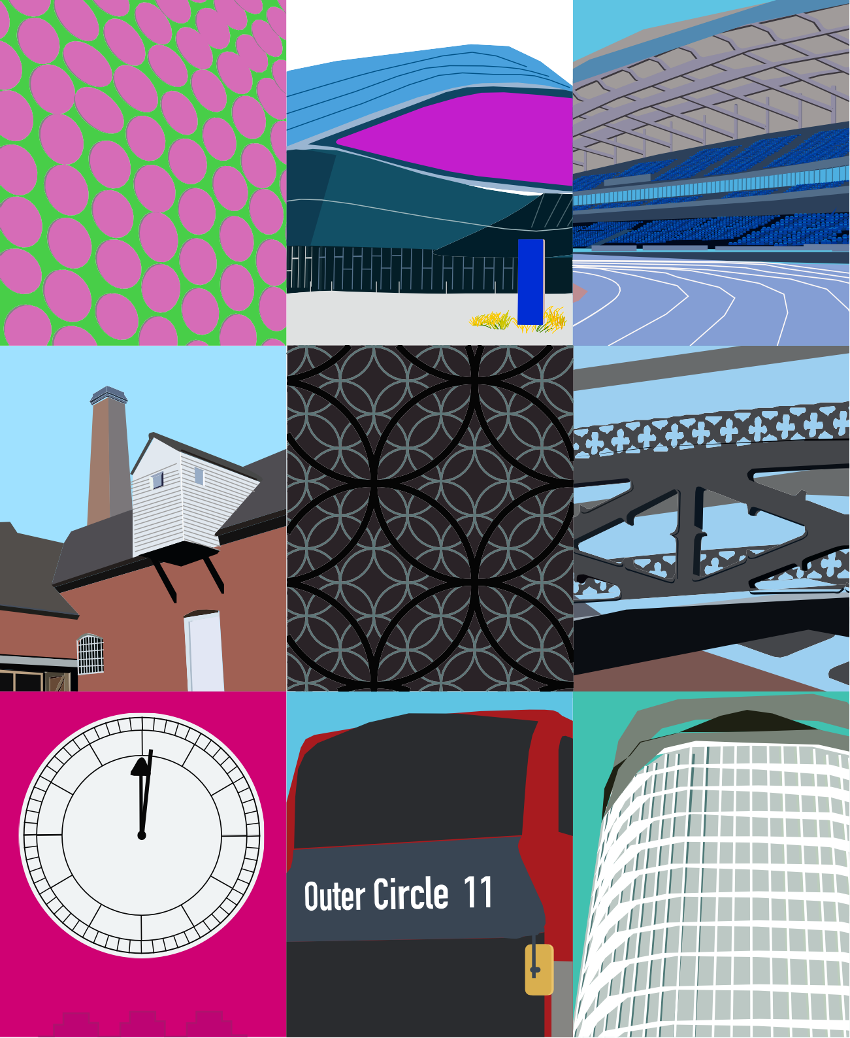



SHAPING BIRMINGHAM’S FUTURE TOGETHER
FOR 2035






Placed like the main attraction, the middle of everything It’s so appropriate that we sit in the centre of the land

A place that so many can reach but few can understand

You have to really breathe it in, walk amongst these people In this so called second city,

we are more than just a sequel Original in every way the light

that never fades

Casey Bailey, Birmingham Poet Laureate

2020 - 2022

2


CONTENTS
Foreword (Chair of Shaping Birmingham’s Future Together) 5
- Understanding our history 7
- Developing a vision for the city in a new way 9
- Birmingham is a city of opportunity and challenges 11
- Shaping Birmingham’s Future Together – what we heard 19
- A Vision and Five Strategic Missions for Birmingham 21
- The Birmingham Promise 26
- How we will Deliver and Measure Progress 31

3 Aston Hall

















New Street Station, City Centre
Selfridges, City Centre
Shard End Library
Douglas Road, Handsworth
4

FOREWORD

Birmingham is our city.

We live here, work here and learn here.

We share a deep pride in our growing and ever-changing city.

But we also know that our city has challenges.

For too long, the Birmingham story has been a Tale of Two Cities: a booming city centre with cranes dotting the skyline, in stark contrast to
neighbourhoods with high levels of poverty and unemployment just a stone’s throw away. That inequality must end if Birmingham is to become a city that truly works for everyone, from every community and neighbourhood.
That’s why we feel it’s important to have shared ambitions for Birmingham, which both address our challenges and harness our incredible collective potential. Through our work on Shaping Birmingham’s Future Together, we have created a shared vision for Birmingham, which draws from our rich history and maps out a bright future.
“Our vision for Birmingham is a city that has a thriving economy, tackles inequality, where all communities can enjoy greater opportunities and the wellbeing that brings”.
As a city that has one of the youngest populations in Europe and is also one of the most diverse, by 2035 we aim to be the best city in Europe
for young people, and a world-leading Anti-Racist City.”
To get there, we must work together, leading collaboratively and courageously to realise the full potential of our city.
A city which really is second to none. Councillor John Cotton,
Chair of Shaping Birmingham’s
Future Together

5
Acknowledgement
Shaping Birmingham’s Future Together for 2035 was only made possible through the goodwill and valuable contributions of so many people across the city who helped support this initiative, and through whose efforts have led to the creation of a new vision for Birmingham.



Thank you to everyone for all their help, brilliant participation, and generosity of time.






“We were once the City of a Thousand Trades, we are now the City of a Thousand Entrepreneurs.”

Cadbury Factory, Bournville

UNDERSTANDING OUR HISTORY

Birmingham was known as the “City of a Thousand Trades”, what has emerged is a young, diverse, entrepreneurial and bold city.

Birmingham started as a workshop full of small, highly skilled firms producing a huge range of products. As a result, levels of enterprise were high and unemployment was low, and in the first half of the 20th century, the city saw huge numbers of new jobs created. It also became specialised in manufacturing motor vehicles but was hit hard by the decline of this industry in the 70s and 80s.

Birmingham’s strong social conscience roots back into its history with the radical work done by Joseph Chamberlain as Mayor in the late19th century to disrupt the system to tackle inequality. This was followed by the leadership of business with the Cadbury brothers, and the legacy they left through the Cadbury Foundation and Barrow
Cadbury Trust. They both embraced disruption to drive meaningful change.

Our city also has a rich tradition of welcoming and embracing difference, a legacy that has shaped its identity as one of the UK’s most diverse and multicultural cities. From the arrival of the Irish in the 19th century seeking work, to
the Windrush generation from the Caribbean who helped rebuild post-war Britain, Birmingham has
always opened its doors to those in need.
The city’s diversity expanded with the migration of South Asians, Africans, and Eastern Europeans throughout the 20th century and into the
21st Century.

This reflection on our history matters.

Our history of welcoming difference has ultimately led to Birmingham becoming a City of Sanctuary, welcoming those refugees fleeing conflict. Today, Birmingham is a proud global majority city.

We have a history and DNA of being bold in tackling inequality, and we will channel that spirit in this City Vision and our ambitions for a Birmingham in which that tale of two cities doesn’t continue.

While we are no longer a “City of a Thousand Trades” we are now a “City of a Thousand Entrepreneurs “. Birmingham boasts several enterprise zones and has been voted the UK’s most entrepreneurial region by Start Up Britain. This bustling entrepreneurship can be seen from the famous Ladypool Road to the STEAMhouse in the city centre.
Birmingham’s history and DNA are rooted in these three things:

- Fostering economic success,
- Being disruptive in tackling inequality, and
- Embracing difference and inclusion.


It’s through understanding our history that this vision for Birmingham will build on these three foundations for our successful future.

Jewellery Quarter Clock
7



Spitfire Island, Erdington

DEVELOPING A VISION FOR THE CITY IN A NEW WAY

Our vision for Birmingham is a city that has a thriving economy, tackles inequality, where all communities can enjoy greater opportunities and the wellbeing that brings.

This is a ten-year vision for the city. It sets out priorities for the whole city which draws on Birmingham’s history and reflects our current context, opportunities and biggest challenges.

As a key convening force in the city, Birmingham City Council have stewardship of the city vision. However, this is not a document or vision that just belongs to Birmingham City Council, it’s a vision that belongs to everyone in the city. Partners from the public, private, voluntary and community organisations, and all communities and citizens working together can achieve our shared aims.

This vision is intended for use as a strategic planning framework for all the city partners. Birmingham City Council will use it to shape its own Corporate Plan and other strategies, other organisations operating in the city are encouraged to do the same.
In that spirit of partnership, partners
and residents have collaborated to develop this vision through the Shaping Birmingham’s Future Together initiative.

Shaping Birmingham’s Future Together (SBFT) was announced by the Leader of Birmingham City Council in March 2024. SBFT brought together partners from the public, private, education, and the voluntary and community sectors throughout the summer of 2024 to inform this city vision.

In addition to these meetings, over 30
face-to-face consultations were held at venues across the city, and eight online sessions
were also held. The sessions were hosted by community organisations including those from Erdington, Bartley Green and Handsworth. They included three ward forums in Stirchley, Small Heath, Sparkbrook and six of the city’s nearly three hundred Warm Welcome spaces, including Nechells and Sutton Coldfield. An e-survey
was hosted online through the summer to capture a wide range of citizen perspectives, and in total, we received over 1,500 responses.

9
The feedback is reflected in this vision and its priorities. However, this document also reflects a wide range of views on how organisations should work together in a new way so that partners and citizens can increase their power to do good together. The vision and priorities are

also informed by existing city and partner strategies, plus data and analysis from the Birmingham City Observatory.

Ozzy














11

New Street Station, City Centre

- BIRMINGHAM IS A CITY OF OPPORTUNITY…

Birmingham is a city of scale. It is a growing city of 1.15 million citizens, and it is the country’s second-largest city economy.

Over the last 15 years, Birmingham has attracted record levels of investment due to its welcoming and enterprising nature. Our population has grown and with this has come new homes, jobs, businesses and opportunities, especially in the city centre.
The city is made up of 69 wards and 10 parliamentary constituencies. Outside of the city centre, there are more than 70 urban centres which are hubs for our communities, providing access to jobs, public services, culture and religious services, transport, and other services.
There are 1,166,000 people living in Birmingham, according to 2023 population estimates,
an increase of 8.5% (91,800) since 2011.
The population is projected to continue growing to 1,186,000 (up 3.9%) by 2028. Our city is superdiverse - more than half the population (51.4%) identify as ‘Black, Asian, Minority Ethnic’.

- A city of warm and welcoming communities:
Birmingham is a place where people can make a good life. We are a City of Sanctuary –where a broad range of local organizations, community groups and faith communities, as well as individuals, are publicly committed to welcoming and including people seeking sanctuary.
- Youthful and diverse: Birmingham has one of the country’s most diverse and youthful populations in Europe, with a proud history

and culture. We are a city of many communities, many of which have their own distinct identity, culture and community spirit. Nearly half of our population is under 30 years of age. We have outstanding international links and host tens of thousands of international students.

- A city with outstanding national and international transport connectivity: Birmingham is centrally located city in England, already within 90 minutes of both London and Manchester by train, at the heart of the major road network and with its own international airport.

- Environment and green spaces: the city
has a wide range of parks, gardens and green spaces, many historic buildings and canals, and attractive, varied neighbourhoods.
- Strong educational Institutions: the city is home to many world-class further and higher educational institutions contributing to the workforce and reputation of the city.

11


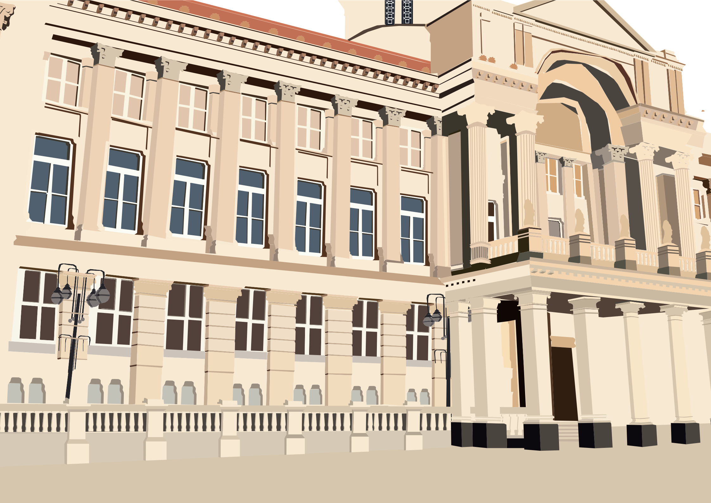


Birmingham Council House, City Centre
12

  - A regionally, nationally and globally important economy: the size and scale of
the Birmingham economy make it the region’s economic leader, vital to the UK economy, and globally significant. A range of global companies are located here and have
a stake in the success of our city.

  - Economic diversity: the city has concentrations of firms in advanced manufacturing, financial services, and technology which are vital to the wider regional and national economy.

  - Thriving Creative Industries: Birmingham and the wider West Midlands region boast a thriving creative cluster. Investing in these
sectors revitalises local areas and enhances the city’s reputation. The government’s Creative Industries Section Vision to 2030 aims to create a million new creative jobs and add £50 billion to the economy, positioning Birmingham at the forefront of this transformation is an important priority for the city.
- A wide range of cultural and sporting wealth: We have a diverse range of roles and people engaged in a thriving cultural sector. We also have assets such as the largest regional library and public cultural space in Europe – the Library of Birmingham – and a world class arts, dance, music, food and cultural offer. We have world-class sporting venues and we are a world class events location.

- A range of specific growth opportunities: for example: Life Sciences at the Birmingham Health Innovation Campus; The Birmingham Innovation Quarter; smart manufacturing at the Tyseley Environmental Enterprise District.

13
13



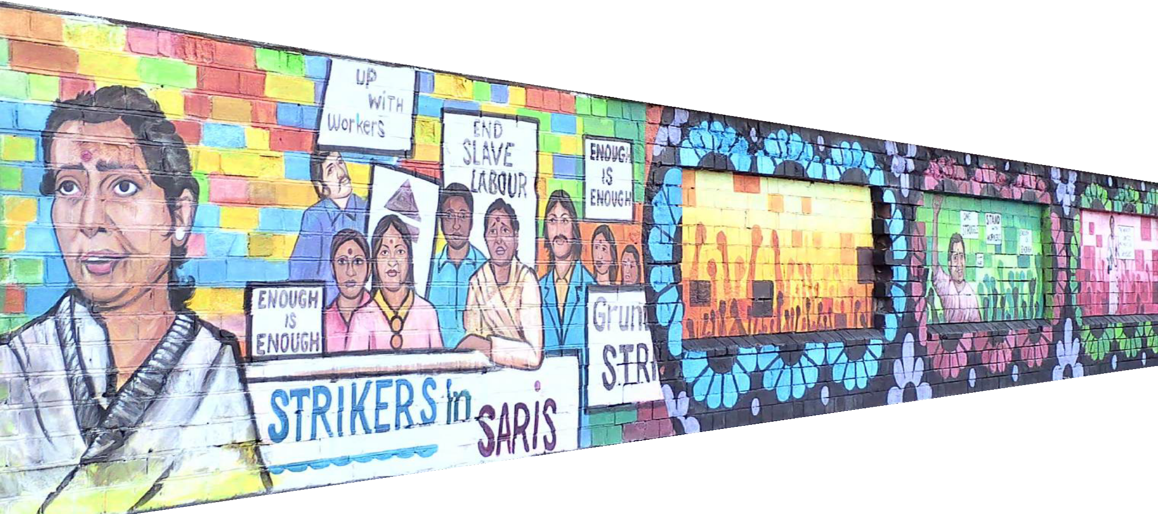
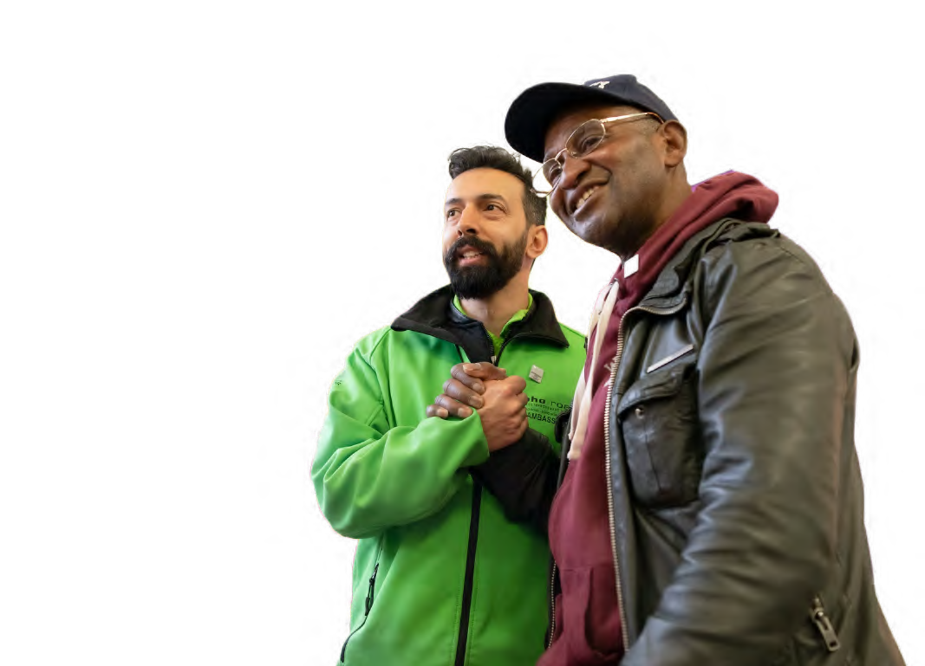

Soho Road Handsworth

…AND CHALLENGES

OUR ECONOMY: In 2022, the average gross value added (GVA) per worker in the Birmingham city region stood at £52,848, above that of smaller cities such as Nottingham, Sheffield and Newcastle but below Greater Manchester, Leeds, Bristol, Cardiff, Liverpool and Glasgow.
Also, Birmingham suffers from exceptionally high rates of unemployment and low levels of employment. This is particularly the case for young people, where the youth unemployment claimant rate in Birmingham is double that of the UK (as of April 2024). If Birmingham’s employment rate came up to the national average, there would be approximately 70,000 more people working and earning in the city.
OUR SKILLS: Average educational outcomes from Birmingham’s schools are better than the national average. However, Birmingham has a higher share of the population with no formal qualifications and a lower share with a degree- level qualification than any other large UK city. The skills of Birmingham residents are not well matched to employer demand, making it harder for people to get jobs and for businesses to find employees.
CHILD POVERTY: Nearly half of our city’s children are living in poverty, which is life-altering and, in some cases, life-threatening. In the most deprived neighbourhoods, three out of four children are affected, leading to shorter life expectancies and increased mortality rates.
OUR HOUSING: Birmingham is experiencing an acute housing crisis, reflected in a lack of truly affordable housing that is accessible to those who need it most, overcrowding and
poor-quality housing stock. Fewer young people in Birmingham own their own home than the national average and there is a higher proportion of young people renting in Birmingham.
Overcrowding is a very serious issue; Birmingham has the highest level of overcrowding in all the core cities in England and Wales, with one in
ten households (9.4%; 39,625) having fewer bedrooms than they need.
OUR HEALTH: Birmingham has worse outcomes across many health indicators than England.
Across the city, there are unacceptable differences in health outcomes which lead to differences in life expectancy. Birmingham’s infant mortality rate is nearly twice the national average (under 1 year of age) at 7.2 per 1,000 live births, compared to 3.7 per 1,000 for England.
Birmingham’s average life expectancy over 65 for females is 20.7 years and for males it is 17.7 years, both of which are lower than the England averages (21.2 years for females and 18.8 years for males). Many deaths are due to preventable conditions like heart disease and type 2 diabetes. Poor health, and the need to provide care for others, are key causes of worklessness in the city.
OUR TRANSPORT: Whilst the city is well connected to the rest of the UK, the current transport infrastructure within the city does not meet the needs of our citizens. A more effective
transport network within the city is urgently needed to sustain inclusive economic growth, create new jobs and support and empower our communities. Safe, reliable, clean public
transport is also vital to help reduce the negative impacts of transport on our environment and contribute to decarbonisation.
OUR ENVIRONMENT: The climate emergency underpins the inclusive economic, social and environmental objectives for the city. Air pollution in Birmingham has fallen since the introduction
of the Clean Air Zone, and there has been rapid growth in the number of ultra-low emission vehicles. However, too many of our journey are still in private vehicles burning fossil fuels, and we have the highest incidence of fuel poverty of the core cities – with one in four households in
the city in fuel poverty (24% in 2022)- reflecting a poor-quality housing stock that is also
carbon-inefficient.
CRIME: Birmingham faces significant challenges with concentrations of both property and violent crimes, particularly in areas of high deprivation. This correlation between crime and deprivation affects the entire city, negatively impacting residents’ health and wellbeing. Beyond the direct health effects of being a victim of violent crime, the fear of crime also has damaging effects on health. Protecting young people is crucial, especially in safeguarding children from various forms of harm such as physical, emotional, and sexual abuse, as well as neglect and exploitation.

15



Queen Elizabeth Hospital, Edgbaston

A PICTURE OF INEQUALITY IN BIRMINGHAM

The graphic below shows
Life Expectancy at Birth (Males): 2016 to 2020
Life Expectancy at Birth (females): 2016 to 2020
Early Years Foundation Stage Profile - 2023 Good Level Development

















how the experience of growing up,

INFANCY & PRE-SCHOOL
Males
in Sutton Four Oaks

83.2
years.
Males in Castle Vale & Nechells

72.3
years.
Females in Sutton Roughley

85.9
years.
Females in Frankley Great Park

years.
77.7
Sutton Mere Green:

84.3%
Shard End:

51.1%

working, and growing old can be very different for
10.9 years difference

Percentage achieving expected standard in Reading,
Writing and Maths (Key Stage 2) – 2023
8.2 year difference

Attainment 8
(Key Stage 4 attainment) – 2023
33.2% pt. difference

Not in Employment Education or Training (as a proportion of total NEETs in Birmingham) (Year 12 and Year 13,
aged 16 to 18) – May 2024

citizens in different parts of our city.

SCHOOL YEARS
Sutton Wylde Green:

79.3%

Holyhead:

43.7%
Hall Green South:

59.4
Castle Vale:

36.6
Glebe Farm & Tile Cross:

4.6%
14 Wards with fewer than
10 NEETs

35.6% pt. difference
22.8% pt. difference
4.6% pt difference

Unemployment claimants
aged 18 to 24 (September 2024)

Unemployment claimants
aged 16 to 64 - (September 2024)
Percentage of Universal Credit recipients as a proportion of eligible population
(18-65) (September 2024)

WORKING

LIFE
Handsworth

22.9%
Bournbrook & Selly Park:

1.2%
Lozells:

23.8%
Sutton Four Oaks:

1.7%
Tyseley & Hay Mills

48.4%
Sutton Four Oaks

6.2%

21.7% pt. difference
22.1% pt. difference
42.4% pt difference

Life expectancy at 65 years Males
Life expectancy at 65 years Females

OLD AGE
Sutton Four Oaks

21.9
Years
Castle Vale

14.4
Years
Sutton Four Oaks

25.1
Years
Castle Vale

16.8
Years

England (all ages):

5.2%.

Birmingham (aged 65+):

17.4%

7.5 years difference
8.3 years difference
12.2% pt difference

17

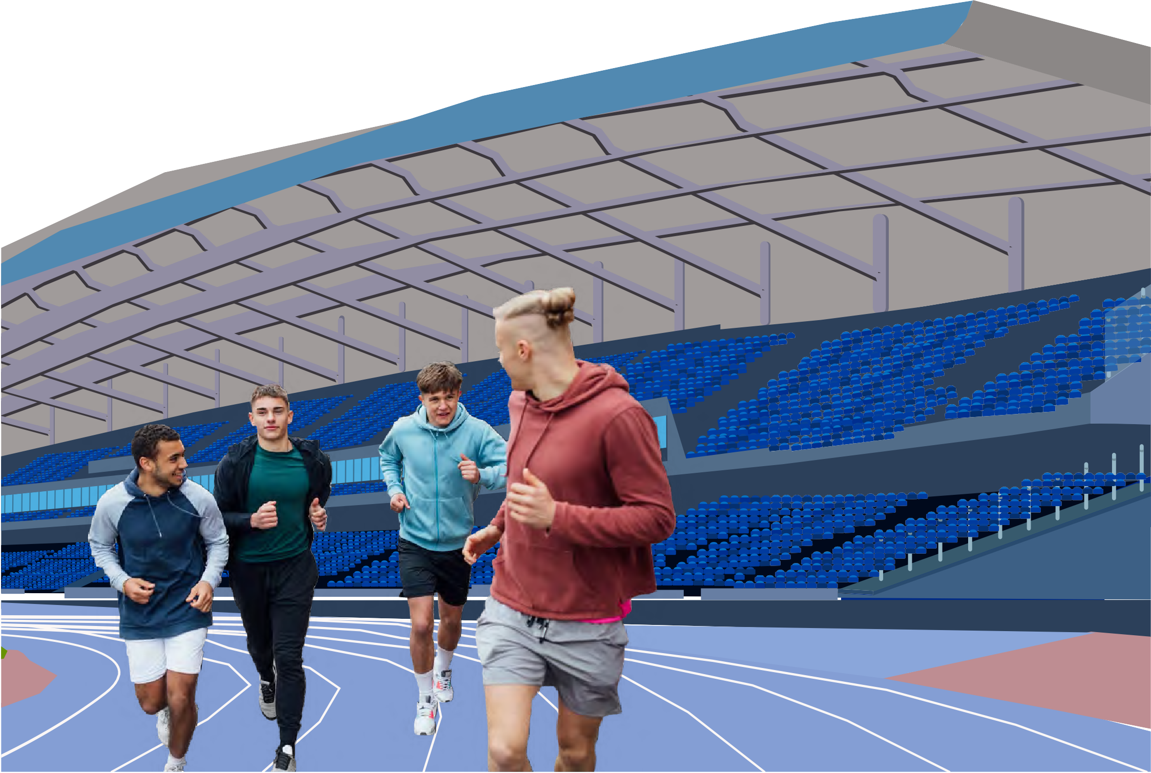
Alexander Stadium, Perry Barr

SHAPING BIRMINGHAM’S FUTURE TOGETHER – WHAT WE HEARD

Engagement with partners and citizens over the summer of 2024 has deepened our understanding of shared priorities and how to work together.

The following policy areas were widely recognised as key to improving lives across the city. The need to tackle inequalities in these areas was a consistent message, as was focusing on
the needs of young people in particular.

  - Housing: Access to safe and affordable housing.
  - Skills: Access to skills development, relevant to the current labour market.
  - Transport: Access to reliable, safe, clean, public transport.
  - Inclusive Economy: An economy which citizens
can participate in and benefit from.
  - Environment: A healthy, clean environment.
  - Health & Wellbeing: Access to good quality health and wellbeing services.
There were also important cross-cutting themes about how we should work together to tackle our challenges:

- Put citizens first in everything we do and
change how we work to meet their needs.
- Create opportunities to listen to and involve citizens and communities in the
design, delivery, and evaluation of services.
- Seek out and listen to those most affected by inequalities, then put them at the heart of designing solutions.
- Build trust by doing what we say and promote participation and community power in everything we do.
- Build on what works and support local organisations that are making a difference.
- Maintain long-term thinking despite short- term pressures,and seize opportunities
for change.
- Work together as a city and have pride in who we are and belief in what we can achieve.
We have also referred to a wide range of supporting plans and strategies from across the city partnership, including:

  - Our Future City Plan
  - Birmingham City of Nature Plan
  - Birmingham Creating a
Bolder Healthier City 2022-2030
  - The Integrated Health Partnership Strategy – A Bolder, Healthier Future for the People of Birmingham and Solihull
  - Housing Strategy (2023-2028)

Maintaining a shared understanding of how our city is developing in these priority areas is important to help test and refine the
City Vision so that it becomes a useful living document for our partnership.

19

I I

- - -
-
-
-
-- -- --
-- .-.-
-- -- --
--
--
--
-- -- --

--
I-■I
.-.-
■■-

II





Edgbaston Cricket Ground ■

A VISION AND FIVE STRATEGIC MISSIONS FOR BIRMINGHAM

Our vision for Birmingham is a city that has a thriving economy, tackles inequality, where all communities can enjoy greater opportunities and the wellbeing that brings.

By 2035 we want Birmingham to be the best city in Europe for young people, and a world-leading Anti-Racist City in recognition of

its youth and diversity.
Birmingham is a healthy, sustainable city that is proud of its diversity, culture and history, and unrelenting in tackling all forms of inequality.
Birmingham maintains its status as the UK’s leading City of Entreneurship, unleashing the power of its young people, building and

SAFETY & SUSTAINABILITY IN BIRMINGHAM
CONNECTED BIRMINGHAM

TACKLING INEQUALITY IN BIRMINGHAM

GROWTH & PROSPERITY
IN BIRMINGHAM

KNOWLEDGE & OPPORTUNITY IN BIRMINGHAM

maintaining a thriving economy in which all Brummies can share its success.

To achieve this, we must work differently and work together to tackle our biggest challenges, to rebuild our city’s capacity to drive change but also to seize our greatest opportunities.
HEALTH, EQUALITY & INCLUSION
IN BIRMINGHAM

We have identified five long-term missions to help deliver this Vision along with measures for our success, but these priorities need to be delivered in a way that tackles various
forms of inequality affecting our city.


Partners across the city also need to work together to focus on early intervention and prevention to support citizens to
maximise their potential.

21

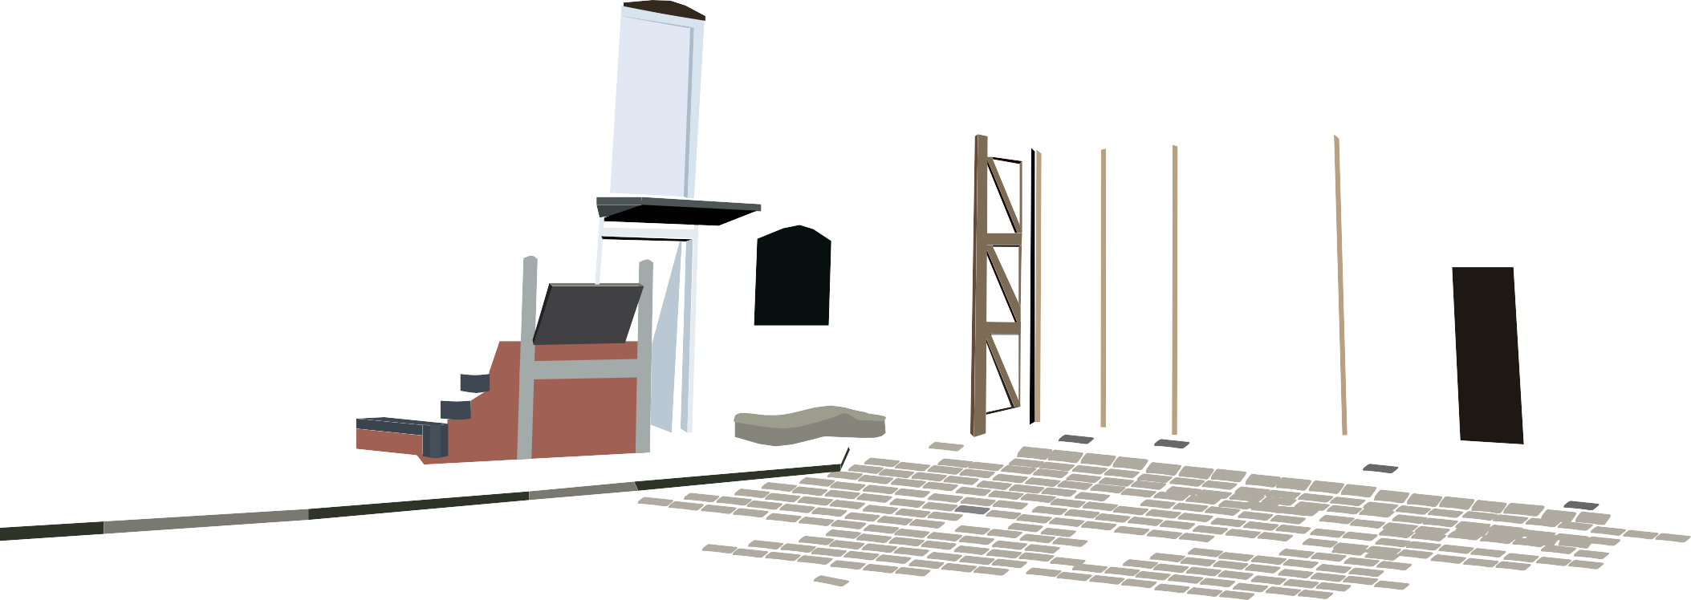

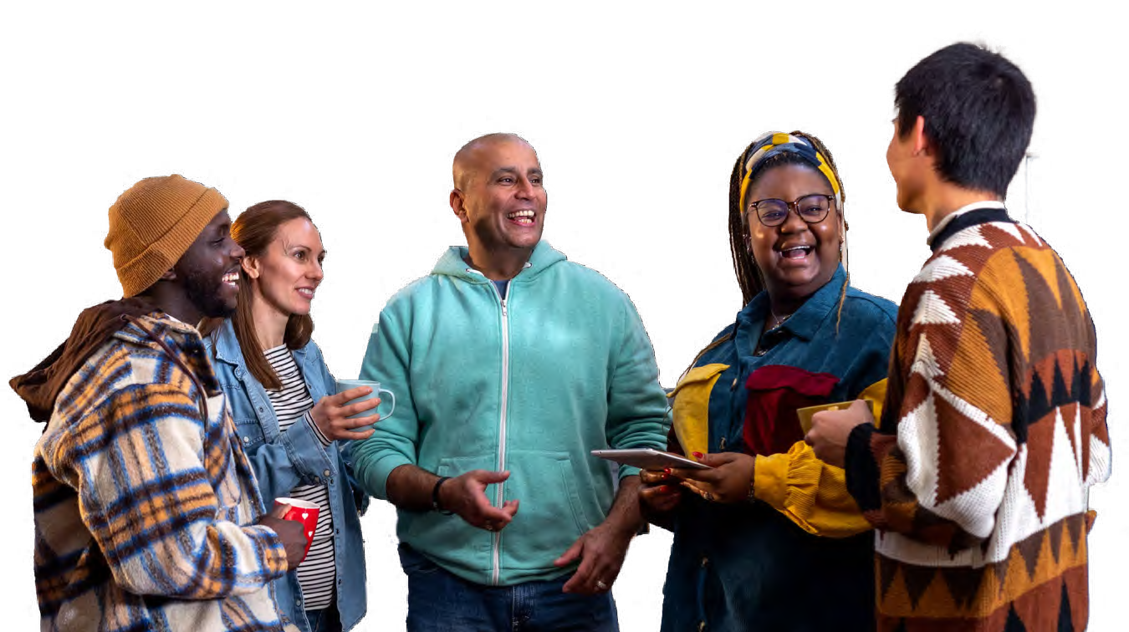

Sarehole Mill Hall Green
22

Growth and Prosperity in Birmingham
- In Birmingham, investment and development that addresses inequality and spreads beyond the city centre, creates inclusive economic growth, increased productivity and employment opportunities for the whole city.
- Birmingham maximises the growth and employment potential for our citizens in growth sectors, including the creative and cultural economy.
- Birmingham builds on our strengths of entrepreneurship, diversity and a thriving arts & cultural scene to make the city a more prosperous city of choice for people and businesses, where more wealth is retained
in local communities.
How we will measure:
- Reduce unemployment rates and increase employment rates in Birmingham relative to the national average.
- Increase Gross Value Added per hour worked in Birmingham.
- Increase the level and benefit from inward investment in the city.
- Increase the amount of land delivering high levels of economic activity and diversifying the economy across the city.
- Reduce the gap between the wages of those living in Birmingham and the wages of those working in the city.
- Reduce inequalities in the income levels between places and groups in the city.

Knowledge & Opportunity in Birmingham
- Birmingham ensures our schools, colleges and universities work in partnership with communities and businesses, to help our young people achieve their academic and personal potential, so they can take full advantage of the opportunities of the future.

- In Birmingham, companies, skills providers and communities work together to ensure jobs are safe, pay the living wage, and provide appropriate training opportunities across the city, so more people get good jobs, and are supported to stay in the city.
- In Birmingham organisations operating in the city deliver social value for our communities, in particular maximising employment and skills for young people.
How we will measure:
- Reduce the youth unemployment rate and increase the youth employment rate relative to the rest of the UK.
- Increase educational attainment across Birmingham.
- Reduce the number of people without qualifications.
- Increase the graduate retention rate in the city.

23





Ladypool Road in Sparkbrook/ Balsall Heath.

Safety and Sustainability in Birmingham
  - Birmingham tackles the housing crisis and increases the number of decent, affordable, and energy-efficient homes that meet resident needs, including by increasing the proportion of genuinely affordable new homes. We support responsible landlord behaviour,
so fewer people suffer from bad housing, overcrowding and homelessness.
  - In Birmingham, we will work together to keep our citizens safe from harm.
  - In Birmingham, we increase the safety and cleanliness of our streets and the quality of our environment: driving up recycling rates, reducing carbon emissions, and improving access to a high-quality natural environment.
How we will measure:
  - Increase the proportion of affordable new homes delivered in the city as a share of all new homes.
  - Reduce the house price affordability ratio
  - Strengthen community cohesion and reduce crime across the city.
  - Increase the liveability of neighbourhoods so citizens have more access to outdoor spaces and amenities.
  - Increase the cleanliness of our streets.
  - Improve air quality across the city.
  - Reduce carbon emissions towards becoming a net zero city.
  - Number of victims of violent crimes.
  - Number of domestic abuse crimes.

Health, Equity & Inclusion in Birmingham
- In Birmingham, we work together to improve the life expectancy of our citizens and close the gap in life expectancy between the least and most deprived, and between different ethnic groups, by tackling the main causes of poor health and by creating a healthier environment.
- Birmingham is an inclusive city that actively involves and collaborates with all communities and celebrates our diversity.
- In Birmingham, we understand the scale of race disparity in our city through the Birmingham Race Disparity Overview and
develop service-level measures with partners across the city to define how we will become a world-leading Anti-Racist City.
How we will measure:
- Increase life expectancy at birth and at 65, increase healthy life expectancy, and reduce gaps between the least and most deprived, and between different ethnic groups.
- Reduce the overall poverty rate in Birmingham.
- Reduce systemic racial disparity in Birmingham.
- Reduce the child poverty rate and reduce childhood obesity.
- Reduce food injustice and increase access to affordable, safe and healthy food.
- Reduce the number of homeless children living in temporary accommodation in Birmingham.
- Reduce Childhood mortality.
- Increase the uptake of eligible children claiming Free School Meals.
25

Connected Birmingham
- Working with West Midlands Combined Authority, transport connectivity within the city and region will improve so that more people can access the opportunities of the city by affordable, accessible and sustainable methods of transport.
- Birmingham is improving digital connectivity and inclusion, working with providers to increase access to fast connections, and tackling data poverty to increase opportunities for citizens to access services and support that meets their needs.
How we will measure:
- Increase the proportion of residents who have reasonable access to work, learning and key services by affordable and sustainable methods of transport.
- Improve quality, safety, and reliability of public transport across the city, in particular making it easier for people to travel in and out of the city centre.
- Reduce the number of people who are unable to access fast and affordable internet services across Birmingham and reduce gaps in access between different communities.





THE BIRMINGHAM PROMISE




THE BIRMINGHAM PROMISE

Organisations in the city must work together for the good of our citizens. Only through effective partnership working can we meet the scale of challenge and opportunity in the city.

This means organisations in Birmingham strengthen partnership working, both
with each other and with citizens in a collaborative way which recognises the value of our different roles and perspectives.

There are already lots of brilliant examples of partnership working across the city. The Birmingham Promise has been developed
to help organisations working in the city achieve this more consistently.
The engagement for the production of this city vision identified a set of key behaviours that exemplify effective partnership working in the city. These are summarised below:









DO WHAT WE SAY WE WILL DO.
Be a reliable, visible, honest partner.

PLAY DIFFERENT ROLES IN PARTNERSHIP WORKING.
Understand when to convene and when to lead.

BE HONEST ABOUT OUR CONSTRAINTS.
These can be budgetary, regulatory, or relate to
statutory duties

WE AND PARTNERS NEED TO CHALLENGE EACH OTHER.
Be more radically creative, use disruptive thinking and action as we work together
on common problems.

HOLD EACH OTHER TO ACCOUNT TO DELIVER IMPACT FOR CITIZENS.
Be brave and honest when doing this.

These behaviours have been used to develop the new Birmingham Promise.

27




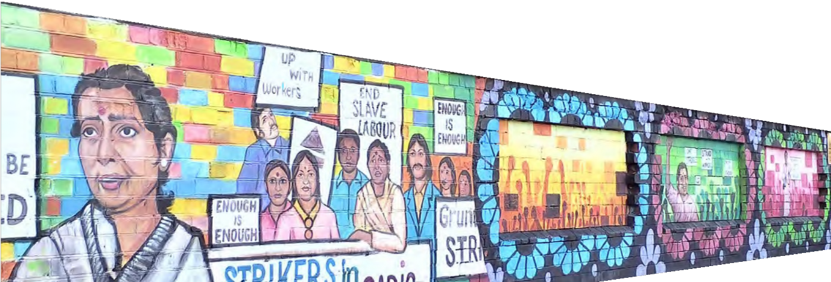


What is the Birmingham Promise?
“The leading idea of the English system of municipal government might be that of a joint-stock or co-operative enterprise in which every citizen is a shareholder and
of which the dividends are received in the improved health and the increase in the comfort and happiness of
the community.”

Joseph Chamberlain
It’s exactly that, a promise.

A promise made by the organisations that work in Birmingham (including the city council) to its citizens and each other. It is also a promise that citizens make to each other.

The Birmingham Promise is about establishing a new civic relationship in the city, based on recognising individual and joint responsibilities, and the role we all must play in helping to make our city and our lives the best they can possibly be. It’s also about increasing a sense of accountability through the visible commitments we make here.

It’s about how we can all help deliver our vision for Birmingham together through making
this promise.

Birmingham has a history of non-conformism and radical reform to meet the challenges the city faces.

The Birmingham Promise lies within this tradition, it is a recognition that we all have a stake in the city’s future.

And that we all need to promise to play our part.

THE BIRMINGHAM PROMISE

THE COMMITMENT FROM ORGANISATIONS IN BIRMINGHAM:
1

Be a reliable, visible partner, true to our word. Explain what we can and cannot do.
2

Ensure everything we deliver is of the highest standards and for the benefit of local people.

THE ASK OF CITIZENS OF BIRMINGHAM:

Communicate with us: get in touch, tell us what is working and what is not working.
1



Commit to tackling inequality and publish data on the extent to which what we do is helping to close the gap.
3
4

Put Brummies at the heart of what we do, co-producing solutions and working in true partnership with organisations and citizens.
5

Listen to the people of Birmingham, act on what they say and be held accountable.

Share your pride

in your neighbourhood.
2

Commit to improving

your patch of Birmingham.
3

Celebrate our city. Shout about what we’re great at, and what’s

great about Birmingham.










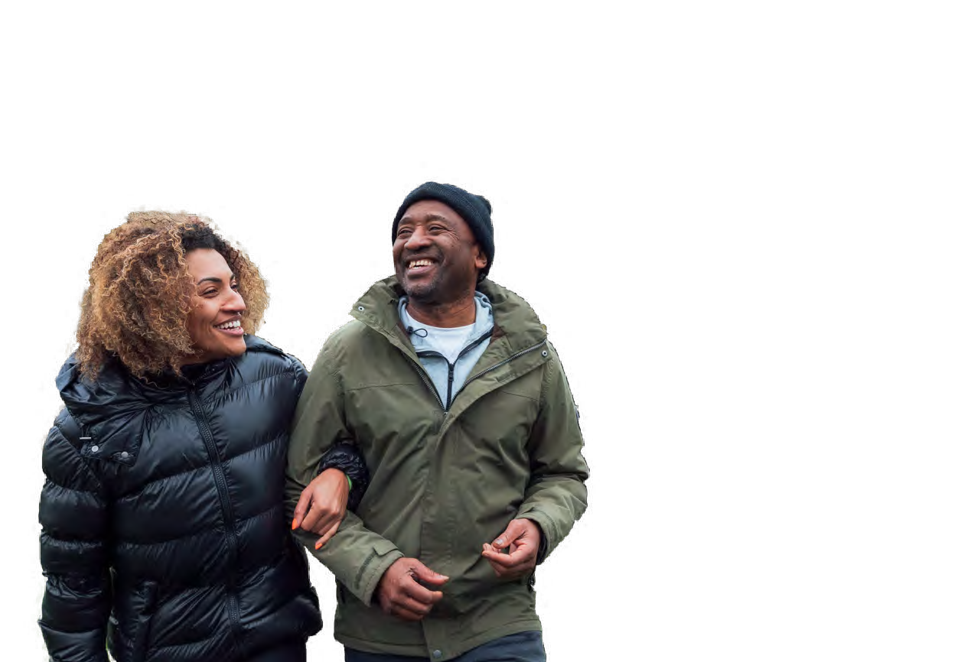


30

HOW WE WILL DELIVER AND MEASURE PROGRESS

This vision cannot be delivered by any one organisation alone, it needs to be delivered through a range of partnership structures and a new understanding of true partnership working.

Birmingham City Council is committed to this city vision and will use the Birmingham City Vision to frame and shape the content of our Corporate Plan and other plans and strategies. We encourage other organisations across the city to do the same and set out how they will contribute to achieving and delivering
this vision.

To support the Birmingham City Vision and deliver the missions, Birmingham City Council commits to the following:

- Birmingham City Council has stewardship of the city vision and will convene partners to ensure this vision remains relevant to the challenges and opportunities in our city.

- Birmingham City Council will promote the Birmingham Promise and encourage
organisations and citizen groups to sign up to the Birmingham Promise. Birmingham City Council will also publicise actions and outcomes resulting from the
Birmingham Promise.
- Birmingham City Council will work with partners to develop a stronger partnership relationship. We will establish city missions for each of the five priorities in the City Vision, developing a shared understanding of the collective action we can and will take to deliver the city vision. This will include special cross-cutting commissions on Young People and how organisations in the city can make Birmingham an Anti-Racist City.

- Birmingham City Council will work with partners to develop a reporting framework which will be published on the Birmingham City Observatory. The vision, mission and measures of success are aligned to the United Nations Sustainable Development Goals. The measures of success will include baseline and comparator data to help monitor progress.

- Birmingham City Council will produce an annual State of the City Report and hold an annual State of Birmingham Summit to assess progress in delivering the vision – focussing on inequality and the citizen experience in Birmingham at different stages of life.
The Birmingham City Vision is a living document, the relevance of the vision and missions will be reviewed at the annual State of Birmingham Summit.


31

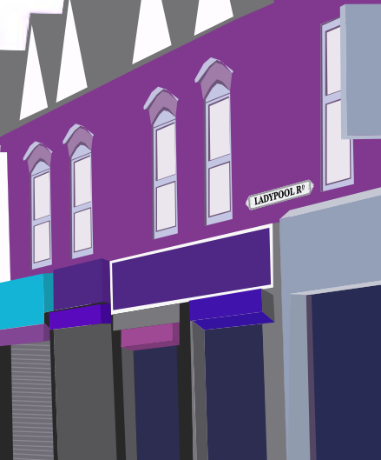

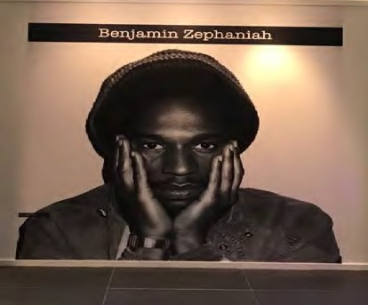














3232

REP
THE

“But for me Birmingham is still the centre of the universe, and I was just a little toddler when I found poetry there - or poetry found me.”

Benjamin Zephaniah




