Consultation Support Document

|  |  |
| --- | --- |
| BCC%20General%20Logo |  |
| Children Young People and Families  Outdoor Learning Service Review | |
|  | |

**Contents**

[1. Introduction 2](#_Toc370737241)

[2. Outdoor Learning 2](#_Toc370737242)

[3. The Outdoor Learning Market 3](#_Toc370737243)

[4. Legislation Relating to Outdoor Education 4](#_Toc370737244)

[5. The Outdoor Learning Service 5](#_Toc370737245)

[6. Service Options 19](#_Toc370737247)

[7. Summary 22](#_Toc370737248)

# 1. Introduction

1.1 The Outdoor Learning Service (OLS) is a non-statutory service. It delivers environmental and adventure activities through five residential centres (Bell Heath, Bockleton, Ogwen, Stansfield and Coopers Mill (leased)) and six day centres (Birmingham Nature Centre; Birmingham Outdoor Education Centre; Botanical Gardens; Mount Pleasant; Hams Hall and Springfield).

1.2 The service offering to schools has a strong educational focus and includes: curriculum support to schools; personal and social development through team building and confidence building activities; professional development for schools staff in delivering outdoor learning; behavioral support projects; short breaks for disabled people; early intervention to tackle drug misuse.

1.3 The service is fully traded and as well as working with Birmingham schools it delivers services to schools from outside of Birmingham and clubs, voluntary groups, other educational providers and charities, (including social enterprise).

1.4 It employs some 36 (31.5 FTE) on a permanent basis at a cost of £1.2m although the service is carrying 6.8 FTE vacancies. There are also 22 Cityserve staff employed.

1.5 Income levels for 2012/13 were £1.1m below the revised budget of £2.3m and expenditure was £2.3m. The overall loss to the City was therefore £1.1m.

1.6 The Council’s budget will reduce by £340m by 2016/17.

1.7 The Council’s Service Review Board published the Education Green Paper earlier this year and outlines options for the future of service to schools. The paper makes the following conclusion in relation to the service:

“*We need to look at how we deliver things. The Council provides a number of services to schools in Birmingham, including school meals, transport for those who qualify and extra activities such as outdoor education centres. We have to accept that in order to serve our most vulnerable children, it may be appropriate to look to the market to provide some services that are now to costly for the council to provide. Careful consideration of such services needs to take place and we are interested to hear views on what services would run more efficiently and effectively if left to the market to deliver*”.

1.8 The purpose of this report is to gain a comprehensive understanding of the operations and business model of the service and make recommendations on its future.

# 2. Outdoor Learning

2.1 In this section we will outline what outdoor learning is, describe the benefits and appraise current market conditions.

2.2 The English Outdoor Learning Council defines outdoor learning as a broad term that includes: outdoor play in the early years; school grounds projects; environmental education; recreational and adventure activities; personal and social development programmes; expeditions, team and leadership education.

2.3 The Department for Education estimate that 7m children go on some form of school visit every year and the Adventure Authorities Licensing Authority claimed that some 3m of these involve some form of adventure activity. A Mori survey of schools in 2004 showed that 68% of schools offered outdoor and adventure activity to their pupils during their time in the school.

2.4 Outdoor learning provision by local authorities was initially offered to give inner-city children the opportunity to spend some time experiencing the countryside and many of the facilities were bequeathed for this purpose.

2.5 The outdoor learning experience has adapted along with socio-demographic changes and the offer now includes:

* Stimulating interest in a subject area and so increase the motivation to learn
* Helping to cover areas of the curriculum that are difficult to address within the confines of the classroom and structure of the school day
* Providing the opportunity to reinforce learning through giving pupils the opportunity to experience the topic area and better understand its relevance and application
* Assisting students to build friendships and relationships that improve attainment levels
* Enhancing trust between pupils and teachers
* Encourage independence and enhance confidence and social skills
* Promoting physical activity

2.6 There are many studies that demonstrate the benefits of outdoor learning.

# 3. The Outdoor Learning Market

3.1 The overall domestic market for activity holidays that includes outdoor learning and adventure breaks for schools are worth £1.77bn per annum. The number of breaks fell by just over 5% between 2006-2010.

3.2 The activity / adventure market can best be described as a mixed economy with provision that includes: large multi-nationals such as TUI, niche providers such as Centre Parcs, small independent centres, charitable organisations such as National Trust and YMCA and local authority owned provision.

3.3 The ‘Factivity’ website lists over 8000 centres in the UK which offer some form of outdoor or adventure activity.

3.4 Many local authorities have been subsidising in-house provision of outdoor learning services, but in response to rising maintenance costs, falling numbers and need for capital receipts are divesting.

3.5 The main private sector providers of outdoor learning activities to schools have also experienced fall in turnover.

3.6 The major private sector providers are:

**Acorn Ventures** that have 25 years experience of activity breaks that run camps in Wales, France, Italy and Spain. Originally provision was focused on schools and uniformed groups (scouts/guides etc) but now provide family activity holidays as well. Turnover for 2010 was £6.1m.

**Holiday Breaks** is an international company that includes a number of brands that provide to schools. These include EST that run subject specific conferences and tours and PGL that provide residential activity experience to 4600 schools every year from their 28 activity centres. Turnover of Holiday Breaks was £461m in 2010.

**Kingswood** have a strong curriculum focus and deliver services from their 10 activity centres. They have embarked on an intensive programme of modernization spending between £1m-2m on most of their centres as well as building a new purpose built centre in the Dearne Valley. Kingswood programmes integrate into key stage 2,3 and 4 of the National Curriculum and the stage 4 programme can count as part of a GCSE. Turnover in 2010 was £17.3m.

3.7 Much of the traditional local authority and private sector residential provision concentrates on the primary school market. The Duke of Edinburgh Award has become the focus of outdoor and adventure activity in the secondary sector.

# 4. Legislation Relating to Outdoor Education

4.1 The provision of outdoor learning activities is not a statutory duty of the local authority.

4.2 The ‘[Common Sense Common Safety’ review](http://www.number10.gov.uk/wp-content/uploads/402906_CommonSense_acc.pdf) undertaken by Lord Young in 2010 recommended ways for removing unnecessary bureaucracy in health and safety. Activities for school pupils had a strong focus and Lord Young identified that schools have been prevented from taking pupils on educational visits, citing health and safety as a ‘reason for non-participation’.

4.3 In order to tackle these issues, Lord Young made the following recommendations:

* Simplifying the process that schools (similar organisations) undertake before taking children on trips.
* Introducing a single consent form that covers all activities a child may undertake during his or her time at a school.
* Introducing a simplified risk assessment for classrooms and shifting from a system of risk assessment to a system of risk–benefit assessment.

4.4 Following this review the Government published revised [health and safety guidelines](http://www.lotc.org.uk/wp-content/uploads/2010/12/health-and-safety-advice.pdf) in order to ensure it was easier for schools to take pupils on trips. The key points are:

* Children should be able to experience a wide range of activities. Health and safety measures should help them to do this safely, not stop them,
* It is important that children learn to understand and manage risks that are a normal part of life.  Common sense should be used in assessing and managing the risks of any activity. Health and Safety procedures should always be proportionate to the risk of activity.
* Schools should use trained staff so they can keep themselves and children safe and manage risks effectively.

4.5 The Council will maintain activities required to ensure that its responsibilities are met; regardless of which option is taken forward.

# 5. The Outdoor Learning Service

**Overview**

5.1 Within this section we will describe and analyse the current operations and performance of the service.

5.2 OLS employs 36 (31.5 FTE) on a permanent basis at a cost of £1.2m although the service is carrying 6.8 FTE vacancies.

5.3 Income levels for 2012/13 were £1.1m below the revised budget of £2.3m and expenditure was £2.3m. The overall loss to the City was therefore £1.1m. The overall budget is outlined in the table below:



Fig: Budget 2012/13

There have been losses for the previous four years.

5.4 130 (32%) out of the 401 schools in Birmingham used OLS residential centres in 2012/13.

5.5 In 2012, an independent review was undertaken by a former Ofsted inspector.

5.6 The exercise involved: visits to centres that included observation of activities and discussions with centre staff, school staff and pupils using the centres; review of documentation at the centres including evaluations; interviews with key stakeholders.

5.7 The report was extremely positive about the work of the service and made the following conclusion:

* OLS provides valuable, positive, good quality learning opportunities helping them achieve well in subject areas such as science, geography, maths, history, PE and environmental studies. It also helps people gain accreditation for a range of awards and promotes personal, spiritual, moral, social and cultural development.
* Programme provision is good and was highlighted as adaptable around the needs and requirements of the school.
* Strategic leadership was judged to be good and has improved with a whole service approach now being adopted rather than management of individual centres that has been adopted.
* The specialist resources available at the centres were highlighted as important in meeting the needs of diverse client groups.
* The service was shown to have experienced and well qualified staff that demonstrate a passion for outdoor learning.
* Day to day management of the centres was considered good.
* The monitoring and management of health and safety was judged to be excellent.
* The majority of schools consider the service to be value for money although transport costs can be prohibitive to some centres.

***Bockleton (Residential Centre)***

5.8 Bockleton is a Grade II listed two-storey Jacobean mansion set in 31 acres lies 40 miles to the South West of Birmingham and was built 147 years ago. It was owned by the Prescott Family who sold the house to Birmingham City Council during the 1950’s. For the next 20 years it was a camp school for children in the City who typically stayed for 3 weeks in order to experience the countryside. OLS now use the mansion as a study centre that includes a 100 bedded unit with 60 additional camping spaces.

|  |
| --- |
| BOCKLETON |

Fig: Bockleton

5.9 There was a loss was £172k for 2012/2013.

|  |  |  |
| --- | --- | --- |
| **2012 – 2013** | **Budget** | **Actual** |
| Income | 480,176.00 | 273,348.45 |
| Expenditure | 538,964.00 | 444,930.34 |
| Surplus/Deficit | -58,788.00 | -171,581.89 |

5.10 The customer profile for Bockleton shows the decline in Birmingham Schools income over the period.

|  |  |  |  |  |  |
| --- | --- | --- | --- | --- | --- |
|  | **BCC Schools** | **Grants** | **Academies** | **Other** | **Total** |
| **2009-2010** | £210,469.63 | £11,573.73 | £0.00 | £62,963.28 | **£285,006.64** |
| **2010-2011** | £249,410.00 | £51,382.00 | £0.00 | £59,079.00 | **£359,871.00** |
| **2011-2012** | £187,128.00 | £65,503.00 | £15,110.00 | £83,317.59 | **£351,058.59** |

Fig: Profile

5.11 In 2012/13, 35 Birmingham schools used Bockleton.

5.12 The decline in the utilization of the Centre is shown below falling from almost 260 days per year to 188 (school and non-school). The number of days per year the centre is used by schools was 112 last year.

|  |
| --- |
|  |

Fig: Days Used

5.13 The decline in pupil numbers during this period is from 2298 in 2010-11 to 1387 during 2012-13

5.14 A projected income for 2013/14 is £277,812 with forecast expenditure of £395,871. The 2013/2014 deficit will be in excess of £100,000.

5.15 Bockleton, (and Bell Heath), are also commissioned to deliver services to vulnerable children, including short breaks to disabled children and their families. The scheme, operated by Birmingham City Council’s Children and Young People Directorate, is currently under review. A new round of commissioning and contracting to ensure services are more closely aligned to identified service user need and preferences will is being undertaken and allow new services to be in place by April 2014.

5.16 The last condition survey was undertaken in 2004 and estimated £1.38m of repairs, whilst this is clearly out of date it does give some indication of likely spend as no major improvement work has been undertaken.

5.17 The property was valued during September 2013 at £1.5m.

.

***Stansfeld Study Centre (Residential Centre)***

5.18 The Stansfeld Outdoor Education Centre in Headington Oxford is set within 17 acres of woodland marshland and meadows. John Stansfeld bought the land that the centre is built on in **1918** and used it to heal patients with fresh air. Through his church work he made contact with the Parish of St Saviour’s in Birmingham and the centre grounds became a boy’s camp for children from the City.

5.19 The main centre is comprised of a two storey block housing two dormitories each sleeping 28 people. Across the courtyard are a kitchen block, dining room and teaching class room.

|  |
| --- |
| stansfeld_outdoor_education_centre_oxford_12 |

Fig: Stansfeld

5.20 The budget for 2012-13 was to make a small surplus of £3k but the centre reported a loss of just over £100k.

|  |  |  |
| --- | --- | --- |
| **2012 – 2013** | **Budget** | **Actual** |
| Income | 349,382.00 | 181,966.47 |
| Expenditure | 346,114.00 | 282,835.61 |
| Surplus / Deficit | 3,268.00 | -100,869.14 |

Fig: Outturn

5.21 The customer profile shows both the variance in performance year to year, the decline in BCC schools income and the increasing amount of external income the centre is bringing in.

|  |  |  |  |
| --- | --- | --- | --- |
| **Customer Profile** | **BCC Schools** | **Other** | **Total** |
| **2009-2010** | £129,285.40 | £15,233.70 | **£144,519.10** |
| **2010-2011** | £168,679.69 | £30,344.00 | **£199,023.69** |
| **2011-2012** | £112,290.70 | £38,256.00 | **£150,546.70** |

Fig: Profile

5.22 28 Birmingham schools used Stansfeld during 2012/13.

5.23 The trend in usage shows an overall decline in school days and total days the centre is utilized but there has been some recovery in 2012-13 albeit not to 2010-11 levels. The total number of school days used was 139 last year.

|  |
| --- |
|  |

Fig: Days Used

5.24 The decline in the total number of pupils visiting the centre during this period is from 1300 to 946 in 2011-12 with a slight recovery last year to 1090.

5.25 An income of £174,209 is predicted for 2013/14 against a forecast expenditure of £308,962.00. The deficit for 2013/2014 is likely to be around £125,000.

5.26 The last condition survey showed repairs of £1.1m again this survey was undertaken in 2004 and some work has been undertaken.

5.27 The last valuation of the site was £375,000.

***Ogwen Cottage Outdoor Pursuits Centre (Residential)***

5.28 Ogwen Cottage dates back over 200 years, originally serving as a coaching inn on Telford’s London to Holyhead (A5) road. The inn was purchased by James, Jones and Mason in 1958 and it was the first privately owned outdoor centre in the UK. James was a former Birmingham teacher and established strong links with Birmingham’s then Education Authority. The centre has 7 dormitories ranging from 2 to 8 beds and sleeps 34 students in total.

|  |
| --- |
| ogwen |

Fig: Ogwen

5.29 Ogwen was budgeted to make a £15k loss last year but lost almost £182k.

|  |  |  |
| --- | --- | --- |
| **2012 – 2013** | **Budget** | **Actual** |
| Expenditure | 447,615.00 | 379,098.63 |
| Income | 432,108.00 | 197,377.00 |
| Total | -15,507.00 | -181,721.63 |

Fig: Outturn

5.30 The overall trend in income shows, in particular, decline from BCC schools although some of this has been replaced by Academies.

|  |  |  |  |  |
| --- | --- | --- | --- | --- |
| **Customer Profile** | **BCC Schools** | **Academies** | **Other** | **Total** |
| **2009-2010** | £149,980 | £ 4,826 | £14,747 | **£169,554** |
| **2010-2011** | £163,331 | £ 6,997 | £35,539 | **£205,868** |
| **2011-2012** | £109,465 | £ 30,200 | £41,712 | **£181,378** |

Fig: Profile

* 1. In 2012/13, 20 Birmingham schools used Ogwen.

5.32 Utilisation shows an overall decline in number of days but with some recovery in 2012-13. Schools used the centre for 142 days last year.

|  |
| --- |
|  |

Fig: Utilisation

5.33 The total number of pupils visiting the centre has declined during this period from 861 to 798 but has shown some recovery last year from the 749 in 2011-12.

5.34 The projected income for 2013/14 is £189,340.00 with forecast expenditure of £393,091.00. There is likely to be a deficit of around £200,000.

5.35 The last condition survey, (2004), showed £141k of repairs were required and whilst some issues have been addressed other areas now need work. The estimate remains approximately the same.

5.36 The last valuation of the centre was £450,000.

***Bell Heath Outdoor Learning Centre (Residential)***

5.37 Bell Health is built on 5¼ acres of land near Stourbridge that was donated by the Cadbury family. It opened as a camp school for boys in 1928 and by the 1930’s girl’s schools were also using the centre with groups of up to 100 staying for up to three weeks at a time. The centre remained open during the war and continued to be used by secondary pupils up to the 1980’s when the centre became focused on primary schools. In 2007 day groups began to use Bell Heath and the centre was modernised in 2010 so that it could be used for young disabled family short breaks. A new camp site was added in 2011.

5.38 The centre can accommodate 54 children and up to 9 adults.

|  |
| --- |
| Bell Heath |

Fig: Bell Heath

5.39 Bell Heath was budgeted to make a £78k loss in 2012/13 but actual losses were £245k loss.

|  |  |  |
| --- | --- | --- |
| **2012/13** | **Budget** | **Actual** |
| Income | 340,861.00 | 181,314.37 |
| Expenditure | 418,439.00 | 426,765.11 |
| Surplus / Deficit | -77,578.00 | -245,450.74 |

Fig: Outturn

5.40 The overall trend in income can be seen below with fall in BCC schools expenditure not being replaced with the rise is other income sources.

|  |  |  |  |  |  |  |  |
| --- | --- | --- | --- | --- | --- | --- | --- |
| **Customer Profile** | **BCC Schools** | **Nursery's** | **Grants** | **BSS** | **Academies** | **Other** | **Total** |
| **2009-2010** | £268,190 | £13,520.00 | £0.00 | £0.00 | £0.00 | £35,281.00 | **£316,991** |
| **2010-2011** | £86,644.79 | £2,600.00 | £58,250.00 | £0.00 | £0.00 | £74,814.00 | **£222,308** |
| **2011-2012** | £90,038.00 | £2,718.00 | £68,825.00 | £215.00 | £1,401.00 | £96,464.00 | **£259,661** |

Fig: Profile

5.41 In 2012/13, 66 Birmingham schools used Bell Heath

5.42 The utilization of the centre has seen a very marginal fall in numbers during the period and was used for 149 school days last year:

|  |
| --- |
|  |

Fig: Utilisation

5.43 Total numbers of pupils visiting the centre during this period has increased from 3095 to 4486.

5.44 Bell Heath, (and Bockleton), are also commissioned to deliver services to vulnerable children, including short breaks to disabled children and their families. The scheme, operated by Birmingham City Council’s Children and Young People Directorate, is currently under review. A new round of commissioning and contracting to ensure services are more closely aligned to identified service user need and preference will is being undertaken and allow new services to be in place by April 2014.

5.45 An overall rise in income to £225,498.00 is predicted for Bell Heath this year with estimated expenditure of £418,316.00. The deficit for 2013/2014 will be approximately £200,000.

5.46 The last valuation of the centre was £600,000.

***Stables (Day and Residential Services)***

5.47 The Cropwood Estate Trust is a registered charity that is managed by the City Council on behalf of the Cropwood Trust. The land includes Hunters Hill Residential Special School and Hunters Hill School. The Stables a converted stable block including classroom, toilet and shower facilities and kitchen is sited across the road from the school. A number of outdoor facilities are delivered on site and delegates have access to 175 acres of land.

5.48 The Stables had budgeted for an £18k loss in 2012-13 but actual losses were £107k

|  |  |  |
| --- | --- | --- |
| **Outturn 2012 -2013** | **Budget** | **Actual** |
| Income | 266,474.00 | 106,116.00 |
| Expenditure | 284,711.00 | 213,218.73 |
| Total | -18,237.00 | -107,102.73 |

Fig: Outturn

5.49 An income of £252,687.00 is predicted for BOEC (Stables and Clifton Rd) this year against a forecast expenditure of £332,218. The approximate deficit will be £80,000.

***Springfield (Day Service)***

5.50 The Springfield Study Centre is based within the grounds of Springfield House Community School. The school has extensive grounds and is situated in a rural area five miles from Knowle, Solihull. It is set within an old walled garden in 10 acres of grounds. The self-contained building comprising class rooms, WC’s and changing and shower rooms.

5.51 The site has not been actively used since the beginning of 2012.

|  |  |  |
| --- | --- | --- |
| **2012 -2013** | **Budget** | **Actual** |
| Income | 40,099 | 0.00 |
| Expenditure | 16,380 | 8,138 |
| Total | 23,719 | -8,138 |

***Coopers Mill (Residential Service)***

5.52 Cooper Mill Cottage is located in a small Hamlet of Button Oak deep in the Wyre Forest on the Worcestershire / Shropshire border. The building was formerly a miller’s cottage that comprises dining room, kitchen, shower room / toilets. The three bedrooms can accommodate up to thirteen people. It is mostly used by small groups for one off activities (teacher training, Duke of Edinburgh etc).

5.53 The centre achieved its breakeven target in 2012-13

|  |  |  |
| --- | --- | --- |
| **Coopers Mill** | **Budget** | **Actuals** |
| Expenditure | 4,359.00 | 5,215.29 |
| Income | 4,359.00 | 5,351.60 |
| Surplus / Deficit | 0.00 | 136.31 |

5.54 The building is owned by the Worgans Trust and leased to Natural England who subleases to BCC.

5.55 The forecast income for 2013/14 is £3,700.

***Hams Hall Environmental Study Centre (Day Service)***

5.56 Hams Hall is a partnership between BCC, and E.ON UK. Established in 1973 on the site of 3 major power stations, E.ON UK owns the land and fund the maintenance of the buildings and grounds. The OLS manage the Centre on a day to day basis and provide all the facilities including a Tutor/Centre Manager for visiting schools. The Centre has two classrooms within the walled gardens of what was “Hams Hall”, the family home of the Adderley family until 1916. Bordered by the River Tame, the site has a large freshwater pond, a reconstructed late Tudor farm worker’s cottage and mixed deciduous woodlands.

5.57 Budget figures for 2012-13 show the Centre returning a surplus although this is unlikely to be sustained, with the inclusion of more accurate ‘actuals’.

|  |  |  |
| --- | --- | --- |
| **Outturn 2012 - 13** | **Budget** | **Actuals** |
| Income | 48,195 | 29,394 |
| Expenditure | 43,198 | 4,100 |
| Totals | 4,997 | 25,293 |

Fig: Outturn

5.58 The number of days the centre is used has fallen from 153 days per year in 2010-11 to 115 days per year in 2012-13.

5.59 The overall trend is a fall in pupil numbers by just over a 1000 per year. The number of days the utilized but there was a small upturn in 2012-13

|  |
| --- |
|  |

Fig: Visitor Numbers

5.60 The forecast income for 2013/14 is £34,336.00 against a budget of £40,643.

***Botanical Gardens (Day Service)***

5.61Opened in 1832 the Botanical Gardens in Edgbaston has a long tradition of providing educational access to foster a greater interest in plants and the role they play in everyday life. They remain a self-financing organisation and were registered as an educational charity in 1962. Birmingham City Council appointed the 1st specialist teacher in 1975.

5.62 The Service delivered a small surplus in 2012-13

|  |  |  |
| --- | --- | --- |
| **Outturn 2012-2013** | **Budget** | **Actuals** |
| Income | 25,099.00 | 31,719.00 |
| Expenditure | 9,891.00 | 27,755.31 |
| Surplus / Deficit | 15,208.00 | 3,963.69 |

Fig: Outurn

5.63 After a dip in 2011-12 use of the centre and pupil numbers have recovered:

|  |
| --- |
|  |

Fig: Visitors

5.64 The total days the centre was used last year was 141 slightly down from 154 in 2010-11.

5.65 The forecast income for 2013/14 is £29,225 against an expenditure budget of £28,910.

***Mount Pleasant Farm (Day Service)***

5.66 Mount Pleasantis a venture between OLS and the Worgan Trust (a Cadbury family foundation). In 1972 the late Paul Cadbury in partnership with BCC set up Chapmans Hill School Farm near Romsley followed a few years later by a classroom designed specifically for younger children at nearby Money Lane Farm. The Worgan Trust provided the farm and classroom facilities while BCC provided the qualified teachers.

5.67 In 2009 the Worgan Trust replaced both classrooms with a newly built facility at Mount Pleasant Farm, near Kings Norton. This land is owned by the Bournville Village Trust.

5.68 Whilst outturn figures show that the Farm returned a surplus in 2012-13 this is due to inaccurate recording of ‘Actuals’.

|  |  |  |
| --- | --- | --- |
| Outturn 2012 - 2013 | Budget | Actual |
| Income | 40,099.00 | 23,056.62 |
| Expenditure | 53,770.00 | 875.11 |
| Totals | -13,671.00 | 22,181.51 |

5.69 The overall trend for pupil numbers and days used is up over the past three years although there has been a fall in 2012-13.

|  |
| --- |
|  |

Fig: Visitors

5.70 The number of days used is 104 days last year up from 97 in 2010-11.

5.71 Forecast income for 2013/14 is £23,555 against an expenditure budget of £51,220.

***Birmingham Outdoor Education Centre (BOEC) Clifton Road***

5.72 The original BOEC was based at Tame Valley School on the Bromford estate and started delivering activities on schools sites and using the city’s parks and reservoirs in 1974. This site was demolished in 2010 and the centre relocated to the Big Lottery funded **Clifton Road Outdoor Learning Centre** on the edge of Sutton Park which was built in 2006. BOEC also operates out of **The Stables.**

5.73 The centre is a first floor extension to Clifton Road Youth Centre. It comprises 2 classrooms, 2 offices, toilet and changing facilities, storage. Parking is shared with the youth centre.

5.74 The centre was budgeted to make a £6.5k surplus in 2012-13 but made a loss of £71k.

|  |  |  |
| --- | --- | --- |
| Outturn 2012 - 2013 | Budget | Actuals |
| Income | 205,670.00 | 103,847.70 |
| Expenditure | 199,186.00 | 175,182.43 |
| Total | -6,484.00 | -71,334.73 |

5.75 Numbers using the centres (Clifton Road and the Stables) and number of days used has recovered after a significant fall in 2011-12:

|  |
| --- |
|  |

|  |
| --- |
|  |

5.76 The net value of the site is likely to be around £250k. (Exact figure to be confirmed).

***Birmingham Nature Centre (Day Service)***

5.77 The Birmingham Nature Centre is located 2 miles south of the City Centre on Pershore Road. The Centre has changed its focus from simply housing a collection of animals to focussing on conservation and captive breeding.

5.78 The OLS has access to the Nature Centre and can use a classroom on site.

5.79 The centre budgeted for a £13.5k surplus in 2012-13 but returned a surplus of just over £2.5k.

|  |  |  |
| --- | --- | --- |
| Outturn 2012 -2013 | Budget | Actuals |
| Income | 25,099.00 | 12,950.00 |
| Expenditure | 11,420.00 | 10,170.50 |
| Totals | 13,679.00 | 2,779.5 |

5.80 Utilisation has fallen to 57 school days last year and pupil numbers have fallen to 3270 per year.

|  |
| --- |
|  |

Fig: Visitors

***Services for Vulnerable Children***

5.81 During the last three years the services have been accessed to support vulnerable children. This includes ad hoc visits for children with behavioral issues and young offenders. In addition there is a contract in place to provide short breaks for children with disabilities.

5.82 For 2013/14 the short breaks for disabled children budget of £86k will provide 26 short breaks (overnight stays) for up to 30 people, including the disabled child, their family and carers. Typically this translates to 8 families per short break. The families make a contribution of between £15 and £25 per person.

5.83 The numbers of disabled children attending short breaks as part of this scheme are outlined in the table below:

|  |  |  |  |
| --- | --- | --- | --- |
|  | 2010-11 | 2011-12 | 2012-13 |
| Bell Heath | 66 | 113 | 49 |
| Bockleton | 95 | 88 | 68 |
| **TOTAL** | **161** | **201** | **117** |

5.84 The Short Breaks for Disabled Children Service is commissioned by the Council’s Children and Young People’s Directorate. They are currently reviewing the service, with a view to improved alignment with service user need. This process will conclude in April 2014 and ensure choices are available for disabled children and their families.

5.85 At this time the Council is also exploring the use of personal budgets for disabled children in line with the requirement of the Children’s and Families Act this will give children and their family’s greater choice and control rather than the Council block contracting with any single provider.

***Education Visits Coordinator Training***

5.86 OLS also delivers Educational Visits Co-ordinator training to schools. The total expenditure for 2012/13 was approximately £82k, (72k of which was staff), against an income of 42k.

5.87 The projected income for 2013/14 is £41,990 against planned expenditure of £79,882. A deficit of approximately £40,000.

5.88 Additional pictures of the sites are provided in Appendix A.

# 6. Service Options

6.1 The benefits of outdoor learning are well understood and supported by BCC, OLS and schools. Birmingham City Council has a long track record of supporting outdoor learning and adventure activity in the City and the experience of tens of thousands of school pupils in the City means the service has a special place in the hearts and minds of citizens.

6.2 Feedback and an independent inspection report demonstrate that the service is of high quality and the commitment and competence of staff is not under any question.

6.3 The Council has to find an additional £340m savings by 2016/17.

6.4 OLS is not a statutory function of the Council.

6.5 The £1.1m subsidy sometimes benefits children from outside the City.

6.6 There was an overall loss of £1.08m in 2012/13. The projected loss for 2013/14 is £1.21m.

6.7 The last valuation of the City owned assets within OLS is £2.875[[1]](#footnote-1)m, this was undertaken under more favorable market conditions and so disposal of these assets may not secure this fee.

6.8 Whilst the last condition survey on the estate is out of date, the total estimated repairs of £4.1m is felt to be a fair indication of cost.

6.9 The residential centres were used for 810 of the 1460 total days available, approximately 55% used. This shows the service is significantly under utilised.

6.10 The market analysis shows that both alternative provision and substitutes are widely available to schools.

**Service Options**

6.11 Three alternative service delivery options have been developed.

|  |
| --- |
| A - Continue to provide the service in-house |
| B – Stop providing the service in part |
| C –Stop providing the service (whole), and where possible transfer some or all of the asset to community or other body (social enterprise) and transfer some or all of the functions to other providers, where this is not of detriment to Birmingham residents. |
|
|

***A - Continue to provide the Service in house***

6.12 Under this option, the Council would continue to provide the service in-house. The following advantages and disadvantages were identified:

|  |  |
| --- | --- |
| **Advantages** | **Disadvantages** |
| * Maintains a Birmingham City Council presence in the market place. * Provides continuity for those schools that use OLS facilities. * Maintains the good relationships that OLS have with schools and other stakeholders in the City. | * Market trends and purchasing behavior demonstrates that there will be limited growth in sales / income and so the service will continue to require a subsidy. * No mechanism to inject the capital required to make the buildings safe and fit for purpose. * Cuts would have to be made in other services to fund this. |
|  |  |

***B – Stop providing the Service in part***

6.13 Under this option the Council would decommission and divest from all its provision apart from the Stables (day activity centre) and Bell Heath (residential). (These sites were identified by managers within OLS as the services to be retained for this option, as the proximity of the sites to one another means that staff could work across both sites and the offering to schools could use the facilities and resources across both premises).

6.14 The model adopted would rely mainly on freelance tutors, with a small core team. This is similar to the model operated by private sector providers.

6.15 The relative advantages and disadvantages of the model are described below:

|  |  |
| --- | --- |
| **Advantages** | **Disadvantages** |
| * Releases a capital receipt for the Council from sales and overall reduction in the revenue liability from the service * Provides opportunity for day and residential based activities for schools in site close to Birmingham * The proximity between the Stables and Bell Heath means that there are synergies across the service offering including some cost saving * Retains some BCC presence in the market place | * Modeling even based on some optimistic assumptions shows that the service would not break even and there would be a revenue liability of over £200k * Even if the level of losses could be sustained then it still does not address the issue of repairs / modernisation at the sites in order to ensure the remaining service can compete in the market place * There will be one off decommissioning and redundancy costs. * Cuts would have to be made in other services to fund this. |

***C - Stop providing the Service (whole),*** ***and where possible transfer some or all of the assets and some or all of the functions to other providers***

6.16 Under this option the City Council would no longer be a provider of outdoor learning services. It will work with existing partners and other interested stakeholders in an effort to maintain services, by transferring assets and/or functions.

6.17 The relative advantages and disadvantages of this option are outlined below:

|  |  |
| --- | --- |
| **Advantages** | **Disadvantages** |
| * There will be a capital receipt from the sale of BCC owned sites. * The net annual revenue liability of approximately £1.1m (2012/2013) will be eliminated. * Released funding can be used to bolster * key statutory services to vulnerable people in the city, (in this instance children). * Possibility for jobs to be retained through TUPE arrangements. | * There will be a one off cost for decommissioning the service. (The exact amount being dependent on exercising opportunities to transfer assets and/or functions). |
|  |

# 7. Summary

7.1 The options appraisal demonstrates that:

* Retaining in-house provision (option A) would cost Birmingham residents approximately £1m per annum as the service is never likely to be financially viable. In addition £4m will need to be found to cover the back log of repairs. This would have to be found by making cuts to other services.
* Stopping part of the service and consolidating provision into a smaller number of sites (Option B) means that although the service would still not break even, the annual deficit would be reduced in proportion to the size of the service retained. The number and cost of repairs would also reduce proportionally.
* Stopping the service (Option C), will eliminate the growing deficit - £1.1m for 2012/2013, and projected to be £1.2m for 2013/2014.
* There are possible opportunities for transferring assets and/or functions to other providers / organisations that can be explored. This includes transfer as a going concern as long as value for money for Birmingham residents can be demonstrated.

**Appendix A – Photographs**

**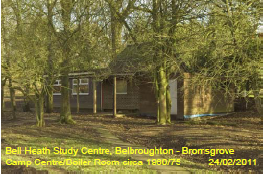**

**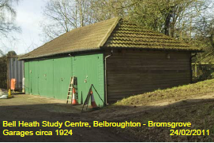**

**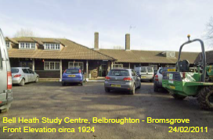**

**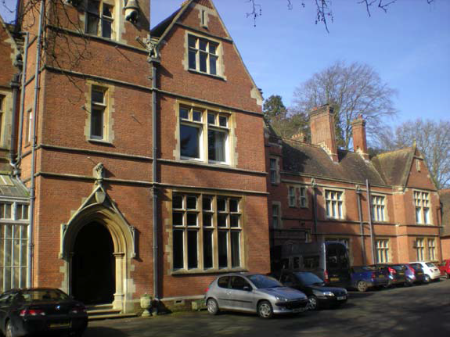**

**Bockleton (front)**

****

**Bockleton Classroom**

**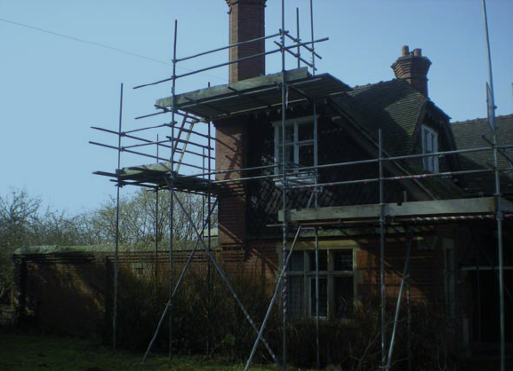**

**Bockleton (Lodge)**

**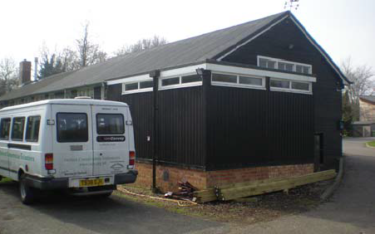**

Stansfeld (Training Centre)

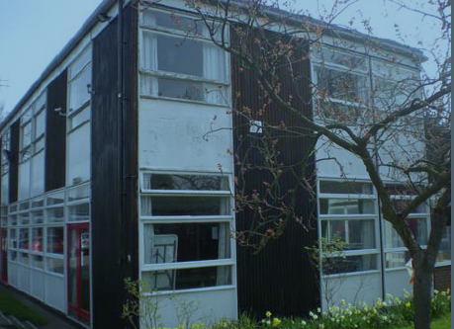

Stansfeld (Main)

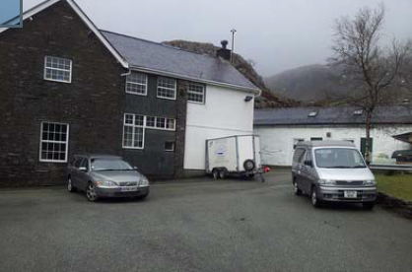

Ogwen (Court)

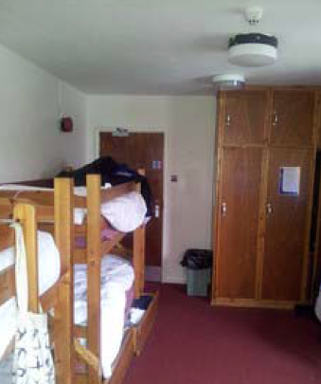

Ogwen Bedroom

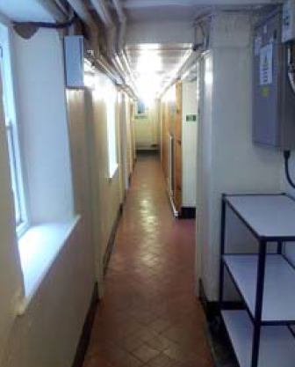

Ogwen

1. Not including Clifton Road [↑](#footnote-ref-1)