

12th July 2013

The Occupier

Dear Sir / Madam

PROPOSED PEDESTRIAN IMPROVEMENTS- MIDDLEMORE ROAD LOCAL CENTRE – WEST HEATH ROAD / STAPLE HALL ROAD

We are considering the introduction of a Zebra Crossing on West Heath Road as shown on the attached drawing number CA-02027_S1_011, to improve accessibility and provide safer crossing facilities for pedestrians at this location.

We would like to hear your views on these proposals and would be grateful if you could inform us of your views / comments using the enclosed questionnaire and prepaid envelope, and return by end of 30th July 2013. Alternatively your response can be sent to transport.projects@birmingham.gov.uk or via www.birminghambeheard.org.uk

Meanwhile, to ensure that these measures are made known to all parties who may be affected by them, i.e. landlords, owners, freeholders etc., I would be grateful if you could bring the contents of this letter to the attention of any persons with an interest in your property.

If you would like to discuss these proposals further, please contact myself Amjid Bashir on: 0121 675 6833 or email me at: transport.projects@birmingham.gov.uk.

Yours faithfully

Amjid Bashir
Engineer

Chris Tunstall, Director | Your Reference:
Sustainability Transportation & Partnerships | Our Reference: | TSP/CA-20373/002/AB
Birmingham City Council | Telephone: | 0121 675 6833
PO Box 16719 | Facsimile: | 0121 303 6379
Birmingham B2 2GA | email: | transport.projects@birmingham.gov.uk

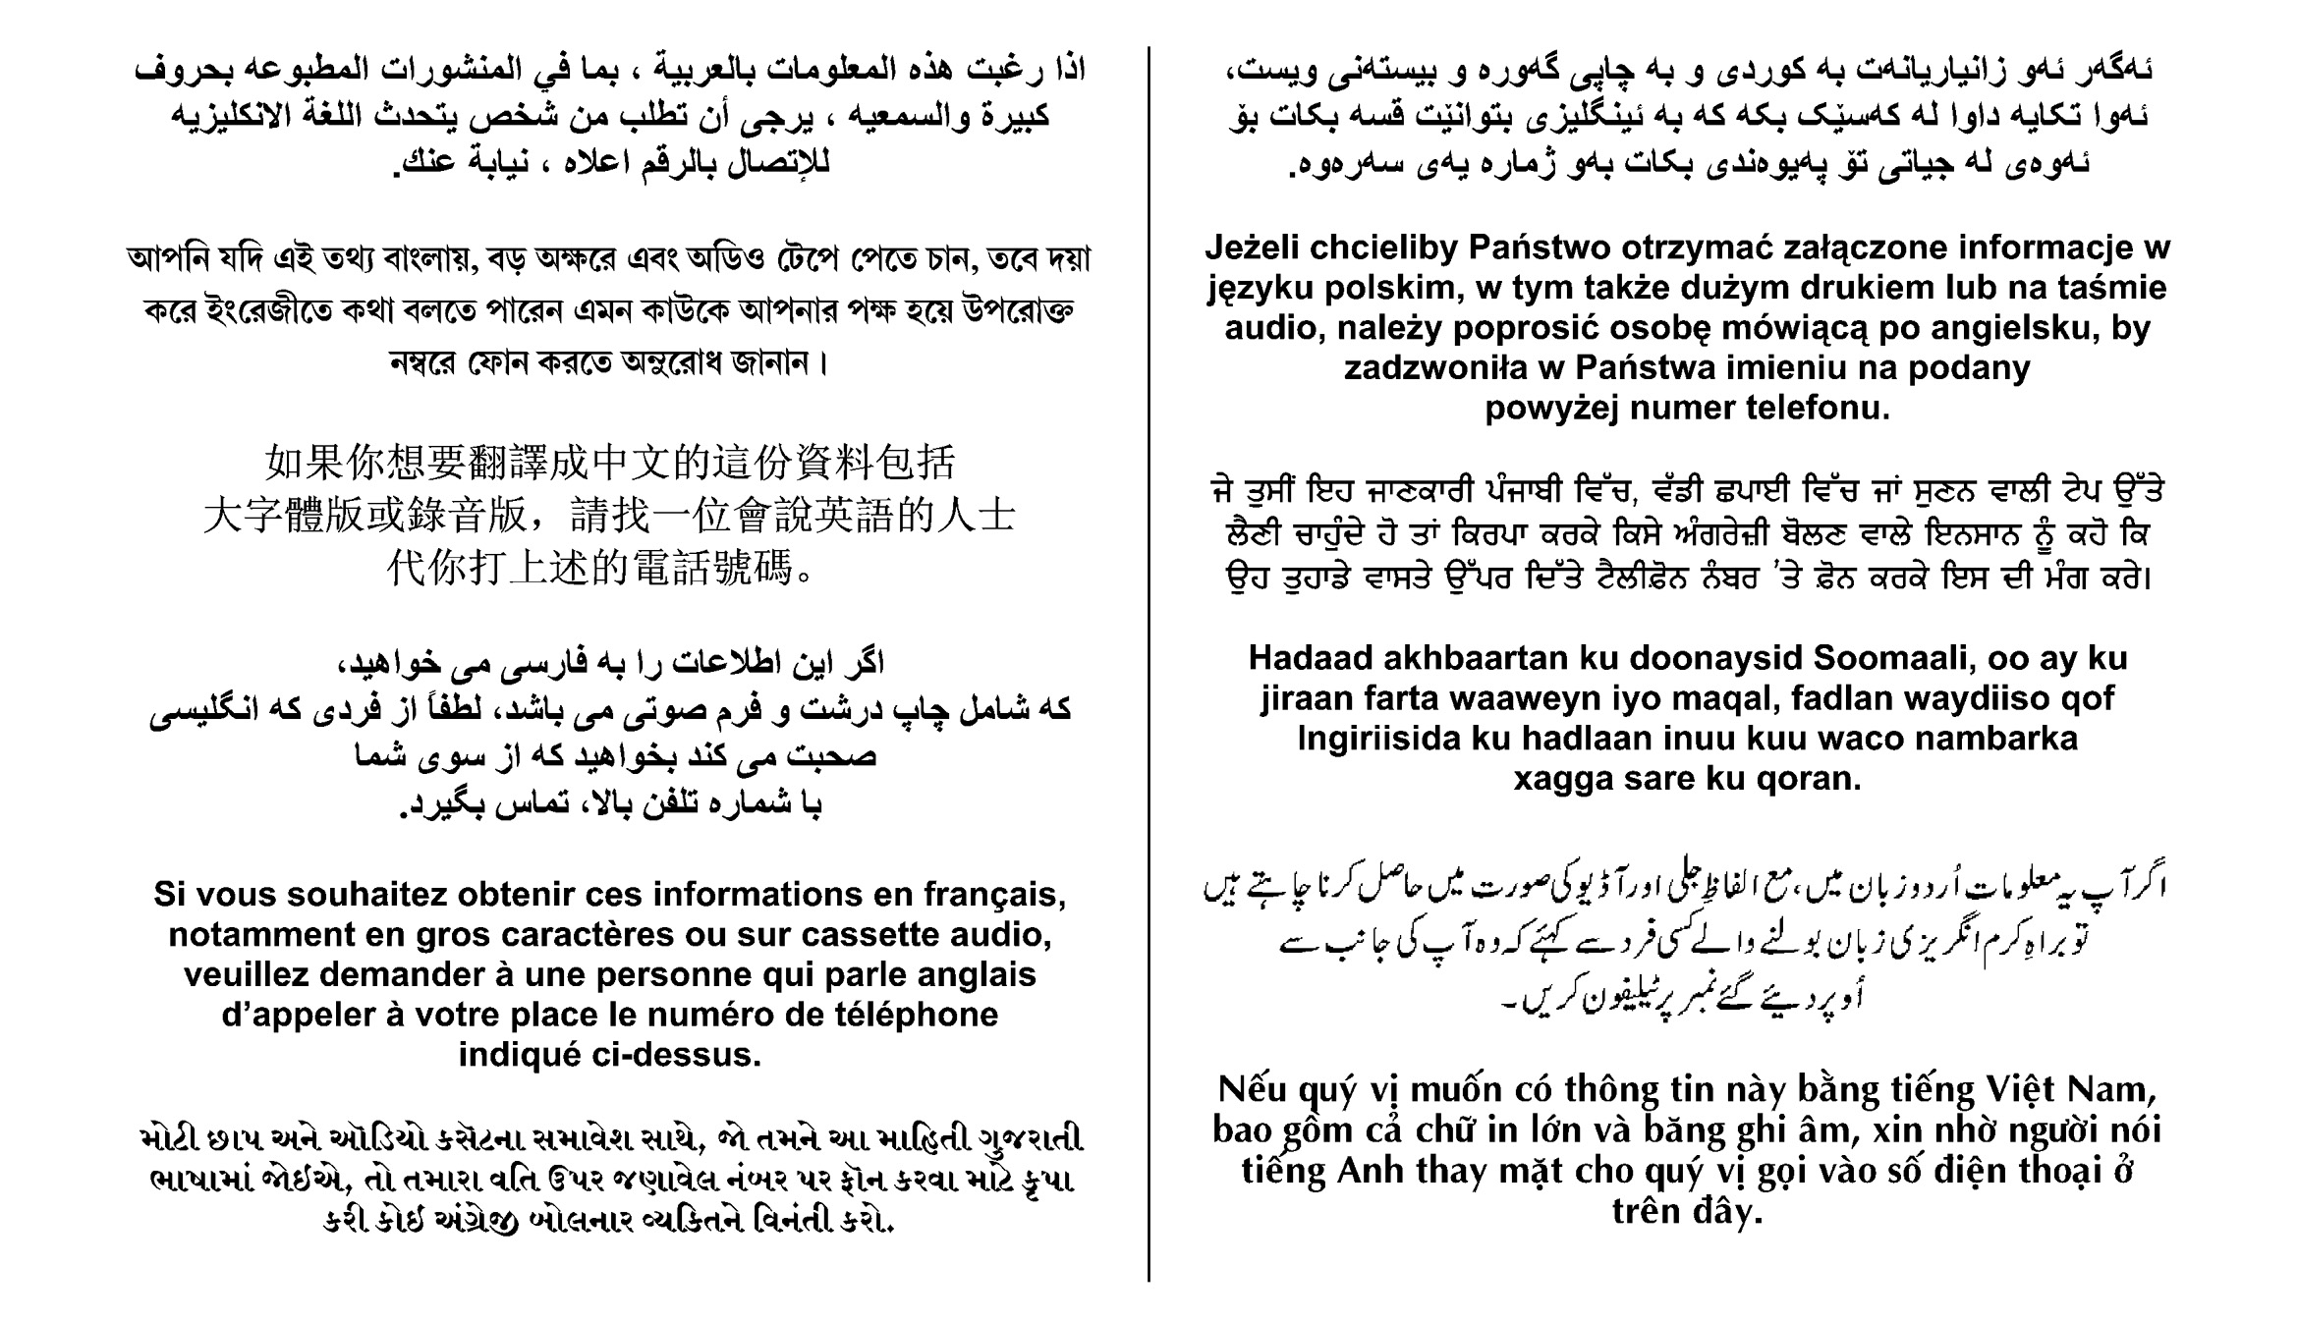
If you would like this information in a different format please call
0121 675 6833
If you are hearing impaired please call us via Typetalk on 18001 0121 675 6833


Amjid Bashir
c/o Infrastructure Projects
PO Box 16719
Birmingham
B2 2GA

PROPOSED PEDESTRIAN IMPROVEMENTS- MIDDLEMORE ROAD LOCAL CENTRE – WEST HEATH ROAD / STAPLE HALL ROAD

QUESTIONNAIRE

PLEASE RETURN BY 30th July 2013
Do you support the proposals shown on drawings CA-02027_011
Please tick | Yes  No |  | If you wish to comment please use this space:  (please continue on a separate sheet if required)
DATA PROTECTION ACT, 1998
The data that you provide is subject to the Data Protection Act 1998, and will be used by Birmingham City Council for the purpose of the Local Sustainable Transport Fund (LSTF) – Middlemore Local Centre scheme only.
Name
Address
Email Address
Date

Please return to:
Amjid Bashir, c/o Infrastructure Projects, Birmingham City Council, PO Box 16719,
Birmingham, B2 2GA.

If you have any questions please contact Amjid Bashir on 0121 675 6833 or email: transport.projects@birmingham.gov.uk

