Local Arts Forum development 2012 – 14

Context in 2011-12
The creation of an individual Local Arts Forum in each District was set up by Birmingham City Council’s Culture Commissioning Service between April 2011 and March 2012. The idea of a dynamic network to bring individual artists together with local arts organisations, education providers, youth and community groups had been developed in Perry Barr led by the Arts Champions Birmingham Opera Company and Birmingham Hippodrome. It was then offered as a contract of services to small and independent organisations. Initially the requirement was to organise four public meetings a year for local artists and community groups, undertake an audit of venues and create a contact database of key contacts in arts and culture across the four wards of the District.

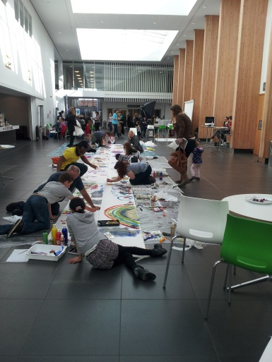
The first year was one of research, networking and information gathering to prepare for activity and delivery during 2012-13. The year of 2011-12 was one of great change for Birmingham City Council Arts Service, moving from direct delivery to a commissioning model with a reduction to half the number of staff. Each of the remaining four Culture Officers took responsibility for three-four Districts, each attending the Local Arts Fora meetings with District or Ward managers to assist with planning and delivery of Arts Champion activities. Local arts planning was developed into a Local Arts Plan for the first time.

Development of brief and direct delivery added 2012 – 13
The Local Arts Fora were given more focused briefs during 2012 – 13 and were required to undertake the creation of a social media presence; deliver local arts activity, present the Local Arts Plan to District committees and support the co-ordination of the Arts Champion programme across all four wards of the District.

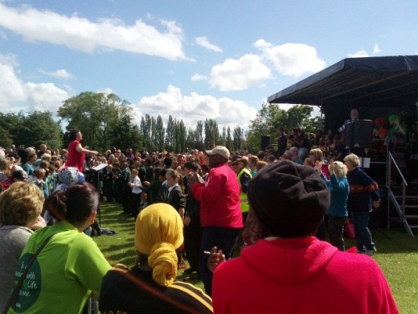
Web and online presence developed local branding so that specific names were linked to key Districts e.g. Café Arts (Erdington), Northfield Arts Forum (NAF), Arts in the Yard (Yardley). Certain areas took a special focus on particular art forms led by local artists. These included poetry and spoken word in Northfield, visual arts in Edgbaston, and performing arts in Selly Oak and Perry Barr. This year saw the first successful funding of small scale local festivals in Selly Oak (Art SOAK), Arts March (Northfield, pictured) and ArtSmile (Edgbaston). Some networks constituted themselves to be able to raise additional funds for their organisations.

The Torch Relay celebrations gave the opportunity and focus for many Local Arts Fora to become engaged in the five arts sites identified along the route over two days. Ladywood
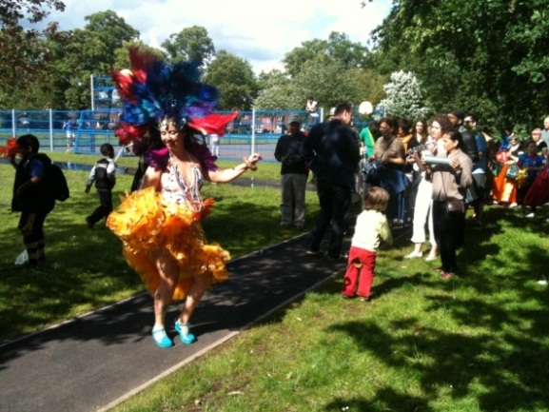
Arts Forum (Fluid Space Arts) organised the Festival of Colours in Summerfield Park (pictured). In total over 100 different groups got involved and over 9,000 audiences turned up to see the events across all five sites, with a commissioned Song for Birmingham (lyrics by Spoz) composed by Jo Broughton with his Birmingham Conservatoire Folk Ensemble. Hall Green Arts and The Drum managed Birmingham to Brazil in Calthorpe Park (pictured), and Sparkhill Park hosted an interfaith breakfast for over 1500 people co-ordinated by the Interfaith group of Sparkhill with producer Keith Horsfall. Working with Birmingham City Council’s Sports and Events team and the Districts proved a successful way of maximising impact and reach.

Development of artistic quality and range of partnership delivery 2013 – 14
The third year of Local Arts Fora has offered the opportunity to combine working with the Arts Champion on the month long showcase of Cultivating Culture. This showcase between February and March 2014 has produced 50 events across all 10 Districts. It has evidenced an innovative approach to arts and cultural programming and has seen dancing in empty shop units, libraries and shopping arcades; singing in care homes and streets; creating poetry and words to find meaning for those who are homeless or isolated; and craft making in coffee shops for families and children. Storytelling, music performance and beat poetry have been showcased revealing the next generation of artists. The arts and cultural activities have appealed to all ages, with activities such as Yardley Forum’s Creative Family Play Day at St Cyprian’s Church, all the way through to ballet work with Handsworth Elders).

The Symposium reviews the learning over the three years and gives the opportunity to reflect on the road travelled. New investment of funding towards local arts from Arts Council England and Birmingham City Council into the Local Arts Fora will be much welcomed at times of increasing austerity in arts and cultural sector. This Symposium will ask Local Arts Forum leads to share case studies of what has worked well and to learn from what has not worked so well.

From these figures we can tell that participation and audiences grew during the Olympic year but are continuing to build a healthy range of participants and audiences.

TOTALS 2012-13 (Olympic year) | 6,754 participants | 18,880 audiences | 88 estimate volunteers | 3,000 facebook & twitter followers
TOTALS 2013-14 | 2,255 participants | 3,986 audiences | 151 estimate volunteers | 20,000 facebook & twitter followers

