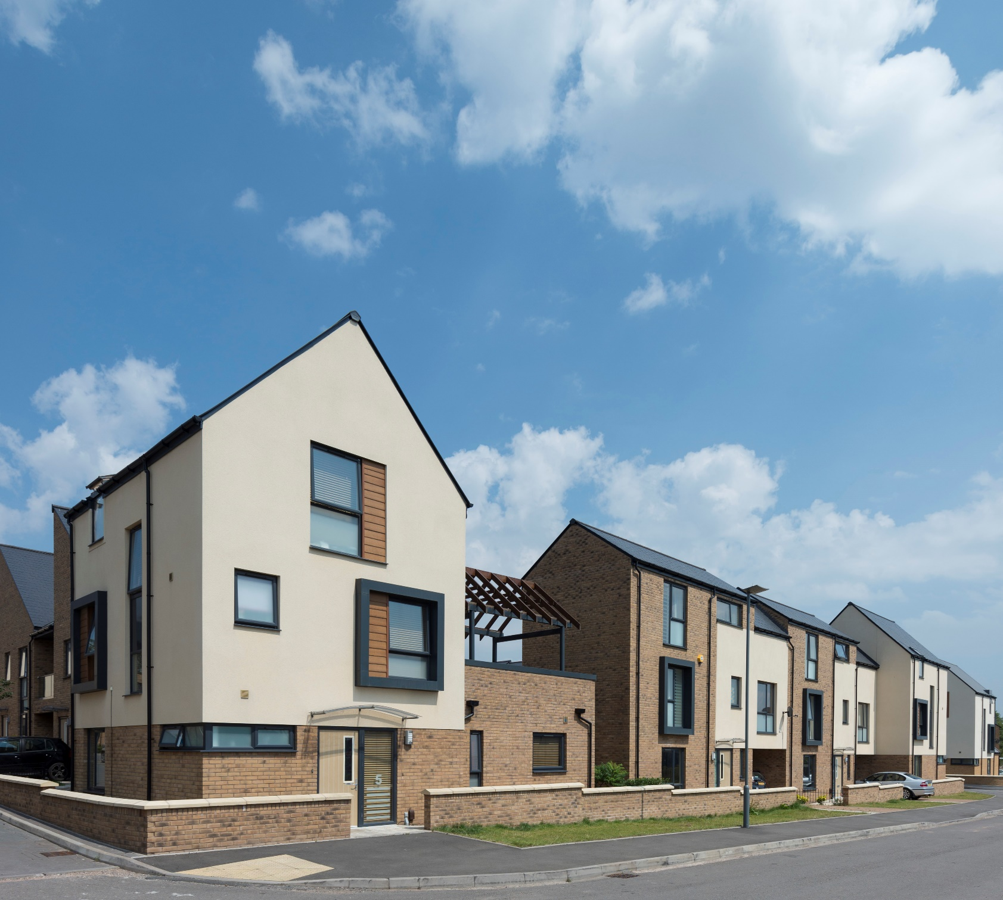
EXAMPLES OF PROPERTIES BUILT BY BIRMINGHAM MUNCIPAL HOUSING TRUST, WORKING IN PARTNERSHIP WITH HOUSING CONTRACTORS

Newtown - Birmingham

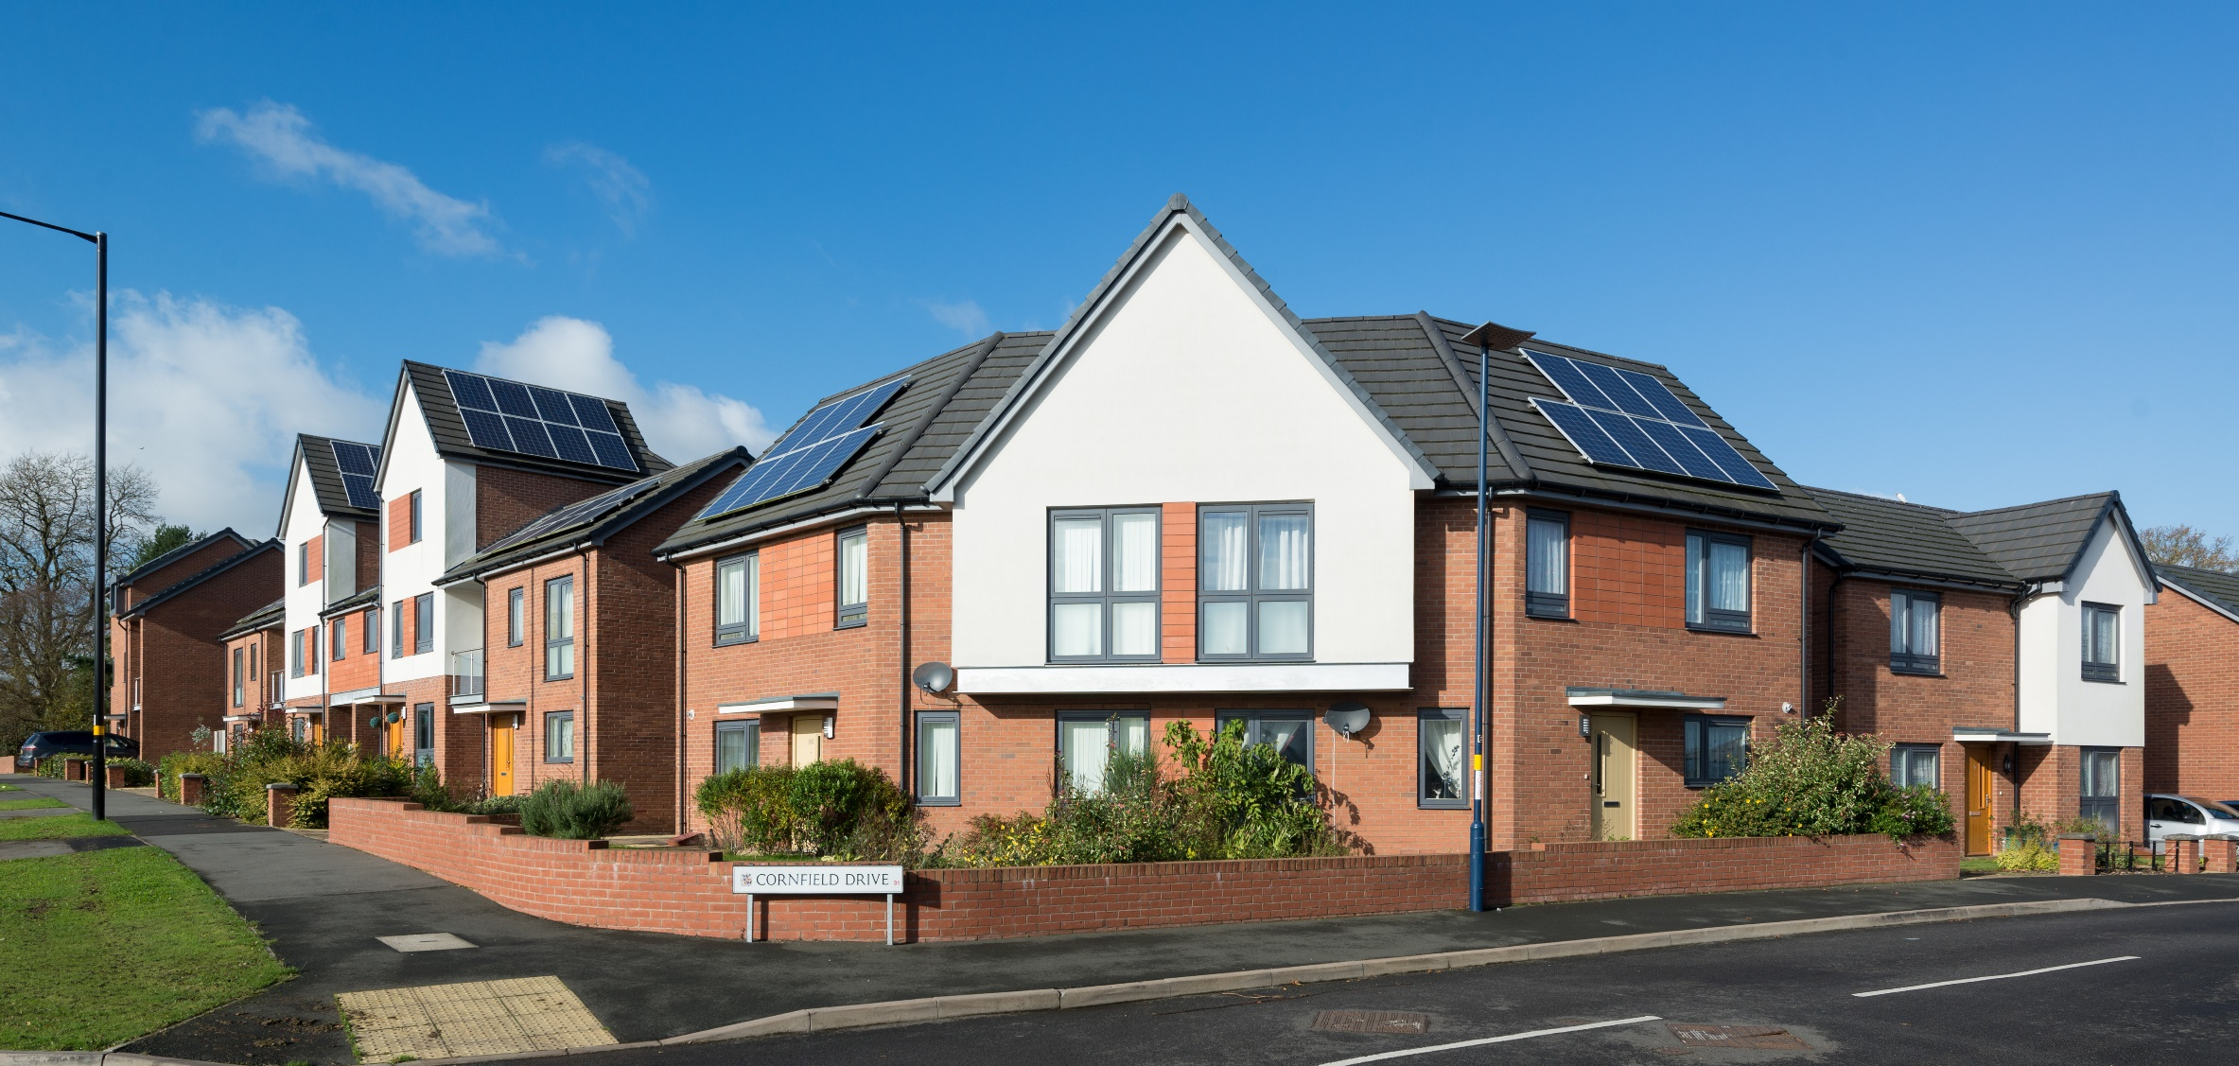
Merrits Hill, Birmingham
[Grab your reader’s attention with a great quote from the document or use this space to emphasize a key point. To place this text box anywhere on the page, just drag it.]

