**BIRMINGHAM CARERS PARTNERSHIP**

**STRATEGY 2024 to 2029**

***ENABLING A LIFE ALONGSIDE CARING***







**CONTENTS**

**Foreword**

1. Introduction
2. Purpose and Scope
3. Our commitment
4. Our vision
5. Who is a Carer?
6. Impact of caring
7. Value of caring
8. A Carers perspective
9. A priority for Birmingham
10. What We Have Achieved
11. Carers pathway
12. What you told us
13. Our challenge
14. Delivering our vision
15. Equality duty
16. Partnership Action Plan

**Appendices:**

Appendix A – Acts, legislation, policies, and references

Appendix B – Source what you told us.

**FOREWORD**

Welcome to Birmingham’s Draft Carers Partnership Strategy five-year strategy, 2024 to 2029, developed with Carers, Integrated Care Board (ICB) Birmingham City Council, Birmingham Children’s Trust, providers, and voluntary and community sector colleagues. It represents our vision and continuing commitment to Carers, alongside a commitment to partnership working.

Carers make a critical and often under-appreciated contribution, not only to loved ones, neighbours and friends, but to the sustainability of the health and social care system. It has already been well established that most people are likely to be affected by or have caring responsibilities at some stage in their lives.

Statistics from the Census 2021 estimates there are 91,445, unpaid Carers living in Birmingham, which represents 8% of the population. It is predicted nationally that as care needs increase the number of Carers is estimated to more than double by 2030. Many people are now balancing work, children and caring for an aging parent and increasing numbers of older people often care for their partner and grandchildren. Parents of children with complex needs know they will be lifetime Carers and the positive shift away from institutional care to living independently with care at home will only increase the need for Carers.

The strategy will take a whole life course approach to reduce the impact of the transition between different ages and stages of life. We want to ensure that Carers get the right type and level of support at the right time. This approach reflects the requirements of the Care Act 2014 provisions for Carers and the priorities identified in Think Local Act Personal guidance making it real for Carers. It also recognises the importance of promoting positive health and wellbeing approaches including self-care and self-management.

We are confident that in collaboration with Carers and together with our experienced and innovative partners, our partnership strategy will make a positive difference to Carers in the City. Our partnership strategy builds on the foundations put in place by our previous Carers strategy with a greater focus on promoting a joined-up approach between Carers, the Council, Birmingham Children’s Trust, Integrated Care Board, Health and the voluntary sector.

In this time of limited resources, we want to work in partnership to take forward the vision of the strategy making the best use of assets and experience and look forward to working together to deliver this strategy to achieve our collective vision for Birmingham.

***To be signed by Chief Executives at BCC BCT & ICB.***

**1. Introduction**

Carers play a vital role in our communities and caring is increasingly becoming a core part of family life. Without the support of Carers, health and social care agencies would struggle to provide the level of care and support that vulnerable people need to continue living in their own homes and communities.

This Strategy replaces the Birmingham City Council Carers Strategy 2018+ and presents a refreshed set of priorities for 2024-2029, that reflect the context in which we are now operating reflecting partnership working to address the strategic needs of all Carers. It builds on achievements to date and has been informed by relevant national and local legislation, policy and guidance (Appendix A) to deliver on the priorities and outcomes important to carers.

The strategy has been developed in partnership with Carers and sets out Birmingham City Council and Integrated Care Board’s (ICB) continued commitment to work together, with partners, to support the health and wellbeing of all Carers in Birmingham.

This strategy is for everyone and all Carers including:

* **Adults who care for other adults** – adults aged 18 years or more. A significant majority of Carers look after another adult, usually a relative or spouse. A person is also defined as a Carer when they provide or intend to provide a substantial amount of support on a regular basis to a relative or friend when for example they have been discharged from hospital.
* **Parent Carers** – parents (or guardians) of disabled children and young people up to 18 years of age who have additional care needs. When the child reaches 18, the parent or guardian is defined as a Carer looking after an adult.
* **Young Adult Carers** – young adults aged 18 to 25.
* **Young Carers** – children and young people under 18 years of age who look after a family member, friend or neighbour who has a disability. In many cases this may well be a parent, grandparent, or brother/sister.

The strategy recognises the diverse range of needs, priorities and interests of Carers and families and the need for inclusiveness and responsiveness when addressing Carers support needs and services.

**“Carers come from all walks of life, all cultures and can be of any age. Many feel they are doing what anyone else would in the same situation, looking after their mother, son or best friend and just getting on with it”.**

*The Princess Royal Trust for Carers*

We want to ensure that people get the right type and level of support at the right time, recognising that Carers may look after more than one person. The strategy will support a whole life approach to reduce the impact of the transition between different ages and stages of life and the caring journey as illustrated in the journey below.

**THE CARING JOURNEY**

Moving on from caring

Living as a

Carer

Before

caring

Becoming a

Carer

**2. Purpose and Scope**

The strategy establishes Birmingham’s priorities and partnership vision for 2024-2029. This will enable Carers, Integrated Care Board (ICB) Birmingham City Council, Birmingham Children’s Trust, providers, voluntary and community sector colleagues employers and other stakeholders to appreciate:

* The *strategic context* in which partners will operate in and the City’s need to respond to challenges and opportunities.
* The *strategic priorities* of partners – enabling resources, delivery plans and operational activity to be aligned to the Carers pathway.
* *Partnership working -* continuing to innovate, transform and drive improvement in services.

**3. Our commitment**

In refreshing our commitment to Carers, we have firmly placed the needs of Carers at the centre of our vision and this strategy. Our commitments to Carers reflect on what Carers have told us is important to them:

1. **I want to be able to take short breaks and have time for relaxation.**
2. **I want to be recognised and respected as a Carer.**
3. **I want my voice to be heard.**
4. **I want to be involved in delivering care and support.**
5. **I want support during childhood and education.**
6. **I want support at work and my employer to be Carer Friendly.**
7. **I want to be safe and healthy.**
8. **I want to be able to financially plan for today and tomorrow.**

These commitments provide the aims and objectives for the strategy.

**4. Our vision**

Birmingham’s vision for Carers over the next five years is:

**“Birmingham is a Carer Friendly City that recognises, supports and values all our Carers.”**

The Carers Commitments will be at the heart of Birmingham’s vision of becoming a carer friendly city over the next five years. Partnership working will take a whole system approach, reduce the negative impact of caring and enable Carers to lead fulfilled, independent lives alongside their caring role.

**5 Who is a Carer?**

This strategy uses the NHS definition of who is a Carer:

**A Carer is anyone, including children and adults who looks after a family member, partner or friend who needs help because of their illness, frailty, disability, a mental health problem or an addiction and cannot cope without their support.**

The care they give is unpaid and many Carers don’t see themselves as Carers and it takes them an average of two years to acknowledge their role as a Carer. (*NHS website, understanding Carers).*

It can be difficult for Carers to see their caring role as separate from the relationship they have with the person for whom they care, whether that relationship is as a parent, child, sibling, partner or a friend.

It is likely that every one of us will have caring responsibilities at some point in our lives, with the challenges faced by Carers taking many forms. Many Carers juggle their caring responsibilities with work, study and other family commitments. Some, in particular Younger Carers, are not known to be a Carer and they don’t tell relatives, friends or health and care professionals about their responsibilities because of a fear of separation, guilt, pride or other reasons.

Carers can help someone to be independent, healthy and well, by supporting them to stay connected to their local community, or be physically and mentally active, or eat nutritious food. Some Carers might have to help with tasks like banking, shopping and housework. Other Carers may have a more intensive care role helping with all daily living tasks – feeding, bathing, dressing, going to the toilet and taking medicines.

Carers say there can be many rewards to caring, including:

* Satisfaction of knowing you have helped someone who needs you, enabling them to improve their quality of life.
* Strengthening the relationship with the person you care for.
* Opportunity for personal growth and to develop new skills.
* Proving to yourself that you can meet new challenges.
* Appreciation from the person you care for and acknowledgement from family and friends.

**6 Impact of Caring**

Carers can face significant challenges in providing good care, such as balancing work or education commitments, managing multiple roles and travel. There are also challenges to their own health and wellbeing as well as having a life of their own alongside the caring responsibilities.

Carers experiences vary depending on a variety of factors including their age, financial circumstances, family make up, where they live, whether they are in education or employment, for who and for how many people they care for and what support is in place. The impact of caring depends on the amount of care provided, the Carers age and the length of time they have been providing care. The needs of the person being cared for and the relationship with their Carer can also have an impact on the life of a Carer.

Some of the main impacts are:

* Health and wellbeing – the most recent GP patient survey found that 60% of Carers have a long-term health condition compared to 50% of non-Carers. For Young Adult Carers the pattern is even more pronounced with 40% of Young Adult Carers (aged 18-24) having a long-term health condition compared to 29% of non-Carers in the same age group. (*Carers UK analysis of GP Patient Survey 2021)*.
* Employment – the ability to access and stay in employment.
* Financial – having a reduced income or getting into debt.
* Social – the ability to access social or recreational activities.
* Relationships – the ability to maintain relationships with wider family and friends.
* Educational – caring responsibilities can have a detrimental effect on young people’s educational achievements and life chances. Young Adult Carers are also less likely to achieve a degree (38%) and adolescence aged Carers (36%) more likely to be bullied for their caring role within the school environment. *(**APPG for Young Carers and Young Adult Carers Inquiry Report, November 2023).*

**7. Value of Caring**

It is difficult to estimate the full value of the care and support provided by informal Carers as it is often an expression of affection and respect or a sense of duty. However, without the support of Carers, demands on health and care services would increase dramatically and services would struggle to cope. It is estimated there are over 6.5 million unpaid Carers in the UK with 1.4 million people providing over 50 hours of unpaid care per week. The economic value of their contribution is estimated at £193 billion per year.

In recognition of the important role that Carers play the Care Act 2014 promoted wellbeing as an overarching principle. The Act included new rights for Carers such as an assessment if a Carer appears to have a need for support regardless of the amount of care provided, their financial situation or whether the person cared for has an eligible need. In addition, it emphasises:

* Parity of esteem for Carers and the person cared for.
* Principles of wellbeing and personalisation.
* Universal rights to information and advice.



**8 A Carers Perspective**

Tommy Whitelaw works to raise awareness of issues facing people living with dementia and their Carers. He cared for his mother who had vascular dementia and they struggled together with the understanding of dementia, the caring and the isolation and loneliness as their world became smaller. For Tommy, to combat his loneliness, he started a blog to talk about his experiences and speak to others who were also living with dementia to see if their struggles were the same. This was the start of him raising awareness of dementia through campaigning and engaging with health and social care professionals.

The following represents some of Tommy’s experiences and views and gives a picture of what matters and is important to Carers.

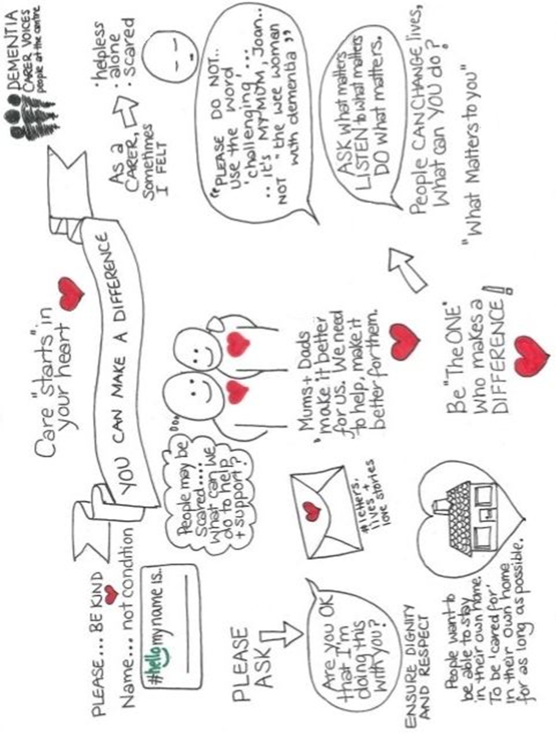

**9 A priority for Birmingham**

Carers are a priority for Birmingham. There is a range of national Acts, legislation, and strategies (see Appendix A) that focus on Carers with the two main Acts being:

* **Care Act 2014** – sets out new legal guidelines relating to care and support for adults and the law to support Carers. There are provisions to safeguard adults from abuse or neglect and care standards. In addition it places clear legal responsibilities on the Local Authority and creates a single duty to undertake a Carers Assessment.
* **Children and Families Act 2014** – makes provisions for children, families, and people with special needs. It seeks to improve services for vulnerable children and introduces new rights for Young or Parent Carers to an assessment of need.

There are also two main local visions and strategies that relate to Carers:

* **Vision and Strategy to modernise Adult Social Care** – provides a fundamental and radical shift in the way in which the Council will deliver desired outcomes for adults and older people. The desired outcomes are that they should be resilient, exercise choice and control and live happy healthy and independent lives within communities for as long as possible. The focus is on early intervention and prevention.
* **Putting Prevention First:** – a prevention first model has been developed which has two integrated components:
  + Community assets and local networks are the natural first point of contact when citizens or Carers need support.
  + Where appropriate, effective and integrated pathways are available into targeted or more structured prevention activity through a prevention pathway.

The prevention first model will deliver against the following prevention outcomes for citizens:

* Reducing and overcoming isolation.
* Maximisation of income.
* Improved health and wellbeing.
* Good quality housing and housing support.
* A good quality of life for Carers.

Since the previous strategy, the rights of unpaid Carers have been strengthened:

* A new Patient and Carer Race Equality Framework (PCREF) has been developed, that sets out the legislative and regulatory context for advancing mental health equalities for Mental Health Trusts.
* The ICB’s carry new duties under the Health and Care Act 2022 which make them responsible for involving Carers, as well as those they care for, in decision-making. Due to new guidance, Carers must be involved when decisions are made around changes to, or developments, to a service where there is an expectation of involved care, in relation to the patient’s prevention, treatment, and diagnosis.
* NHS Hospital Trusts in England must ensure that unpaid Carers are involved as soon as possible when plans for a patient’s discharge after treatment are being made. This covers all Carers of adults needing care and support following hospital discharge, including health care support, such as Continuing Healthcare.
* Carers Leave Act will come into force from 6th April 2024 and places duties on the support offered to all unpaid Carers in the workforce.

It is vital that partners continue to build on the strong foundations that have been established. Yet the commitment to unpaid Carers, must be set within the context of the current health and social care landscape. it requires system leadership and ownership by all system partners.

**10 What We Have Achieved**

Over the past few years some of the achievements and outcomes include:

* An integrated pathway for Carers of all ages.
* Improved governance with the establishment of Birmingham Carers Partnership Group, Commissioning and Operational delivery groups.
* Commissioners and providers working together to deliver a whole life course approach.
* Recommissioning of Birmingham Carers Hub (Adult Carers).
* Establishing Birmingham City Council Decompression Chamber for Carers, a weekly gathering to share experiences.
* Specialist dementia services developed including Dementia Carer Groups and training.
* Health Liaison Project.
* Partners in Care Cards available so Carers can be recognised and be involved in delivering care in a hospital environment.
* Carer Friendly Brum - Where a community is Carer Friendly, the places Carers go from the hospital or workplace to the ‘high street’ shops and beyond will be a place that recognises Carers and treats them like a VIP!
* Carer Friendly Employer schemes.
* Partnership working during the pandemic adapting services to help deliver what was needed, when it was needed e.g. food parcels.
* Award winning online platform developed for Birmingham Carers.

**11 Carers pathway**



**12 What you told us**

The first phase of consultation took place during Carers Week 2023 where we asked what was important to Carers, how important short breaks were and what period of short break Carers would prefer.

The three top priorities identified by Carers were:

* Self-care tools and techniques.
* Professionals that listen and don't patronize or judge.
* Not having to struggle and fight for services, wellbeing support and advocacy support.

Having time to themselves was also stated as important by 28% of Carers with having time to relax being the most common feature. The other area identified as being important was having someone to talk to or regular contact.

All the Carers consulted stated it was important to have a short break which is consistent with the question what is important to Carers. The most popular length of time for a short break was a day followed by hours. One Carer recorded a week as their preferred option.

The second phase of consultation took place at a Carers Rights event where over 200 Carers attended. The focus was on the Carers Commitments and what is important to Carers.

The most important commitment, highlighted by a quarter of Carers, was I want to be able to take short breaks and have time for relaxation whilst being confident that the person they care for is safe and well. Carers also told us that they wanted to be involved in planning and delivering care and support for the person they care for.

**13 Our challenge**

Nationally the 2011 Census was the first to ask people to identify whether they were undertaking a caring role and it revealed there were 6.5 million Carers in the UK. It is estimated that around 10% of Birmingham’s population are caring for someone. The 2021 Census revealed that there was a slight drop in the number of people identifying as a non-paid Carer to circa 8% of Birmingham’s population.

Analysis of population data estimates that for every 100 patients on a GP practice list 10 will be Carers providing less than 20 hours care per week, 3 to 4 will be providing more than 20 hours per week and 2 will be caring for at least 50 hours per week (12.5%). In Birmingham 65% of Carers registered with Birmingham Carers HUB provide more than 50 hours of care per week.

For Young Carers the 2021 Census tells us:

* There is a significant decrease in the number of Young Carers (127,175) and Young Adult Carers (229,690) identified through the census when compared to 2011.
* As was the case for Adult Carers, there were more female Young Carers and Young Adult Carers identified in the Census.
* There are over 35,000 Young Carers in Birmingham providing significant levels of care each week (20 hours or more) , and this is likely to be an underestimation of the true picture.
* There has been a rise in the proportion and number of young carers in Birmingham providing more than 20 hours of care each week between 2011 and 2021, and there are over 47,000 children and young people providing more than 50 hours a week of care.

Data from Birmingham Carers Hub also highlights:

* Women are more likely to be Carers than men. But, as Carers age (75+) over half are men.
* Nationally the peak age group for caring is 50 to 64 years and in Birmingham 30% of Carers are this age, but 34% are 65 or older.
* In Birmingham a quarter of Carers live with the person they care for.
* For a Carer to carry out their caring responsibilities they need to be well yet 21% have their own health needs and 12% have a disability.
* To be successful the strategy cannot be delivered by specialist Carers services or statutory services alone. To be successful the challenge is for a range of health, social care, leisure, housing, employment and commissioned services to work together putting Carers at the heart of everything they do.

**14 Delivering our vision**

Responsibility for oversight of the strategy:

**CARERS PARTNERSHIP GROUP**

**Accountability**

**Assurance**

**Oversight**

**CARERS OPERATIONAL GROUP**

**Monitoring of action plan**

**Reporting of action plan**

Proposed governance for strategy:

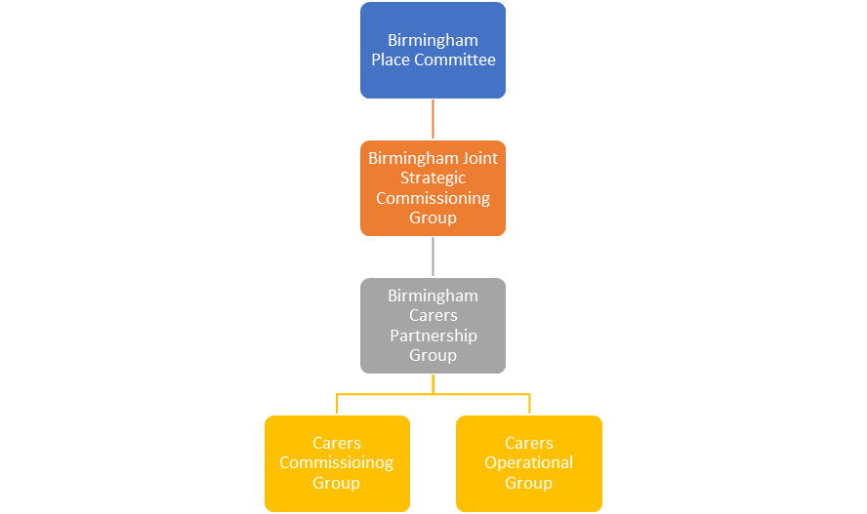

**15 Equality duty**

The Public Sector Equality Duty (Equality Act 2010) requires public bodies to have due regard to the need to eliminate discrimination, advance equality of opportunity and foster good relations between different people when carrying out their activities.

As such, our approach has and will continue to be informed by the latest available intelligence when determining key actions associated with the delivery of our strategy vision.

**16 Partnership Action Plan**

The strategy presents an opportunity to develop a new integrated Carers support and services action plan, aligning and bringing together commissioning bodies, partners, key stakeholders and Carers across the City. In addition, the strategy provides an opportunity to build on the pathway approach to commissioning and set out a future integrated approach to deliver the vision.

The Partnership Action Plan sets out a series of deliverable actions to support the strategic vision and help deliver Birmingham’s commitments to Carers. It links to the commitment we made to our Carers at the start of the strategy and the high-level partnership action plan will turn this into reality:

|  |  |  |  |
| --- | --- | --- | --- |
| **Action** | **Detail** | **Timeframe** | **Responsibility** |
| Complex SCA Pathway | Develop a clear, formal pathway between Birmingham Carers Hub and Adult Social Care for the escalation of Statutory Carers Assessments where Carer needs are too complex to be assessed appropriately via Birmingham Carers Hub alone. | In progress | Birmingham Carers Hub and BCC Adult Social Care |
| Safeguarding Pathway | To develop a clear, formal pathway between Birmingham Carers Hub and BCC Adult Social Care for the effective raising of safeguarding alerts, information sharing, follow-up on agreed actions and where any trends in safeguarding concerns can be identified and addressed through preventative action. | In progress | Birmingham Carers Hub and BCC Adult Social Care |
| Carer awareness | Continue to embed Carers awareness across Birmingham City Council, Birmingham Children’s Trust, Integrated Care Board, partners and voluntary and community sector. | In progress | Birmingham Carers Partnership Group |
| Short breaks | Review short breaks and produce options appraisal report. | Sep-24 | Birmingham City Council, Adult Social Care |
| Direct payments | Review approach to Direct Payments for Carers. | Dec-24 | Birmingham City Council, Adult Social Care |
| Carers voice | Continue to work with partners through Carers Partnership Group and carers Operational Group to ensure Carers voices are represented and listened to. | In progress | Birmingham Carers Partnership Group & Birmingham Carers Operational Group |
| Social Justice | Ensure all Carers are treated with equity. | In progress | All |

**APPENDIX A**

**National legislation**

Care Act 2014

Care Matters Green and White papers 2007

Carers Action Plan March 2021

Carers and Disabled Children’s Act 2000

Carers Strategy 2008 with action plan 2018 to 2020

Children and Young Persons Act 2008

Data Protection Act 2022

Education Act 2011

Equality Act 2010 update 2012

Gender Recognition Act 2015

Human Rights Act 1998

Health and Safety at Work Act update 2015

Independent Living Strategy 2008

Protection of Freedoms Act 2012

Public Sector Equality Act 2011

Putting People First 2007

Special Educational Needs and Disability Act 2001

Social Value Act 2012 and amendment 2021

The Children and Families Act 2014

**Local priorities**

Aging Well Programme

Early Intervention and Prevention

Locality agenda

Integrated Care Systems

Public Sector Equality Act 2010

Putting Prevention First

Strategy for Early Help in Birmingham 2015 to 2017

Vision and Strategy to modernise Adult Social Care

**References**

ADASS

APPG for Young Carers and Young Adult Carers Inquiry Report, November 2023

Care Act 2014

Carers UK

Census 2021

Children and Families Act 2014

Forward Carers

National Carers Strategy

Positive Pathway – St Basils

Princess Royal Trust for Carers

Putting Prevention First

Strategy for Early Help in Birmingham 2015 to 2017

Think Local Act Personal guidance

Tommy Whitelaw *(permission granted to use material)*

Vision and Strategy to modernise Adult Social Care

**APPENDIX B**

**What you told us**

|  |  |  |  |
| --- | --- | --- | --- |
| Date | Event/Document | Method | Numbers |
| 7th June 2023 | Launch Hub - Carers Week | Market stall | 200+ |
| 22nd November 2023 | Carers Rights event | Market stall | 200+ |
|  |  |  |  |

To be updated following consultation.