Birmingham carers Hub

Consultation document

Introduction

The vision for Adult Social Care is for people to live healthy happy independent lives within their communities.

It is important that unpaid carers have access to support when it is needed.

A carer is someone of any age who provides unpaid support to family or friends who could not manage without this help. This could be caring for a relative, partner or friend, who is; ill, frail, disabled or has mental health or substance misuse problems. In this instance the carer will be 18 years of age or older and be unpaid and/or informal.

Existing adult carer support services, Birmingham Carers Hub, for people aged 18 years or more are coming to the end of the contract period, 31st March 2023.

We want to recommission these types of services but improve on service design and delivery to ensure services are more person centred and build resilience and independence. We want to seek good outcomes for individuals and design the right services to achieve this.

Our consultation document sets out our proposals and we want to know what you think.

Background

Birmingham Carers Hub (Hub) was commissioned in 2019 and was jointly procured with Birmingham Children’s Trust and Birmingham and Solihull Clinical Commissioning Group embedding a carers pathway across all services. The Hub delivers a range of services including; young adult transition, carers partners in care card, emergency response, advice and information, dementia, small grants and health liaison project.

The Hub was commissioned as part of the carer’s pathway model with young carer and mental health carer services. There are clear links and pathways between the services to make a carers journey as easy as possible. Referrals and introductions are made between services to ensure the carer receives the right support at the right time.

The current contract will come to an end on 31st March 2023 and we need to begin a recommissioning process following the vision and pathway model which has proved very successful over the past three years.

The pathway approach will also ensure greater connections for carers with local community assets and Neighbourhood Network Services. The intention being that carers accessing the proposed commissioned services are also supported to gain access to a wider support and activity offer close to where they live, creating greater levels of independence, community resilience and overcoming isolation or unintended dependency on one support agency.

The pathway is illustrated below:

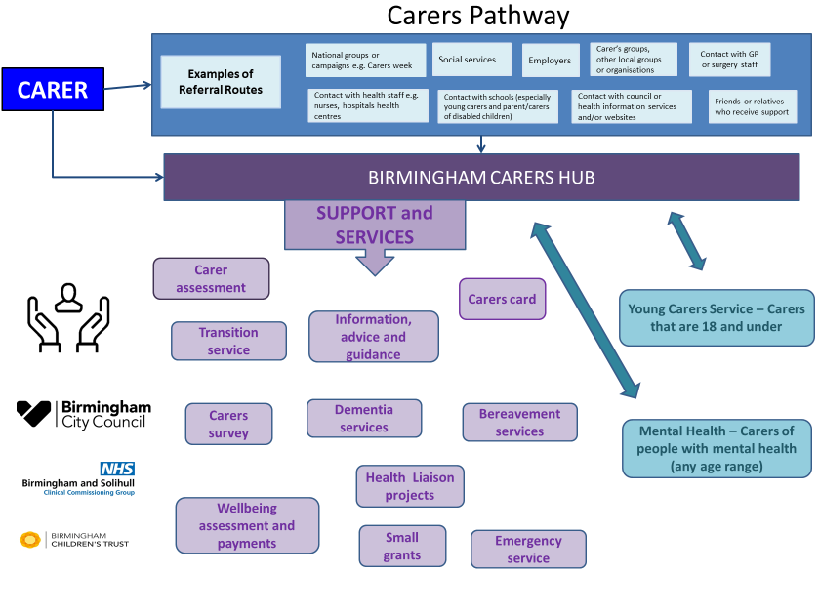
An effective prevention pathway will respond early and respond well to carers who are beginning to have difficulties in balancing their caring responsibilities, work and life. Key elements of the pathway include:

- A clear referral route into Birmingham Carers Hub.
- A clear link with young carer and mental health carer services.
- An indication of the type of support available.

The delivery of the Pathway will be commissioned across the key elements set out below. The intention being that the services commissioned work together as a system which prevents anyone from falling off the Pathway, failing to access services and enables re-entry into services should the need arise.

Proposed services to be commissioned

Carer assessments

The Care Act sets out the general duty to promote individual well-being which governs how local authorities must carry out their care and support functions under the Act. Section 10 of the Act provides a single duty to assess carers and requires a local authority to carry out an assessment (“carer’s assessment”) where it appears that a carer may have needs for support at that time, or in the future”.

Birmingham Carers Hub will carry out carers assessments for adult carers who have an appearance of needs and refer any complex cases to Adult Social Care. The assessment should add value to the statutory requirements by taking a whole family/household approach to include early identification of potential future carers such as young siblings of current carer and produce a support plan where needs have been identified.

Carers wellbeing assessments and payments

A wellbeing payment scheme providing funds of up to £250 to enable carers to take a break from their caring role.

Carers cards

A community and hospital carers card to provide identification and emergency contact details. The community card will provide local discounts and offers, and the hospital card will enable carers to assist with personal care and bathing, support and communication, care and discharge planning whilst the cared for is in hospital.

Advice and information for adult carers

Develop and maintain direct access to or signposting to a comprehensive information and advice set for carers of all ages.

Alongside a bespoke website, opportunities will be provided for carers to engage with online resources, be signposted to specific services for example through contact with peer support or volunteers, to visit mini HUBs or be provided with hard copies of specific information. A directory/register will be developed to enable carers to see what’s available and to be able to choose the type of service and support they may require.

Practical emotional and peer support

This will include informal networks of carers and ex-carers who are willing to act as experts by experience to support other carers who may be new to caring, at a point of crisis and seeking peer or emotional support and; 1:1 outreach support, emotional support including stress and brokerage to other services.

Advocacy and navigator role

Carers will have an advocate to help them access any services they may require and a navigator to guide them through the network and pathways of service provision in the city.

Community based work

Birmingham Carers Hub will develop strong links with and work in partnership with Neighbourhood Network Schemes and other community organisations to coordinate and support the design, development and delivery of a relevant, diverse and accessible offer for carers in their neighbourhoods and communities. This might include locally based provision for meeting venues and opportunities to mix, socialise, discover relevant advice and information and engage in activities.

Awareness raising and engagement

Birmingham Carers Hub will provide a social media profile which provides an environment(s) in which carers of all ages can chat and self-service through requesting and providing peer support. Develop partnerships with the voluntary and statutory sector to link across advice and information services and relevant strategies and policies to ensure a consistent approach to carers across the city raising the profile of carers and the services available.

Ensure stakeholders, partners and others are aware of the role a carer provides and the services available at Birmingham Carers Hub.

Training in relation to the caring role

Signpost or arrange relevant training in relation to caring roles such as self-care, managing stress, lifting and handling, carers entitlements, dementia, autism etc.

Bereavement service

Offer support for bereavement before the loss and after. This may involve providing direct support or sign posting/referring to existing bereavement services or counselling if appropriate. Develop and maintain peer networks to share advice and experiences.

Carers emergency and planned response (CERS)

Establish, maintain and deliver a planned and emergency response service for carers registered with Birmingham Carers HUB. Emergencies will include the sudden illness of the carer and the service provided will be an at home service for up to 48 hours while other family members or friend arrangements are established.
Planned events will include attendance at GP surgeries or hospitals to maintain the health of the carer. Access to planned services will require booking with Birmingham Carers HUB.

Parent carers

Birmingham Carers Hub will identify and develop appropriate support and advice/information for parent carers and promote support, benefits, activities and services available.

Young adult carers (18 – 25 years) transition service

This service will focus on all young carers transitioning into adulthood and all other young adult carers aged 18 – 25 years. The service components will include:
- Working jointly with the young carers services to co-design and deliver a transition space to enable a seamless journey between being a young carer and becoming an adult carer.
- Intensive one to one support and peer groups.
- Support to continue with existing networks and social integration.
- Undertake statutory transition carer assessments.
- Carer group sessions and fun activities.
- Support to achieve educational aspirations and to access employment.
- Help with accessing other support services.

Annual carers survey

An annual survey will be carried out to establish satisfaction levels of carers across the city and help us to identify any gaps in services provided.

Small grants specialist services

As part of the journey towards an integrated pathway for carers, there has been a recognition that small grant-based arrangements offer a unique flexibility in their activity and support for carers. Birmingham Carers Hub will issue small grants to smaller organisations who can provide a specialist service.

Health liaison project

The health liaison project is to support carers in a range of health settings including GP surgeries and hospitals. There will be a physical presence at hospitals and GP surgeries alongside liaison with health professionals. In addition, it will develop and maintain direct links with hospices to enable carers of people wanting to die at home to have access to relevant training and support.

Support dementia carers

These services will focus on specific support for carers who care for someone with dementia. They will:
- Be a person-centred support service for carers of people with a dementia
- Support carers at all stages of caring journey and be flexible and responsive to changes in circumstances.
- Be a single point of access for dementia related information, support and appropriate signposting to sustain caring role.
- Maintain contact with carers to check on progress and any changes in support requirements.
- Promote and advocate improvements and support for carers.
- Facilitate access to community-based support services.
- Develop networks with partners and key stakeholders.
- Assist in identifying needs and increase access to services.
- Advise on and facilitate access to peer led group support.
- Engage with GPs to encourage identification of carers and encourage referrals to appropriate services.
- Align to social prescribing model as a non-medical service providing a referral pathway helping to provide psychosocial and practical support.
- Work with other providers who can offer support in other ways.
- Provide specialist information and advice for carers of people with dementia and memory loss

