Draft BCC Private Sector Empty Property Strategy 2019 – 2024

- Foreword
- Key Objectives
- National Context
- Local Context and Analysis
- Achievements 2013 to 2018
- Delivering on Aims & Objectives 2019 - 2024

- Appendix A – Empty Property Action Plan
- Appendix B – Supporting Actions

- Foreword

Like most major cities in Britain Birmingham is faced with an acute and ongoing housing shortage. This gives rise to increased homelessness and housing affordability problems for many people.

Empty properties seriously affect the lives of people in the vicinity and have an adverse impact, driving down values around the problematic property. They attract vandalism and anti-social behaviour and are an unnecessary drain on public services.

Though empty property numbers have declined since Birmingham City Council published its first Empty Property Strategy in 2003 there are currently approximately 9,900 private sector empty homes in the city. This strategy aims to bring more empty homes back into use providing good quality, affordable housing to meet the evidenced housing need in the city.

At a time when local government resources are decreasing it is vital we make best use of available resources. The strategy and action plan that supports it outline how we propose to do this.

Empty homes are not the whole answer to the current housing crisis but government and local authorities cannot ignore their potential and the need to ensure that owners are both encouraged and, where appropriate, required to unlock the potential of this wasted resource.

The success Birmingham has had in tackling empty properties to date has been considerable. We aim to continue this, to ensure the city has the largest, highest quality stock possible to accommodate both its existing and future citizens.

2. Key Objectives

In developing the strategy we have identified a set of objectives we wish to achieve.

- Have a coordinated approach to empty property work to ensure the broadest corporate ownership of the need to address the blight of empty homes

- Ensure delivery of the Empty Property Strategy is linked with the Council Plan 2018 to 2022, the Birmingham Development Plan, the Housing Birmingham Strategy and the Homelessness Prevention Strategy

- Further publicise empty homes initiatives

- Provide encouragement and practical support to empty property owners

- Further develop and adopt enforcement procedures

- Enhance our approach to returning empty homes to use by continuing to work and share experiences with other local authorities

- Utilise funding available to bring empty homes back into use and provide affordable housing solutions across the city for people in housing need.

- National Context

High levels of empty properties have an adverse impact on communities and the environment. Returning empty homes to use assists in reducing homelessness and overcrowding pressures. It also tackles blight, the fear of crime and in the post Grenfell Tower era, fire safety.

In addition to the direct benefits to families and communities, bringing empty homes back into use plays an important role in meeting the need for new homes and the government’s target of delivering 300,000 new homes a year by the mid-2020s.

Alongside measures to increase council tax costs for owners allowing their property to stand empty, the Government has updated local planning polices to ensure they support the development of under-utilised land and buildings.

New Homes Bonus

New Homes Bonus is a grant paid by central government to local authorities for increasing the level of housing. The bonus is based on extra Council Tax revenue raised from new build homes, properties converted into homes and long term empty properties brought back into use. There is also an additional payment if the property is an affordable home.
The scheme is intended to act as an incentive for local authorities to have effective empty homes strategies. Rewards will only be paid for a net increase in housing, meaning local authorities could miss out on rewards for new homes built if empty property levels are allowed to increase.
Birmingham’s New Homes Bonus payments for 2017/18 totalled £14.19m. It’s clear that at a time when local government resources are diminishing the benefits BCC can accrue from the New Homes Bonus remain significant. It is imperative therefore we seek to maximise the value of the bonus payment.

- Local Context and Analysis

Birmingham City Council Plan: 2018 to 2022

The Council has a vision for Birmingham as a great city to live in. It states:

‘We want Birmingham to be a sustainable city of vibrant culture, flourishing neighbourhoods with good quality housing. A city with clean air, safe and clean streets and green spaces. We want to be a city where citizens have pride in where they live, have a strong sense of belonging and a voice in how Birmingham is run’.

To enable this the Council Plan identifies a number of priority outcomes against which success can be measured.

- Increasing the number of new homes completed in the city across a range of tenures
- Increasing the number of private rented sector properties improved as a result of local authority intervention
- Ensuring an appropriate number of homes built are affordable
- Minimising the number of households living in temporary accommodation.

Returning empty properties to use plays a major role in providing decent, long term homes for citizens.

Birmingham Development Plan 2031

By 2031 Birmingham will need an additional 89,000 homes for its growing population. Adopted in January 2017, the Birmingham Development Plan

sets out the statutory planning framework to guide decisions on development and regeneration to meet that requirement. Returning empty properties to occupation can make up a significant number of the additional homes needed.

Housing Birmingham Strategy

The Housing Birmingham Strategy is the Council’s housing strategy and is owned and managed by the Housing Birmingham Partnership. The partnership is open to all parties with an interest in housing in Birmingham and includes social landlords, private landlords and third sector organisations.
The strategy seeks to address empty homes in terms of homelessness reduction, improving stock condition and building neighbourhood pride.

Fig 1

Percentage of Homes (All tenures) Empty Longer Than Six Months at October 2017

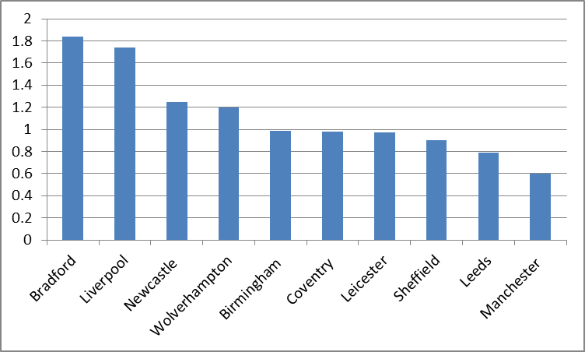

Selected comparison Cities

Source - Government Live Table 615

Council Tax records indicate that at June 2018 approximately 3,000 of Birmingham’s 9,900 empty properties had been unoccupied for less than six months. Figure 1 indicates that in terms of longer term empty homes Birmingham’s percentage figure rates as average compared to other large densely populated cities in England.

Breakdown of Empty Properties by Period Empty

Figure 2 illustrates how Birmingham’s 9,900 empty homes break down in terms of length of time empty. The 3,000 empty less than six months represents 30% of the total number of properties empty and 1.3% of the city’s total private housing stock.

A further 3,500 had been empty for less than two years and as a cumulative total, just under 66% have been empty for less than three years. Numbers continue to drop off steadily after three years. Numbers only rise again where properties empty for nine years or longer have been banded together. This figure includes cases where ownership of empty homes is unknown and difficult to establish.

Fig 2

Empty Property Numbers by Period Empty

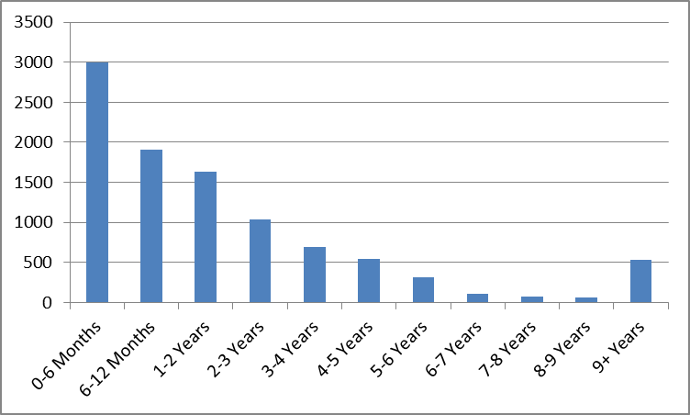

Distribution of Privately Owned Properties Empty Longer than
Six Months by District

Birmingham has a diverse housing market divided into ten districts. As the level of privately owned housing stock varies considerably between districts it’s useful to look at empty properties in individual districts as a percentage of their overall private housing stock.

At June 2018 the city wide average for private sector properties empty longer than six months was 3.1%. Four of the city’s ten districts (Ladywood, Edgbaston, Northfield and Hall Green) have an above average empty

property rate. These four districts contain 35.7% of the city’s private housing stock but account for 46.5% of its privately owned properties empty for longer than six months.

Fig 3 illustrates the per cent of empty stock within each district.

Percentage of Private Sector Empty Properties by District

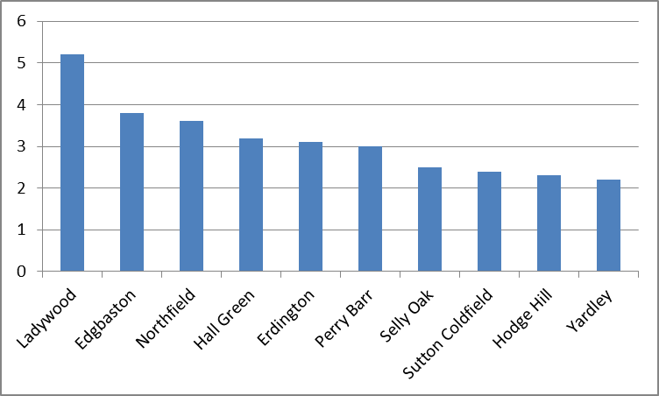

- Achievements 20013 to 2018

The Council’s Empty Homes Team have been particularly focussed on affordable, family size properties in areas of the city where a high incidence of empty homes and overcrowding has been identified. Precise targets included:

- Reducing the number of problematic and long term empty properties in the city by 1,158.
- Ensuring 60% of properties returned to use citywide were family sized homes (three or more bedrooms) in the more affordable Council Tax bands A-C.
- Ensuring 40% of all properties returned to use were in the housing market areas of East Birmingham and North West Birmingham – areas of the city where overcrowding and empty property levels are high.
- Investigation of all reported empty properties and proactive investigation of all identified long term empty properties.

The team has exceeded strategy targets, returning 1,647 problematic and long term empty homes that are unlikely to have been returned to use without
intervention. Within the headline target 63% of properties had three bedrooms or more and were in Council tax bands A to C. 37% were in the East and North West Birmingham HMAs.

The team also utilised enforcement powers to secure 198 dwellings to prevent unauthorised entry and ensure they are free from visual nuisance affecting the wider neighbourhood. In addition they have also been successful in securing Government funding to lease and repair 20 previously long term empty properties for use as additional social housing in the city.

Partnership Working

The value of partnership working in effective local government is well known. In addition to exceeding the headline strategy target the team have developed strong links with community groups, the Police and emergency services. Birmingham has also played a leading role in the West Midlands Empty Property Officers Group and the Empty Homes Network.

Empty Property Council Tax Restructuring

To further incentivise the occupation of empty homes Birmingham introduced changes in the way its council tax charges operate in relation to empty properties. Discounts relating to unfurnished properties or properties in need of structural repair have been abolished. Where a property has been empty and unfurnished for two years a council tax charge of 150 per cent is now applied.

The Government has recently announced that with effect from April 2019 local authorities will be free to charge up to 300% Council Tax on similarly qualifying empty properties. BCC Revenue and Finance officers have indicated they will be recommending the introduction of the full 300% rate at that date.

- Delivering on Aims and Objectives 2019 to 2024

Birmingham’s Empty Property Team has a strong track record in returning long term and problematic empty homes to use. For the lifetime of the 2019-24 Strategy we aim to ensure a minimum of 350 empty properties are returned to use each year. This is a challenging target equating to over 25% of the number of properties currently unoccupied for longer than six months in Birmingham.

Proactive Advice, Assistance and Enforcement

In the first instance owners of problematic or long term empty homes are contacted and asked about their future intentions for the property. General advice is offered including signposting to resources to support the owner.
Enforcement action is only pursued where less formal, lower level approaches have made no impact or where a property is a hazard to public health. Where the council considers enforcement action to be appropriate the approach will be fair, impartial and incremental.

Enforcement powers at our disposal include:

- Town & Country Planning Act 1990 (Section 215) – A notice can be served on the homeowner where a home is considered to be ‘detrimental to the amenities of the neighbourhood’.

- Local Government (Miscellaneous provision) Act 1982 – Under Section 29 the Council has the power to secure empty homes against access, where there is considered to be a danger to public health.

- Enforced Sale (Law of Property Act 1925) – The use of enforcement actions on empty properties can result in the gradual build up of debt if the work is carried out in default of the owner failing to comply with the enforcement notice. Where a reasonable charge has been registered against the property it is possible to force the sale of the property to recover that debt.

- Compulsory Purchase Order (CPO) S17 Housing Act 1985 – where owners cannot be traced, or are unwilling to bring their property back into use, the Council can seek to compulsory purchase a property and then sell it on the open market.

- Empty Dwelling Management Orders (EDMOs) – The Housing Act 2006 gives local authorities power to apply to the Residential Property Tribunal for an interim management order which may lead to compulsory leasing of the property for a fixed period of time.

As in the 20013-18 Strategy the team will place emphasis on some specific strategic areas and property types;

Affordable and Family Sized Homes

As part of a wider, citywide focus on delivering affordable, family sized homes, Empty Property Officers will continue to ensure that a minimum of 60% of properties returned to use have three or more bedrooms and are in the most affordable A-C Council Tax bands.

Tackling Overcrowding

The Survey of English Housing uses a ‘bedroom standard’ as an indicator for occupation density, allocating a number of bedrooms to each household according to the age, sex and marital status composition coupled with the relationship of the members to one another.

Data contained in the 2011 Census indicates that Birmingham’s citywide average for households lacking at least one bedroom is 8.9%. Of the city’s ten districts Ladywood (15.3%) and Hodge Hill (15.2%) stand out as the worst affected. For this reason we will ensure that 40% of all properties returned to use are in these two districts.

Strategy Action Plan and Supporting Actions 2019 – 2024

In addition to the numerical targets outlined in the Strategy Action Plan (Appendix A) a number of supporting actions are identified at Appendix B to support the continuous improvement of empty property work.

Strategy Review and Update

To ensure Empty Property Strategy delivery remains effective a full review will be undertaken each year. As well as monitoring progress against existing targets this will serve as an opportunity to revise strategy targets and supporting actions to reflect changing priorities.

EMPTY PROPERTY ACTION PLAN

Increasing the supply of affordable housing to meet the city’s needs
Links to other strategies and plans and national housing policy objectives | Local  BCC Council Plan 2018-22  Birmingham Development Plan 2031  Housing Birmingham Strategy  Homelessness Prevention Strategy 2017 |  | Regional  West Midlands Empty Property Officers Group |  |  | National  Empty Homes Network  New Homes Bonus
Partner Organisations | Empty Homes Agency, Empty Homes Network, National Landlords Association
Targets |  | 2019/20 |  | 2020/21 | 2021/22 |  | 2022/23 | 2023/24
Reduce headline number of empty properties in Birmingham by 1,750 by 2024  - 60% of homes returned to use to be family sized properties (3+ bedrooms) in council tax bands A-C  - Number of empty properties returned to use in Hodge Hill district  - Number of empty properties returned to use in Ladywood district |  | 350  (210)  (70)  (70) |  | 350  (210)  (70)  (70) | 350  (210)  (70)  (70) |  | 350  (210)  (70)  (70) | 350  (210)  (70)  (70)
Totals |  | 350 |  | 350 | 350 |  | 350 | 350
Appendix A: Outcomes – NB. These are draft outcomes and subject to change prior to publication

Appendix B: Supporting Actions
 | Action | Outcome | Implementation  Date | Responsibility | Monitoring
1 | Empty Property Website | Review and further develop empty property pages on the Council’s website with links to other relevant websites and an enquiry and reporting facility for people with concerns about empty properties. | 31 March 2020 | Private Sector  Empty  Property  Team | Housing Transformation Board
2 | Social Media | Continue to develop use of social media to advertise and disseminate advice and information on empty property issues to customers and partners. | Ongoing | Private Sector  Empty  Property  Team | Housing  Transformation  Board
3 | Council Tax Data Cleansing | Work with Council Tax colleagues to improve data quality relating to empty homes. | 31 March 2021 | Private Sector  Empty  Property  Team | Housing  Transformation  Board
4 | Additional Resources | Explore opportunities to acquire additional staff resource for the Empty Property Team. | Ongoing | Private Sector  Empty  Property  Team | Housing Transformation Board
5 | Annual Strategy Review | - Monitor progress against existing targets  - Consider revision of strategy targets and actions to reflect changing priorities. | Ongoing | Private Sector  Empty  Property  Team | Housing Transformation Board

