

COMMISSIONING PLAN VULNERABLE ADULTS SUPPORT FOR DISABILITIES AND MENTAL HEALTH



CONTENT

Introduction

Prevention First Outcomes

Disabilities and Mental Health pathway

Commissioning intentions

Evidence base:
- What you told us
- Needs analysis

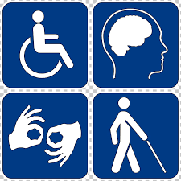

INTRODUCTION

We want to set out proposed commissioning intentions for vulnerable adults who have a disability or mild mental health issues such as anxiety or low mood. The ideas in the plan will be developed and co-designed with citizens, providers, partners and key stakeholders.

The aim is to commission services that address an identified need and achieve good outcomes for people.

The Prevention First Outcomes provide a focus for our services which are about early help and prevention.

Our commissioning will take a prevention pathway approach, which is based upon existing best practices within the city and nationally, to help drive systems change.

The pathway starts from the premise that the needs of vulnerable adults are not static and often change at different points in their lives and due to life events.

An effective prevention pathway will respond early and well to people who are at risk of losing their independence or home or are beginning to have difficulty in managing their home. The pathway works to provide a range of flexible responses for people requiring some form of support to create an environment where they can flourish.
PREVENTION FIRST OUTCOMES

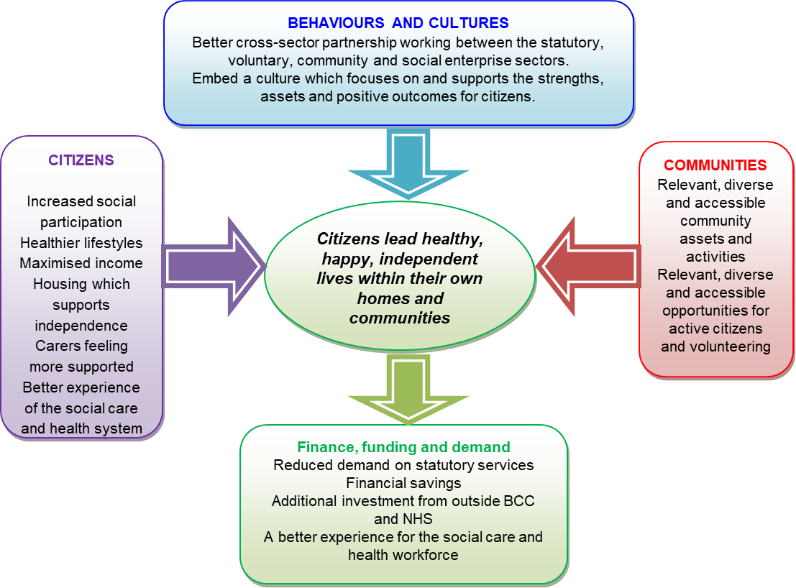
Birmingham City Council has committed to a “Prevention First” vision of Birmingham where “citizens lead healthy, happy, independent lives within their own homes and communities”. This vision underpins a new approach to commissioning prevention focused services and activities in the Adult Social Care Directorate, with four domains.

DISABILITIES AND MENTAL HEALTH – PATHWAY

Our pathway has been developed taking a prevention approach with providers, stakeholders, partners, the voluntary sector and importantly service users. This will ensure we get it right and develop a pathway that is transparent and easy for service users to follow and that is practical and deliverable. Our pathway can be seen on the next page.

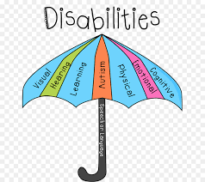

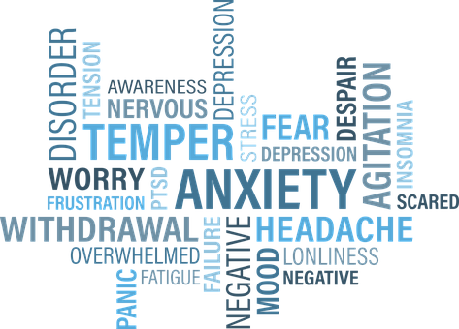
Disabilities and Mental Health Pathway

TARGETED

UNIVERSAL

TRANSITION

ADVICE & INFORMATION

LEAD WORKER
SUPPORT INTO ACCOMMODATION

ADVOCACY

COMMUNITY
NAVIGATOR
ENABLEMENT SERVICE

PURE*

* PURE is a part-funded European Social Funded project. It brings together a range of coordinated interventions which will assist the needs of citizens with barriers into the employment market
COMMUNITY
ASSETS AND HUBS
The key parts of the pathway and the services we want to commission are:

Universal Prevention

We want to ensure that everyone has access to the advice and information they need with the intention to link into existing services.

This will include access to a wide range of timely, accurate information and advice about, health and wellbeing, financial issues, education, work, training opportunities, community assets and housing options. The aim is to prevent personal crisis or issues with accommodation occurring in the first place. Web based chat will also be available.

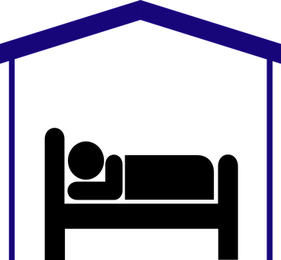

Targeted Prevention

Targeted prevention will provide support for those who need help to overcome the challenges they face. At the core will be a Community Navigator service to help people find the right information at the right time and access services they may require. This will be a short-term service providing face to face support and access to relevant services aimed at providing prevention activity. Co-location of Community Navigator services is being considered to enable vulnerable adults support and other requirements to be accessed in the same place providing an easier pathway for individuals to get the right support at the right time.

Part of the Community Navigator service will be universal.

Lead Workers will provide initial and on-going engagement with clients and develop support plans and will be a longer-term service. The intention is to provide support individuals need to overcome challenges and equip them to face and deal with challenges in the future.

Transition

Accommodation will be short or longer term and will be delivered by multiple providers based on specialism.

Support will provide a multi-agency response to presenting health needs; including primary health interventions.

In addition, as part of the transition services, there will be a six-month enablement service for people with learning disabilities moving out into the community. They could be leaving residential care or moving out of a family home setting. In addition, the service will provide links to mental health community groups.



COMMISSIONING INTENTIONS

The commissioned support for disabilities and mental health will help create an environment where vulnerable and sometimes excluded people can flourish. This may include having a suitable home to move into, living an independent life, better managing health and wellbeing, contributing to wider society and managing their own home.

In terms of commissioning there are a range of considerations including:

- The contribution of vulnerable adult support for disabilities and mental health services to the strategic objectives of Birmingham City Council;
- Integrated approach to commissioning with Public Health and Adult Social Care, with a shared priority to focus on prevention. This may include co-location of services. Integrated commissioning will remove the risk of any duplication in service delivery making best use of limited available resources;
- Outcomes based commissioning including an element of Payment by Outcomes, focusing on system change and partnership working, contracting methodology;
- Diversity competent services;
- The commissioner defined social value outcomes and provider led innovation outcomes: and
- The most appropriate commissioning methods.

All the services will support and help to deliver Prevention First outcomes and key elements will include:

- Approaches which promote improved health and
wellbeing including outcomes related to overcoming isolation, financial inclusion through access to paid work, better managing mental and physical health and connections into local community assets in order to regain or maintain independence within communities.
- A response at the right time to people who do become
vulnerable due to personal circumstances including leaving institutional settings or care, family circumstances and health issues.
- Provision of supported accommodations for vulnerable
adults who find themselves in crisis for a short period of time.
- Activity enabling people to make informed choices
about their housing circumstances before the need for more costly interventions.

The new commissioning of vulnerable adult support for disabilities and mental health sets out to ensure accommodation is not a barrier or cause of poor health and wellbeing with the intention people move to their optimal position along prevention pathways at a pace suited to them.

EVIDENCE BASE

What you told us

As part of our co-design process you told us:

- Things have changed in the mental health world including:
  - People’s needs are much more complex.
  - There has been an impact from the reduction of substance misuse services.
  - The changes to benefits have also had an impact.
- There are three main types of client facing mental health issues:
  - Anxiety issues requiring wellbeing type support.
  - People that can’t be supported by the Mental Health Trust.
  - People who have been assessed by the Mental Health Trust but also need housing and wellbeing support. This represents a big percentage of the client base.
- The service needs to be flexible for people at different stages of their journey.
- It is also important to be flexible on length of stay in supported housing, number of hours per client and be clear about timescale of floating support.
- There is not enough support for people presenting with low level needs in the community.
- Housing is a big gap.

Needs analysis

By 2026 it is estimated that the number of learning disability clients requiring support will increase by 117 and mental health 74 as shown in Tables one and two.

Table one – estimated increase learning disability clients
Age | 2016  No’ clients | 2021  % change | 2021  No’ clients | 2026  % change | 2026  No’ clients
Less than 18 | 6 | 8.1% | 7 | 4.0% | 8
18 to 24 | 175 | -4.1% | 168 | 6.5% | 179
25 to 38 | 398 | 6.4% | 424 | -0.7% | 421
39 to 52 | 541 | -0.7% | 537 | 6.7% | 573
53 to 64 | 301 | 10.4% | 332 | 3.5% | 344
65+ | 99 | 4.9% | 104 | 8.1% | 112
Total | 1,520 |  | 1,572 |  | 1,637
Data source: BCC

Table two – estimated increase mental health clients
Age | 2016  No’ clients | 2021  % change | 2021  No’ clients | 2026  % change | 2026  No’ clients
Less than 18 | 0 | 8.1% | 0 | 4.0% | 0
18 to 24 | 43 | -4.1% | 41 | 6.5% | 44
25 to 38 | 227 | 6.4% | 242 | -0.7% | 240
39 to 52 | 456 | -0.7% | 453 | 6.7% | 483
53 to 64 | 192 | 10.4% | 212 | 3.5% | 219
65+ | 45 | 4.9% | 47 | 8.1% | 51
Total | 963 |  | 995 |  | 1,037
Data source: BCC

Learning disabilities

The risk of dying under the age of 50 for someone with a learning disability is 58 times greater than the general population. This is reflected in Table three which illustrates that it is the younger age groups that experience a higher number of people with this type of disability and the overall learning disability population is expected to increase by 7.5% over an eleven-year period.

Table three – predicted population learning disability
Predicted LD | 2017 | 2020 | 2025 | 2030
18 to 24 years | 3,723 | 3,671 | 3,669 | 4,006
25 to 34 years | 4,395 | 4,532 | 4,619 | 4,475
35 to 44 years | 3,509 | 3,643 | 3,785 | 3,987
45 to 54 years | 3,155 | 3,111 | 3,041 | 3,141
55 to 64 years | 2,380 | 2,541 | 2,752 | 2,723
65 to 74 years | 1,668 | 1,722 | 1,813 | 2,041
75 to 84 years | 984 | 1026 | 1414 | 1,238
85+ years | 413 | 439 | 500 | 572
Total | 20,227 | 20,685 | 21,593 | 22,183
Data source: Pansi & Poppi 2019

Not all the learning disability population will require a specific service and it is estimated that 21.3% will have a moderate or severe disability that necessitates some level of support. Table four shows the expected numbers by age group.

Table four – predicted moderate/severe learning disability
Predicted moderate/ | 2017 | 2020 | 2025 | 2030
severe
18 to 24 years | 861 | 852 | 861 | 947
25 to 34 years | 944 | 973 | 992 | 961
35 to 44 years | 881 | 906 | 952 | 1,004
45 to 54 years | 711 | 701 | 689 | 717
55 to 64 years | 519 | 554 | 596 | 587
65 to 74 years | 270 | 279 | 294 | 332
75 to 84 years | 102 | 106 | 118 | 126
85+ years | 39 | 41 | 46 | 52
Total | 4,327 | 4,412 | 4,548 | 4,726
Data source: Pansi & Poppi 2019

In addition, it is expected that the population with autistic spectrum disorders is expected to increase by 9%. Table five shows the numbers by age.

Table five– predicted autistic spectrum disorders
Predicted autistic | 2017 | 2020 | 2025 | 2030
spectrum disorders
18 to 24 years | 1,381 | 1,366 | 1,396 | 1,498
25 to 34 years | 1,779 | 1,657 | 1,926 | 1,875
35 to 44 years | 1,421 | 1,451 | 1,532 | 1,636
45 to 54 years | 1,328 | 1,310 | 1,269 | 1,302
55 to 64 years | 1,035 | 1,096 | 1,183 | 1,176
65 to 74 years | 741 | 770 | 812 | 906
75+ years | 613 | 648 | 734 | 820
Total | 8,298 | 8,298 | 8,852 | 9,213
Data source: Pansi & Poppi 2019

Physical disabilities

Data modelled using POPGROUP Software estimates the number of people aged 10 or more in Birmingham estimated to have some form of disability over the next 20 years. They show estimates across a range of scenarios and for higher severity disabilities each scenario presents an increase of around 10,000 people every five years, whilst for lower severity disabilities it is 4,000. This represents a 20% increase for higher severity and 17% for lower by 2031.

For locomotor disabilities there is an expected average increase of 4,000 every five years resulting in an 18% increase by 2031. For sensory disabilities the estimated increase is 21% by 2031. Table six shows the scenarios and estimates for a range of disabilities.
Table six – Estimates disability population aged 10 or over – optimistic scenario
Disability | 2011 | 2016 | 2021
Higher severity | 42,949 | 44,336 | 46,356
Lower severity | 102,976 | 106,284 | 110,692
Locomotor | 105,947 | 109,402 | 114,215
Personal care | 55,915 | 57,783 | 60,244
Hearing | 38,599 | 39,946 | 41,827
Sight | 18,828 | 19,425 | 20,356
Data source: POPGROUP Software data modelling

Mental health

It is estimated that in 2014 there were circa 166,109 adults aged 18 to 64 experiencing some form of mental health issue. By 2025 the numbers are expected to increase by 5.6%. Table seven shows the estimated and predicted number of people expected to experience some form of mental health issue across a spectrum of disorders.

Table seven – Mental health disorders
Disorder | 2017 | 2020 | 2025 | 2030
Common mental disorder | 112,273 | 114,084 | 116,608 | 119,206
Borderline personality disorder | 3,140 | 3,188 | 3,257 | 3,328
Antisocial personality disorder | 2,431 | 2,478 | 2,547 | 2,618
Psychotic disorder | 2,790 | 2,834 | 2,897 | 2,961
2 or more psychiatric disorders | 50,171 | 50,999 | 52,196 | 53,414
Total | 170,805 | 173,583 | 177,505 | 181,527
Data source: PANSI & POPPI 2019

- There are currently too many mental health patients in hospital around 250 of which around 160 could be moved out.
- The NHS is investing in community provision.
- There is a presence at GP surgeries with CPNs providing primary care liaison.
- There are around 800 people in the city in accommodation under a section 117.
  - There are around 250 people in a long-term hospital setting falling under the following categories; High dependency presenting challenges such as aggression in hospital 5 years or more.
  - Continuing needs such as people aging with many ending up in residential care.
  - Active rehabilitation where they are encouraged to go out and have open doors. This may be the client group where housing and wellbeing support could assist in getting them back out into the community, around 125 people.
- There are around 3 NHS referrals each month with a potential of 40 new clients each year.



