Vulnerable adults Support FOR DISABILITIES AND MENTAL HEALTH

Consultation document

Introduction

The vision for Adult Social Care is for people to live healthy happy independent lives within their communities. Access to a supply of good quality, affordable housing and support options are key to the delivery of that vision.

It is important that vulnerable adults have access to safe, secure, quality affordable housing and support at the moment when it is needed.

A vulnerable adult in this instance could be anyone who has a disability or poor mental health and are struggling to self-manage a home, finances or their health.

Existing support services that support the needs of people affected by a disability or poor mental health are due to reach the end of the contract period on 30th June 2022. Birmingham City Council is keen to not only recommission these services, but also improve on service design and delivery to ensure that services are more person centred and build resilience and independence.

Background

On 16th April 2019 a report to Cabinet for the recommissioning of ‘Vulnerable Adults Housing and Wellbeing Support Services’ was agreed. This was part one of commissioning, which included support services for homelessness, domestic abuse, young people, and people leaving intuitional settings. These contacts went live 1st December 2019.

We are now preparing for the second phase of recommissioning that covers the disabilities and mental health client groups.

The approach is similar to the first phase of commissioning, with a Positive Pathway consideration being used. Commissioners are working closely with CCG partners to ensure that there is a seamless step down for citizens, who move through statutory health and social care services into community-based living.

The current contracts come to an end 30th June 2022 with the new contracts expected to start 1st July 2022. It is proposed that the contracts will run for five years.

Commissioning will take a pathway approach across the key components set out in this document. The access points for vulnerable adults will be dependent upon their individual needs and circumstance, with the intention that services commissioned work together as a system which prevents anyone from falling off the pathway, failing to access services and enables re-entry into services should the need arise.

Pathway

This consultation concerns the development of a prevention focused support pathway.

Online resources/information, advice and guidance are proposed to be a significant feature of the pathway approach, ensuring that both customers and professionals have a clear overall picture of available resources to prevent escalating need or alleviate crisis.

The access points for vulnerable adults will be dependent upon their individual needs and circumstance.

The Pathway will build on and integrate with the NHS Transformation Pathway for mental health services. This will enable robust links, seamless transitions and avoid duplication.

This will be achieved by:
- Building upon the success of nationally and locally recognised pathways such as Carers, Young People and Homelessness.
- The Pathway will have a focus on Universal, Targeted and Transitional services.
- Proposed commissioning along the Pathway will be subject to continued co–design with existing providers, service users, wider stakeholders, including the social work teams, public health, carers, CCG and this formal public consultation process.

The Pathway starts from the premise that support needs of vulnerable adults are not static they often change at different points in their lives and as a consequence of life events. Similarly national research undertaken by Crisis 2018 demonstrates that certain cohorts of population are at greater risk because of their precarious housing circumstances which can lead to a deterioration in their physical and mental health, repeat and increased access to institutional settings such as hospital, registered care or its extremes of prison, homelessness or rough sleeping.

An effective prevention pathway will respond early and respond well to people who are beginning to have difficulties in managing their home, health and finances. Key elements of the pathway include:

- Activity which enables people to make informed choices about their housing circumstances before their needs escalate into more costly interventions.
- Provide a time critical response to those that do become vulnerable due to precarious housing and personal circumstances including leaving institutional settings, family circumstances, care-leavers, and people experiencing domestic abuse.
- Provision of support into accommodation for vulnerable adults who find themselves in crisis for a short period of time in order to provide a range of support interventions that focus on strength based approaches to recovery and resilience which promote wider health and wellbeing including outcomes relating to overcoming isolation, financial inclusion through access to paid work and connections into local community assets in order to regain or maintain independence within communities.

The delivery of the Pathway will be commissioned across the key elements set out below; the access points for vulnerable adults will be dependent upon their individual needs and circumstance. The intention being that the services commissioned work together as a systems which prevents anyone from falling off the Pathway, failing to access services and enables re-entry into services should the need arise.

The proposed types of services are:

- Universal prevention - Services will be available to all vulnerable adults and will focus on self-enablement and accessing local community assets such as Neighbourhood Networks:
  - A comprehensive online housing and independence support service is being developed to act as a proactive response to a combination of presenting factors such as poverty, poor health, precarious housing circumstances and risks of homelessness. This may involve the use of existing advice and information services rather than commissioning a new and separate service.
  - The service will be tailored for individuals to self-navigate and for use by professionals, practitioners and carers acting on behalf of the individual.
  - It is proposed that this service will be part of the Navigator service, which will also provide universal support in terms of advice and information.

- Targeted prevention - Services will be client specific and delivered by a Navigator service to provide face to face support and access to relevant services aimed at providing prevention activity. Part of the Navigator services will be universal as mentioned above and will be a short-term service. Co-location of Navigator services is being considered to enable vulnerable adult support and other requirements to be accessed in the same place providing an easier pathway for individuals to get the right support at the right time.

Lead Workers will provide a longer term and more personalised service including; initial and on-going engagement with clients and development of support plans. The intention is to provide support individuals need to overcome challenges and equip them to face and deal with challenges in the future.

- Transition – services will provide support delivered into accommodation and maybe short or longer term delivered by a range of providers. There will also be an enablement service for people with learning disabilities.

The design and specification of the services will facilitate clear pathways for support and ensure that a strong prevention first focus is built into every stage. Dialogue relating to alignment, integration and opportunities for joint commissioning with partners is continually taking place in order to secure access into services for the most vulnerable. These include:

- Development of a joint mental health pathway with CCG and NHS provider trusts.
- Potential to co-locate services with other providers.
- Access to community assets and local neighbourhood networks services, migration and resettlement support.

There are three main client groups being identified across the pathway:
- Mental health
- Learning disabilities
- Physical/sensory disabilities.

The identification of the client groups will be informed by this consultation alongside the detail and scope of the proposed service provision.

A diagram of the pathway can be seen on the next page.
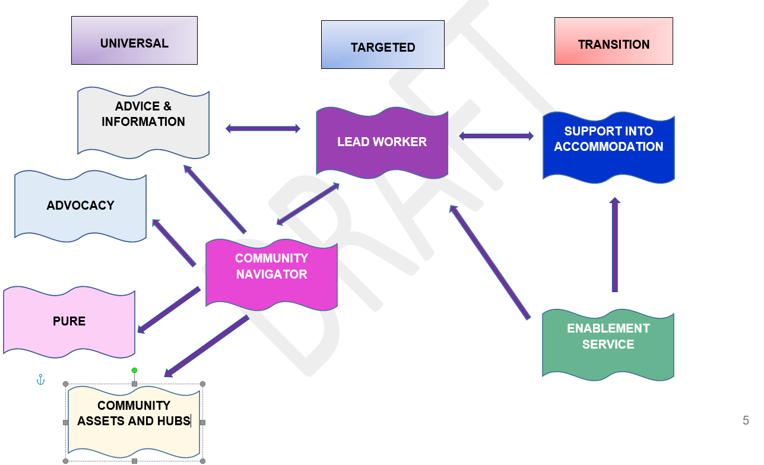
PURE is a part-funded European Social Funded project. It brings together a range of coordinated interventions which will assist the needs of citizens with barriers into the employment market

