Directorate for Adult Social Care

VULNERABLE ADULTS SUPPORT FOR DISABILITIES AND MENTAL HEALTH

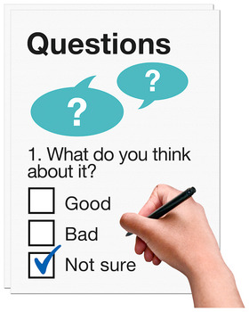
EASY READ QUESTIONNAIRE

February 2021 to
March 2021

This questionnaire is easy to read

Adult Social Care pay for vulnerable adults support for people with disabilities – these are: Learning Disabilities, Mental Health and Physical and Sensory Disabilities.
Our services provide support to help people to live independently; this support helps to prevent people accessing statutory services, which cost more.
We have written a document (Commissioning Plan) which explains the type of vulnerable adult support for people with disabilities we would like in future. We want to make sure that we get the right type of services that offer the right kind of support.
We want to know what you think about some of the changes we are thinking about:
- We want to help vulnerable people to do as much as they can for themselves
- We want to support vulnerable people to move into more independent and community living
- We want to support vulnerable people to stop their condition from getting worse and having to access higher level services
These ideas are called a “Customer Pathway” and describe the way we would like these services to work in future.
Learning Disability and Mental Health Services
All services will have to give advice, information and guidance; they must be able to support people with different needs. We would like to support people to help them live in community based accommodation – we need to make sure that we have as much of this kind of accommodation as we can.
Physical and Sensory Disabilities
We would like to make sure that people with these disabilities get good quality advice and guidance, as well as some short-term support to help them to be more independent and to be able to do more for themselves.


QUESTIONS
Q1. Do you agree with the ideas for a customer pathway for prevention services?
Yes No
Tell us why you think this

Q2. Do you agree that Lead Workers/Navigators should share office space with others across the city?
Yes No
Tell us why you think this

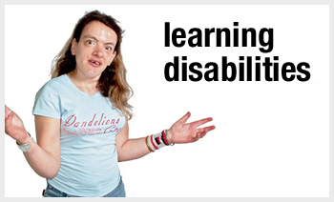




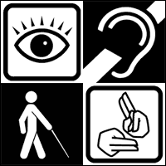
Q3. Do you agree that advice and information should be provided by existing services?
Yes No

Tell us why you think this

Q4. Do you think we need specialist services for autism and/or personality disorders?
Yes No
Tell us why you think this:


Q5. Do you think our services need to be flexible to deliver support in different ways such as texts, telephone calls or emails?
Yes No
Tell us why you think this:


Q6. Do you think that we should work more closely with the community and support people to join community organisations and groups?
Yes No

Tell us why you think this

Q7
Do you have any other comments? Please provide below.

About You
We would like you to tell us something about you. You do not have to tell us but if you do it will help us to plan these services.
Data Protection Act 1998
The personal information you give us on this form will be kept safe and is protected by law. You can see more about data protection on our website at: http://www.birmingham.gov.uk/privacy

What best describes your interest in this consultation:
A member of the general public
Someone who has accessed housing support services
Health or Care Professional
Provider of a housing support service
Other (please state): _________________________________________________________________

Your Postcode: ___________________________________________________________
Which age group applies to you? (please ✓)
24 or younger | 25 to 29 | 30 to 34 | 35 to 39 | 40 to 44 | 45 to 49 | 50 to 54 | 55 to 59
60 to 64 | 65 to 69 | 70 to 74 | 75 to 79 | 80 to 84 | 85 or over | Prefer not to say

What is your gender?
Female Male Prefer not to say

Do you have any physical or mental health conditions or illnesses lasting or expecting to last for 12 months or more?
Yes No Prefer not to say

What is your ethnic group (please ✓ below):
Ethnicity | ✓
White – English/Welsh/Scottish/Northern Irish/British
Other White background – please state
Mixed/multiple ethnic group
Asian/Asian British
Black African/Caribbean/Black British
Indian Sikh
Jewish
Other ethnic group – please state

What is your religion or belief? (please ✓ below):
Religious Belief | ✓
No religion
Christian - including Church of England, Catholic, protestant and all other Christian denominations
Buddhist
Hindu
Jewish
Muslim
Sikh
Other religion – please state

What is your sexual orientation (please ✓ below):
Sexual Orientation | ✓
Heterosexual or straight
Gay or Lesbian
Bisexual
Prefer not to say
Other – please state

Thank you for taking part in this questionnaire

