Statutory Notice
Proposal by the Governing Body of King’s Norton Boys’ School.

Notice is given in accordance with section 19 (3) of the Education & Inspections Act 2006 that the Governing Body of King’s Norton Boys’ School proposes to make a prescribed alteration to King’s Norton Boys’ School (a foundation school), Northfield Road, Birmingham B30 1DY, namely to alter the age range of the school from 11 – 18 to 11 – 16 with effect from 31st August 2018.
The Governing Body is proposing that the school would stop offering sixth form places and that no Year 12 students will be admitted to the sixth form in September 2017. However, as the school’s admission arrangements have already been determined for September 2017, the school is required to also ask the Schools’ Adjudicator for permission to change the arrangements.
The current capacity of the sixth form is 120 – of which 50 places are reserved for external applicants.
The proposed capacity of the sixth form is 0.
This notice is an extract from the complete proposal. Copies of the complete proposal can be found on line (www.kingsnortonboys.bham.sch.uk) or can be obtained from the school by writing to Mrs Sarah Holland, PA to Headteacher, King’s Norton Boys’ School, Northfield Road, Birmingham B30 1DY.
Within four weeks from the date of publication of this proposal, any person may object to or make comments on the proposal. Anyone who wishes to make representations about these proposals should either make comments through the Birmingham Beheard website:
https://www.birminghambeheard.org.uk/people-1/kingsnortonboys
Or by writing to the School Organisation Team Education and Skills Infrastructure, PO Box 15843, Birmingham B2 2RT. The date by which objections or comments must be received by is midnight on Thursday 2 February 2017.
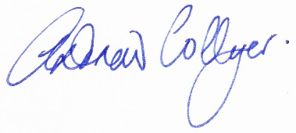
Andrew Collyer
Chair of Governors

Publication date: 5 January 2017

