
Birmingham City Council Education Department

Gorcott Hill
Redditch
Worcestershire
B98 9ET
(for SatNav purposes ref: B98 9EN) Registered Charity No. 1112214
Telephone: 01527 853851
www.skiltsschool.co.uk
email: enquiry@skilts.bham.sch.uk

Headteacher: D A Crompton B. Ed Hons PG. Dip NPQH
Deputy Head: Miss C Redman B Ed Hons

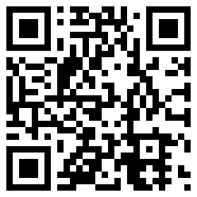
Re: Formal Consultation

Monday 4th May 2020

Dear Colleague
I am writing to inform you about the start of a formal consultation period proposed by Skilts Interim Executive Board with regard to a temporary alteration to the Skilts School pupil age range. We are proposing this from September 2020

The details about the proposal and information about how to make representation are in the accompanying consultation document. The consultation will run from today until Friday 5th June 2020.

Yours sincerely

Dominic Crompton
Head Teacher
For and on Behalf of the Interim Executive Board of Skilts School

