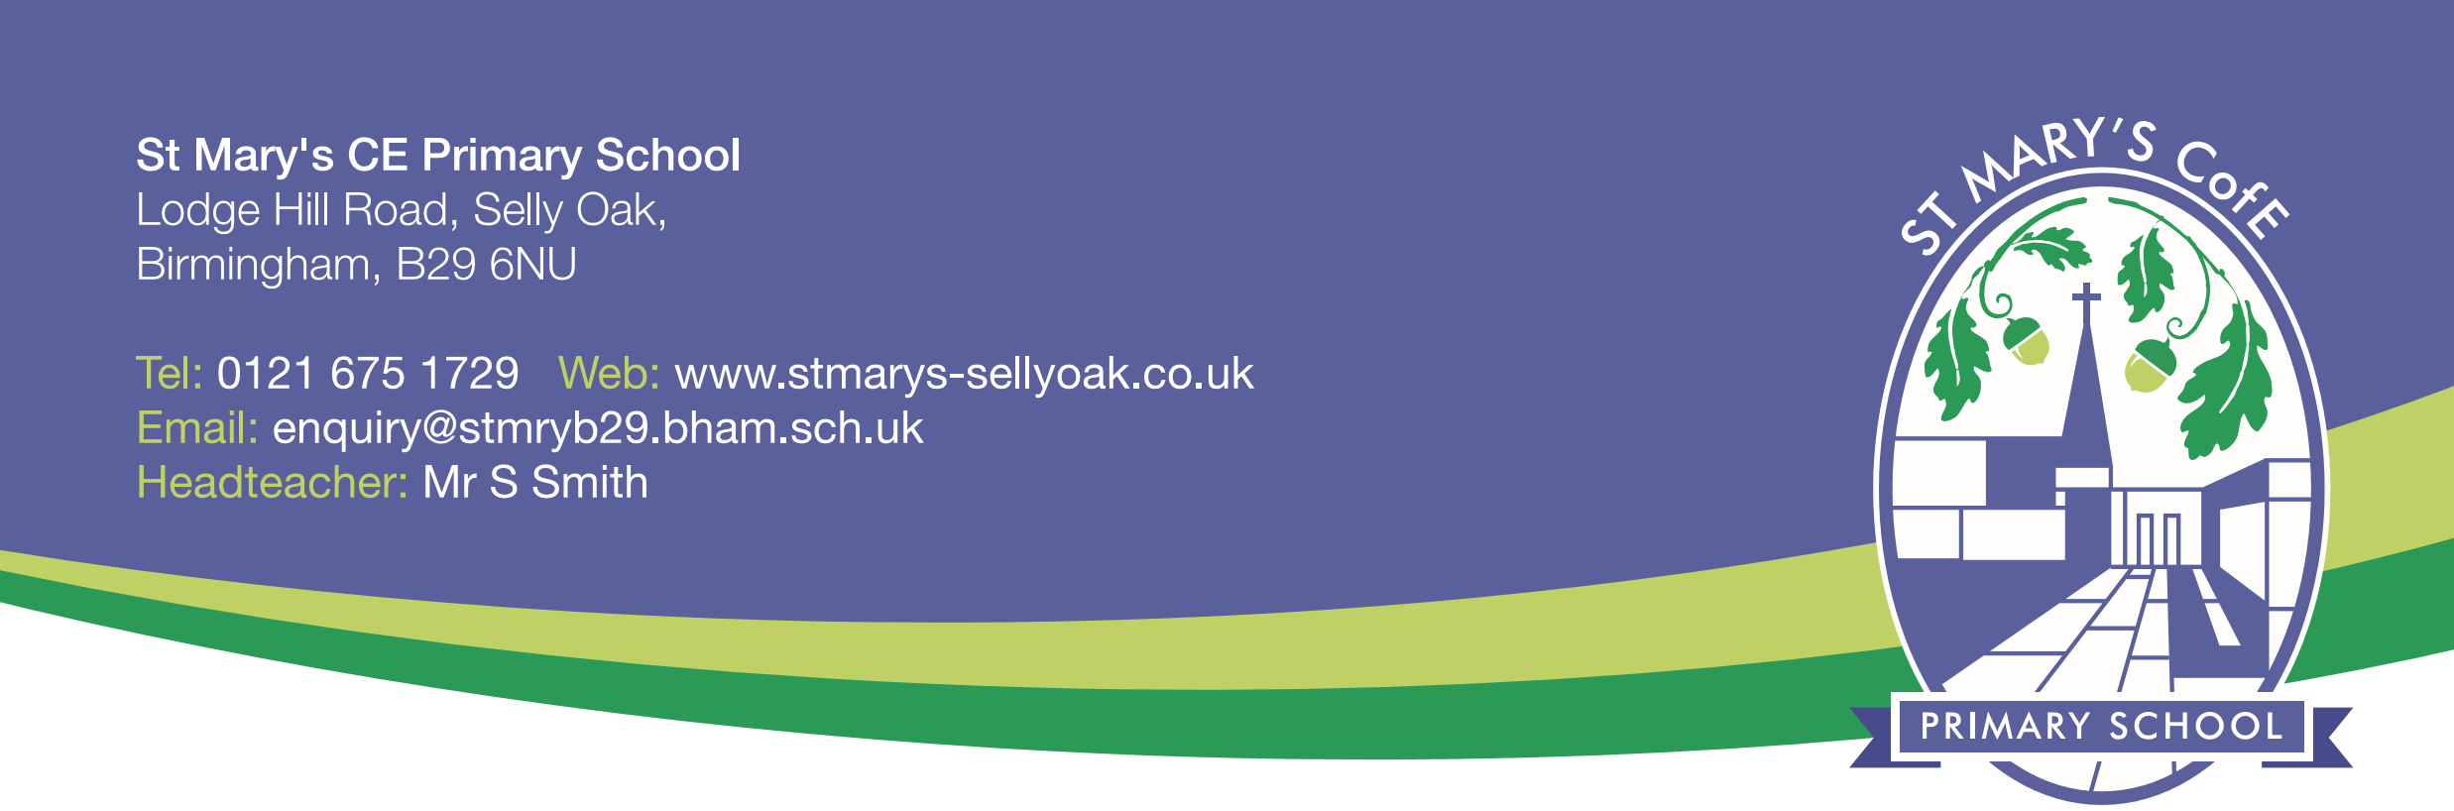
Statutory Notice
St. Mary’s Church of England Primary School Proposal for change of status from Voluntary Controlled to Voluntary Aided

Notice is given in accordance with section 19(3) of the Education and Inspections Act 2006 that the Governing Body of St. Mary’s Church of England Primary School intends to make a prescribed alteration to St. Mary’s Church of England Primary School, Lodge Hill Road, Selly Oak, Birmingham, B29 6NU from 1st September 2019.
It is a proposed strategic decision by the Governing body to change the status of the school from Voluntary Controlled to Voluntary Aided. This notice is an extract from the complete proposal document. Copies of the complete proposal can be obtained from the school website at:
www.stmarys-sellyoak.co.uk
Within four weeks from the date of publication of this proposal, any person may object to or make comments on the proposal. Anyone who wishes to make representations about this proposal should either make comments through the web site:
https://www.birminghambeheard.org.uk/people-1/stmarysceb29final
or in writing to:
The School Organisation Team, Education Infrastructure, PO Box 15843, 1 Lancaster Circus, B2 2RT

Comments or objections must be received not later than this date: 27/03/2019.

Mr Gerald Fage Mrs Sarah Down
Co -Chair of Governors Co -Chair of Governors

Publication date: Thursday 28th February 2019

