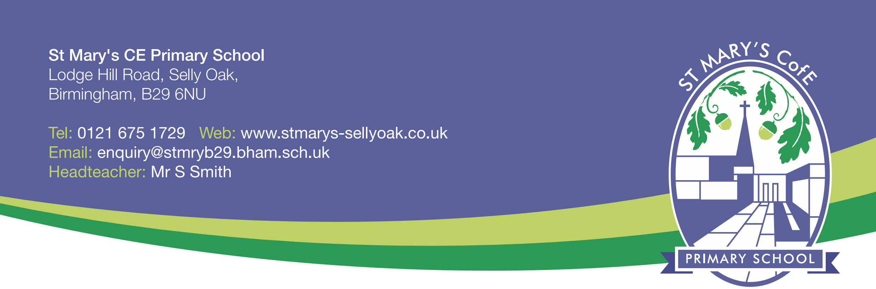
FULL PROPOSAL
CHANGE OF STATUS FROM VOLUNTARY CONTROLLED TO VOLUNTARY AIDED
- St. Mary’s CE Primary School, Lodge Hill Road, Selly Oak, Birmingham, B29 6NU.
- LA details: Birmingham City Council, Education & Skills Infrastructure, PO Box 15843 Birmingham B2 2RT
The Governing Body are proposing to alter the school’s current status of ‘voluntary controlled’ to ‘voluntary aided’.
St. Mary’s CE Primary School is a 2 form entry voluntary controlled school under Birmingham City Council. It is a popular school and serves the local community very well. All classes are full and there are waiting lists in many year groups. The school has always had very close links with St. Mary’s church, located close by, and will continue to do so. Outcomes for pupils leaving the school from 2014 onwards have been strong and consistently above the national average and within the top 10% of schools nationally at KS2. The school, like all schools, faces financial challenges but is well-placed to sustain this in the long-term due to careful and precise long term planning; this conversion forms part of this long-term planning.

- Whilst we are proposing to change our status, we are not intending to make changes to our admissions and strategic decisions will continue to be taken by the school’s governing body.

- The governing body of the school has agreed on the change of status as it will give them more freedoms when making strategic decisions. They will have more flexibility when making decisions on areas of the curriculum – notably RE and also within governance and finance.

- `Changing our status will have no effect on local schools within the area and there will not be an increase in the number of faith schools as we are currently a faith school.

- Any additional costs to the change will be minimal and met through the school’s budget. The publication of the statutory notice in a local newspaper will be the only cost to the school.

- The school intends to convert on 1st September 2019.

Within four weeks from the date of publication of this proposal, any person may object or comment on the proposal. Anyone wishing to make comments can do so through the website:
https://www.birminghambeheard.org.uk/people-1/stmarysceb29final
or in writing to:
The School Organisation Team, Birmingham City Council, Education & Skills Infrastructure, PO Box 15843, Birmingham, B2 2RT.
The date by which objections or comments should be received is 27/03/2019
Date of proposal: 28/02/2019

