ENVIRONMENTAL PROTECTION ACT 1990

CLEAN NEIGHBOURHOODS AND ENVIRONMENT ACT 2005

Section 94B Free Distribution of Printed Matter

Schedule 3A Distribution of Printed Matter on Designated Land

Notice is hereby given that the Council of the City of Birmingham (“Birmingham City Council”) propose by virtue of Section 94B and Schedule 3A, paragraph 2 of the Environmental Protection Act 1990 (“The 1990 Act”) (as inserted by the Clean Neighbourhoods and Environment Act 2005) and subject to considering any objections received, to designate certain places and streets where the distribution of free printed matter is prohibited without the consent of Birmingham City Council and subject to the following proposed conditions of consent.

The places and streets it is proposed to designate are as follows:
Berkley Street, Bishopsgate Street (Broad Street to Tennant Street), Bridge Street (Broad Street to Holliday Street), Brindley Place, Broad Street, Brunswick Square, Brunswick Street, Cambridge Street, Centenary Square, Centenary Way, Cumberland Street, Essington Street, Friston Avenue, Gas Street, Granville Street (Broad Street to Holliday Street), Grosvenor Street West, Grosvenor Terrace, Holliday Street (Granville Street to Suffolk Street Queensway), Islington Row, King Edward’s Road, Ladywood Middleway (Friston Avenue to Five Ways), Oozells Square, Oozells Street, Oozells Street North, Ruston Street (Friston Avenue to Grosvenor Street West), Ryland Street (Grosvenor Street West to Broad Street), Sheepcote Street, St Martin’s Street, St Vincent Street (Sheepcote Street to King Edwards Road), Tennant Street, Upper William Street.

Birmingham City Council proposes to adopt the provisions of Section 94B and Schedule 3A of The 1990 Act by 1st September 2015. The section does not apply to the distribution of free printed matter by charity, by or on behalf of a political organisation or for the purpose of a religion or belief (Section 94B and Schedule 3A, paragraph 1(4) of The 1990 Act). Free printed matter which directly relates to reducing crime and disorder is also exempt from proposed scheme. The Act should be consulted for full details. More information on the proposed scheme can be obtained by telephoning 0121 303 5932 or by visiting www.birmingham.gov.uk/freeliterature.

Any objections to the proposal should be sent by letter or by e-mail no later than the 30th April 2015 to the Head of Environmental Health, Regulation and Enforcement, Birmingham City Council, PO Box 16978, Birmingham, B2 2AX or by e-mail to cs.environmentalcrime@birmingham.gov.uk.

Dated: 26 March 2015
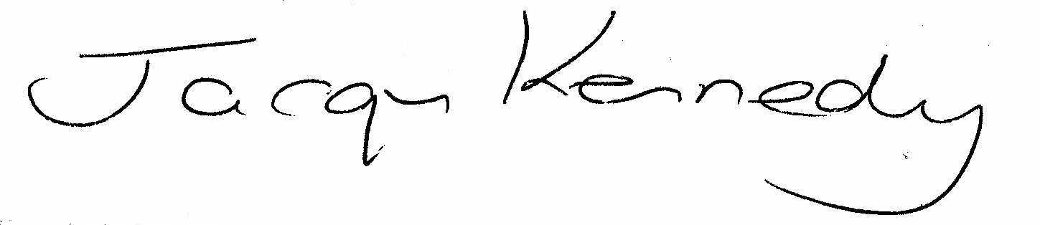
Jacqueline Mary Teresa Kennedy
Director of Regulation and Enforcement

Proposed Conditions of Consent:

1. Any person engaged in the distribution of free printed matter shall wear a clearly visible authorisation badge issued by the City Council.

2. The above authorisation shall be produced on demand to an authorised officer of the Council or a Police Constable/Police Community Support Officer.

3. No free printed matter shall be left unattended by consent holders for the general public to take at their discretion.

4. All places in which free printed matter has been distributed are to be cleansed forthwith by the consent holder to a radius of 50 metres from the distribution point of any litter caused by the distribution of the said printed matter.

5. The free printed matter must bear the name and address of the consent holder who is responsible for its distribution.

6. Applications for consent must be made not less than seven days before the required date for the distribution of free printed matter.

7. Consents will be subject to the payment of a fee based on the number of distributors per application.

8. Any person engaged in the distribution of free printed matter shall provide on demand to an authorised officer of the Council or a Police Constable/Police Community Support Officer any information reasonably required to enable compliance with consent conditions to be verified. This may include:

  - their full name and address
  - details of any person(s) commissioning them to distribute free literature [where applicable]
  - details of their employer or agent [where applicable]

Proposed Cost of Obtaining Consent:
An annual consent fee of £260 per person has been proposed which allows the distribution of free printed matter in any of the designated areas.

