Information Concerning Mausoleums and vaults
Mausoleum chambers are free standing units provided for the interment of deceased persons above ground on a lease period. This is a common method of interring individuals throughout Europe, particularly Southern Europe. They date back to the 4th Century BC when Queen Artemisia built a burial vault to house the remains of her husband King Mausolus of Caria, from which the name is derived. The Taj Mahal is the definitive example of a mausoleum.
Demand for this type of interment facility is increasing within the UK. Each individual chamber containing the coffin is sealed and able to accommodate a range of personal memorabilia. The chamber is capped by a large plaque which can be inscribed with the name of the deceased and any inscriptions or motifs requested by the family. Side chambers may also be provided for those wishing a larger plaque for inscriptions. Alternatively separate niches may be provided to accommodate personal items or to house cremated remains.
There are varying reasons why people choose this as an alternative to burial i.e. they prefer this over below ground burial or it negates the need to maintain a grave and memorial stone.
Below are examples of mausoleums.
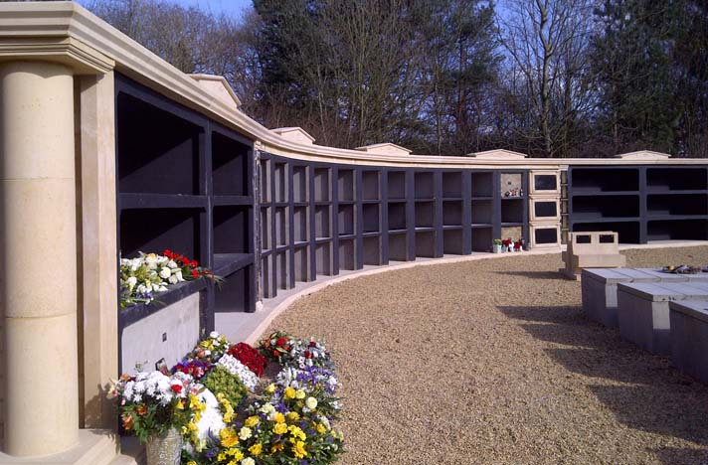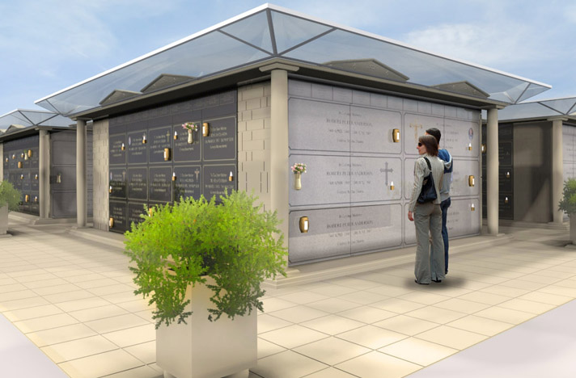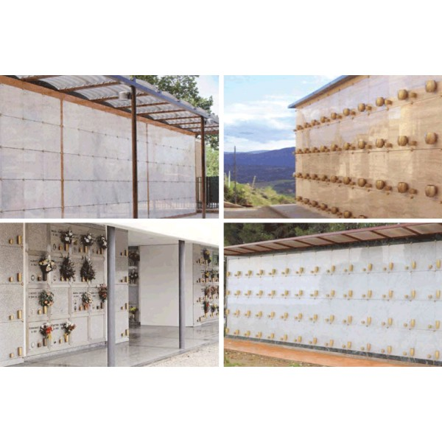

Information concerning vaults
Vaults are pre-cast chambers that are buried in the ground. Dependent upon the design, they may be fully underground or the top of the chamber may be partially above ground and then encased in granite or other stone to form the memorial.
Vaults are similar to bricked graves with the exception that they are pre-cast and placed into the ground as opposed to being constructed underground.
At the time of an interment, the chamber would be unsealed and then permanently resealed once the coffin has been placed inside.
Vaults may be available to accept one, two or three interments, dependent upon the design of the installation.
Examples of various vaults are illustrated below:

