1. INTRODUCTION

Birmingham City Council is consulting on the proposal to introduce a Public Space Protection Order (PSPO) in the area around the Robert Clinic Station Road. This is to address certain behaviour by members of Pro- Life – Pro-Choice groups outside and in the locality of the clinic.

The consultation will run from Monday 4th April 2022 to 23th May 2022

A local authority can make a PSPO if satisfied on reasonable grounds that there are a number of activities, carried out or likely to be carried out in a public space ‘the restricted area’, shown outlined on the map attached, that have had, or are likely to have, a detrimental effect on the quality of life of those in the locality. The effect or likely effect of these activities is of a persistent or continuing nature such as to make these activities unreasonable, and justifies the restrictions imposed in this order. (Anti-social Behaviour Crime and Policing Act 2014 (for full details see www.legislation.gov.uk)

2. BACKGROUND

The BPAS clinic is a health care facility whose services include providing medical and surgical abortion care. Since Autumn 2019 concerns have been raised about protesters outside Robert Clinic, many of whom are part of 40 Days For Life, a pro-life group which campaigns against abortion.
Twice a year in Autumn and over Lent protestors attend the Clinic between 8am and 8pm every day, for 40 days with as many as 8-9 individuals outside including families and small children. Prior to the shift in focus to the Robert Clinic the group were present outside the Calthorpe Clinic in Edgbaston for 9 years. Outside of the organised 40-day campaigns, members of 40 DFL attend regularly, on a twice weekly basis, to continue their protest.
The activities complained of relate to protesters making known their disapproval of the users, visitors and employees of the clinic by handing out leaflets including leaflets with disturbing and graphic images, praying, chanting, singing hymns; harassing and intimidating behaviour including blocking the pathway to the clinic, approaching those entering the clinic, blocking the pavement, making their views known to anyone in the proposed restricted area including children, taking away from those using the clinic their ability to attend in confidence, free from intimidation or judgment. The protests have led to verbal and on occasion physical confrontations between protesters and other members of the public including local residents. Local residents have reported the effect the activities of the protesters and the presence of the protesters have had on their quality of life, including being unable to enjoy their homes and gardens, having to explain the presence and purpose of the protesters to their own young children, and their mental health being affected by the continuing presence of the protest outside their homes or whilst they go about their day to day lives. Residents have felt upset at the effect the protesters’ presence has on those using the clinic.

3. INVESTIGATION AND EVIDENCE

i) Birmingham City Council have investigated complaints surrounding protesters at Robert Clinic. There has been engagement with the local community at various community meetings over the last 12 months, including the views of local residents and Councillors. There has been engagement with the protesters and more specifically 40 days for life via telephone conversation with a further face to face meeting to take place during the consultation period.

ii) Birmingham City Council have gathered evidence from West Midlands Police, those working, using or visiting the Clinic and from local residents.

iii) evidence can be summarised as follows:

(a) West Midlands Police record increased anti- social behaviour in the area proposed as the ‘restricted area’. A significant amount of time is being spent by Police officers and PCSOs dealing with incidents relating to the Robert Clinic protesters, and patrols of the area to ensure that all parties are safe and to reduce offences.
Between 8/1/21-8/1/22 5% of anti -social behaviour in the proposed restricted area related to the Robert Clinic protests, 16 recorded cases of asb, and 8 crimes against residents and against protesters. In addition, WMP record numerous calls, emails, and face to face complaints which fall outside these figures. Between 2/20-12/21 there were 65 calls and 17 crimes recorded again against residents and protesters.
Police logs record complaints of protestors: intimidating staff and clients entering the clinic, blocking access to the premises, handing out leaflets including leaflets with graphic images and incorrect scientific information, holdings prayers, approaching school children, and shouting at members of the public.
The presence of protesters outside the clinic has led to confrontations between the protesters and other members of the public, including verbal confrontations and threats from both sides. Predominately criminal offences have been recorded by protesters.

There is a higher level of anti -social behaviour recorded in the proposed restricted area than in the surrounding area.

(b) Local residents have formed an informal group where they have drawn together their experiences of the protests and explained why they feel the presence of protesters is having a detrimental effect upon them. The group has 60 resident/household members who live in and around the Clinic.
They record:
The stress and anxiety the campaign causes to local residents, on a daily basis, is profound. We walk past them; we hear their chanting/praying; our children question their presence; we see them disseminating information to locals (including teenage schoolchildren); and most disturbingly, we see them disseminating information to the patients of the Clinic, at times pushing it on them. The presence of the protestors is seriously affecting the mental health of so many local residents
  - "The impact of their presence on our community is palpable. There have been arguments in the street between protestors and residents and even just people walking past. As a community we do not want them here and I personally do not want to open my curtains or front door to them for 80 days a year! 80 days of feeling negative and angry, 80 days of worrying about the poor women using the clinic, 80 days of having to stop myself from walking over and shouting at them. They are part of some massive global organisation; they aren’t part of our community and they have no right to upset so many of us by protesting about something which is totally legal in this country! I just want them gone and our street corner to be safe for everyone". (local resident)
  - "I have lived by the clinic for the past 11 years. Every time the protestors are there, I become really anxious. As a Christian it angers me that they use their religion to imply they are there to support women to make better choices. This is not only judgmental but untrue. They force leaflets on them and chat in their faces. When I pass by night they lurk in the dark in large groups. By day they appear to wear the brightest clothing so as to draw more attention to themselves. At the weekend they stand outside the clinic as families, often with children my children's age. This causes me great upset. We don't question or judge the people who need to access the clinic - it is none of our business. I know the decision to have an abortion is not an easy one and the women deserve to access the services without feeling judged.” (local resident)
  - The protestors are intimidating and approaching women, women who have made their choice and who are entitled to have an abortion in privacy and with dignity and without being harassed by a stranger. I have seen the protestors approach women as they get out of their cars, I have seen them force leaflets into their hands as they walk into the clinic and I have seen them approach school girls on their way to and from school
  - Their chanting is so loud that it can be heard from inside residents' houses, offices and their gardens, above the noise of traffic.
  - we can hear the commotion from our garden. Every day we are exposed to a constant drip drip drip of people praying, conflict and arguments. This is constant and is having a detrimental effect on my peace of mind and mental health." (local resident)
    - "I could leave my curtains closed, not open my front door and not sit in my lounge – then I wouldn’t have to see them, but why should I have to do that to protect my mental health! My lounge is a lovely, sunny haven – and yet for 80 days a year I can’t sit in there without feeling miserable and helpless. They are there every day – even on weekends when the clinic is closed."
  - "Absent the protestors, the Clinic is otherwise a discrete provision. My children were none the wiser – it looks like a house. It is a source of great anxiety to me that I have to explain or lie to my children. They are 6 and 8." (local resident)
  - "…… I work at the girls’ school, have children there, and at the local primary school. I am very concerned by the protestors regularly engaging and sharing disturbing leaflets with local school children. They draw attention to themselves by increasing the volume of their prayer in what feels like an aggressive/confrontational way as people walk past. I know that my own children and some of my pupils (aged 11-18) have felt intimidated by their persistent presence on the route to the school." (local resident)

(c) Staff and service users of Robert Clinic record

Staff and service users have recorded the presence of the group, often multiple men, praying and using rosary beads, having explicit signs ‘ do not kill your baby’, approaching women as they enter or leave the clinic, and following cars as they park. The effect on service users has been recorded. Service users can feel emotional and scared, crying and having their mental health affected, and feeling harassed and intimidated.
An example of the evidence from service users is:
‘I cried in the car, it was already a horrible day and the thought of being harassed from my decision (which had been difficult one to make) was too much for me. I felt threatened and intimidated as I didn’t know what these men were going to do. I felt lucky to have my partner with me who helped me to calm down and walked up to the clinic door with me to shield me from the men. Whilst in the waiting room another woman who had been given a leaflet was crying on her own. It clearly distressed a lot of woman.’
There is a negative impact on members of staff, and even experienced members of staff are upset by the presence of the protesters.

4. Consultation

This public consultation invites views on the proposed PSPO from people with an interest in the affect area. This will include identifying people who reside in the area, work in the area, visit the area to access services in the area, and people who pass through and visit the area. While all views are welcome, more weight will be given to those who are directly affected by the behaviours complained of and by the proposed prohibitions and restrictions.

The Council will consult with the police, whatever community representatives the local authority thinks appropriate to consult, and owners and occupiers of land within the restricted area. In addition, there will be an online survey, and a number of face to face engagement opportunities over the 6 week consultation period.

Should any person have difficulty in accessing services on-line or attending any of the consultation events, provision will be made for any person who may need additional support in making their views heard. Please contact Oliver Humpidge on 07818 510 681 for any help with consultation or any questions.

5. Following Consultation.

The responses to the consultation exercise will be considered and inform the decision on whether to implement a Public Space Protection Order. In making any decision particular regard will be had to rights of freedom of expression and freedom of assembly set out in articles 10 and 11 of the Convention. Convention has the meaning given by section 21(1) Human Rights Act 1998.

6. Map of the proposed restricted area in the proposed Public Space Protection Order

Please note that the restricted area has been extended to the left and right of the map further up the junction of Franklin Rd and Linden Road and Franklin Road and Selly Oak Rd, this is because there is a line of sight directly to the clinic from those locations.
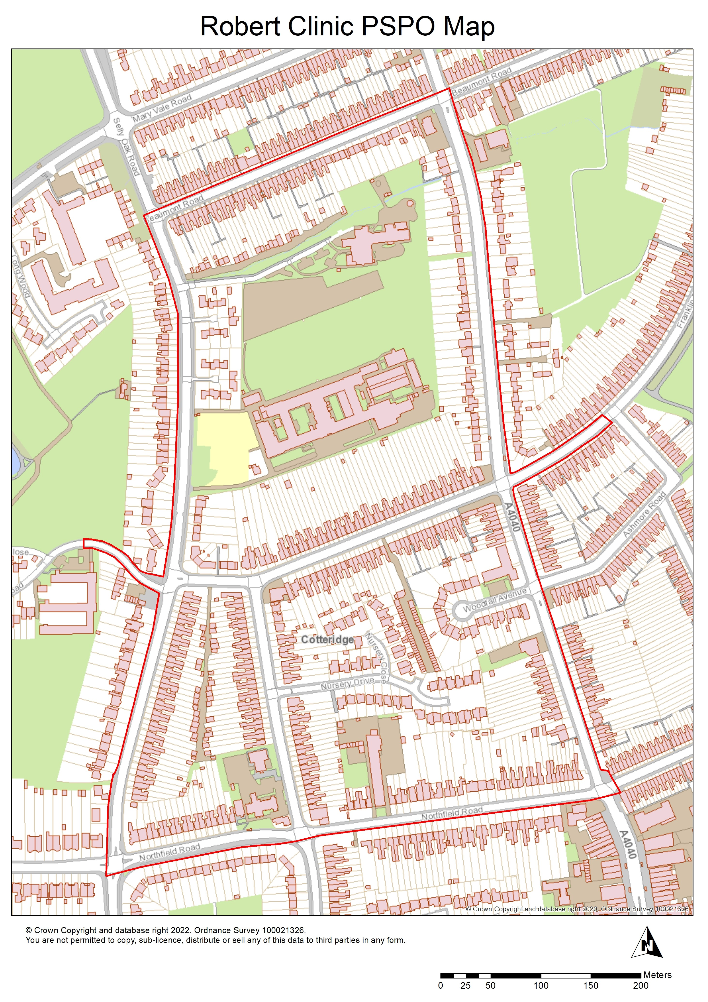

7. Draft Public Space Protection Order.



Birmingham City Council (Station Road B30) Public Space Protection Order
Anti-Social Behaviour, Crime and Policing Act 2014 – Section 59
Public Space Protection Order
The Order shall come into force on ****** 2022 at 00.00hrs
If you do not obey the order you will be committing a criminal offence and may be prosecuted by the Council within a Magistrates’ Court for an offence under Section 67 of the Anti-Social Behaviour, Crime and Policing Act 2014.

THIS ORDER is made by Birmingham City Council (the Council) under section 59 of the Anti-Social Behaviour, Crime and Policing Act 2014, because the council is satisfied on reasonable grounds that there are a number of activities, carried out or are likely to be carried out in a public space namely the area within and surrounding Station Road, Birmingham, B30, shown outlined on the map attached ( the restricted area) that have had, or are likely to have, a detrimental effect on the quality of life of those in the locality. The effect or likely effect of these activities is of a persistent or continuing nature such as to make these activities unreasonable, and justifies the restrictions imposed in this order.

The Council has had regard to the rights and freedoms set out in the European Convention on Human Rights. The Council has had particular regard to the rights and freedoms set out in Article 10 ( right of freedom of expression) and Article 11 ( right of assembly) of the European Convention on Human Rights and has concluded that the restrictions on such rights and freedoms imposed by this Order are lawful, necessary and proportionate.

THE ACTIVITIES

The Activities prohibited by the Order are:

i Protesting, namely engaging in any act of approval or disapproval or attempted act of approval or disapproval, with respect to issues related to abortion services, by any means. This includes but is not limited to graphic, verbal or written means, prayer or counselling,

ii Interfering, or attempting to interfere, whether verbally or physically, with a Robert Clinic service user, visitor or member of staff,
iii Intimidating or harassing, or attempting to intimidate or harass, a Robert Clinic service user, visitor or a member of staff,
iv Recording or photographing a Robert Clinic service user, visitor or member of staff or
v Displaying any text or images relating directly or indirectly to the termination of pregnancy.

THE PROHIBITION

5. A person shall not engage in any of the Activities anywhere within the restricted area as shown outlined in red on the attached map.

DEFINITIONS

7. In this Order the following words or phrases are defined as follows:
‘Robert Clinic’ means the Robert Clinic on Station Rd, Birmingham B30 1DB
‘Restricted Area’ means the area outlined in red as identified on the attached map
‘Displaying any text or images relating directly or indirectly to the termination of pregnancy’ includes but is not limited to, imagery or textual references to abortion, baby, mum, foetus, soul, kill, hell, murder;
‘Member of staff’ includes any employee, agent or contractor of the Robert Clinic;
‘Protesting’ means being in the restricted area (whether by yourself or with others) and engaging in any act of approval or disapproval or attempted act of approval or disapproval, with respect to issues related to abortion services, by any means. This includes but is not limited to, graphic, verbal or written means, prayer or counselling;
‘Service user’ includes any patient or visitor to the Robert Clinic.

REQUIREMENTS

8. A person who is believed to have engaged in a breach of this order or in anti-social behaviour within the restricted area, is required to give their name and address to a police officer, police community support officer or other person designated by Birmingham City Council.
9. A person who is believed to have engaged in a breach of this order or in anti-social behaviour within the restricted area, is required to leave the area if asked to do so by a police officer, police community support officer or other person designated by Birmingham City Council.

THIS ORDER WILL BE IN FORCE FOR A PERIOD OF 3 YEARS AND WILL EXPIRE ON THE ******** 2025 AT 23.59HRS.
At any point before the expiry of this three year period the Council can extend the Order by up to three years if they are satisfied on reasonable grounds that this is necessary to prevent the activities identified in the Order from occurring or recurring or to prevent an increase in the frequency or seriousness of those activities after that time.

Right to challenge the validity of this order
An interested person may apply to the High Court to question the validity of this order. An interested person is someone who lives in, regularly works in, or visits the restricted area. An application must be made within the period of 6 weeks beginning with the date on which the Order is made. This right to challenge also exists where an order is varied by a council.
Interested persons can challenge the validity of a PSPO on two grounds. They could argue that the council did not have power to make the order, or to include prohibitions or requirements. In addition, the interested person could argue that one of the requirements (for instance, consultation) had not been complied with.
When the application is made, the High Court can decide to suspend the operation of the PSPO pending the verdict in part or in totality. The High Court has the ability to uphold the PSPO, quash it, or vary it.

SIGNED DATED

Duly Authorised Officer
Director of City Operations
City Operations Directorate

SIGNED DATED
Duly Authorised Officer
West Midlands Police

Any enquiry relating to this order may be made from 09.00 – 16.00 hours Monday to Friday at:
CSP Enquiries cspenquiries@birmingham.gov.uk

Offence and Penalty on breach.

It is an offence for a person, without reasonable excuse, to:

- Do anything that the person is prohibited from doing by a PSPO or
- Fail to comply with a requirement to which the person is subject under a PSPO.

A person does not commit an offence by failing to comply with a prohibition or requirement that the Council did not have power to include in the PSPO. A person guilty of an offence is liable on summary conviction to a fine not exceeding level 3 on the standard scale.

Depending on the behaviour in question, the enforcing officer could decide that a fixed penalty notice (FPN) would be the most appropriate sanction. The FPN can be issued by a police officer, or other authorised person. In making the decision to issue a FPN, the officer should consider that if issued, payment of the FPN would discharge any liability to conviction for the offence. However, where the FPN is not paid within the required timescale, court proceedings can be initiated (prosecution for the offence or failing to comply with the PSPO).

